YREAK POLICE DEPARTMENT MRAP TRAINING
Smith integrated Technologies
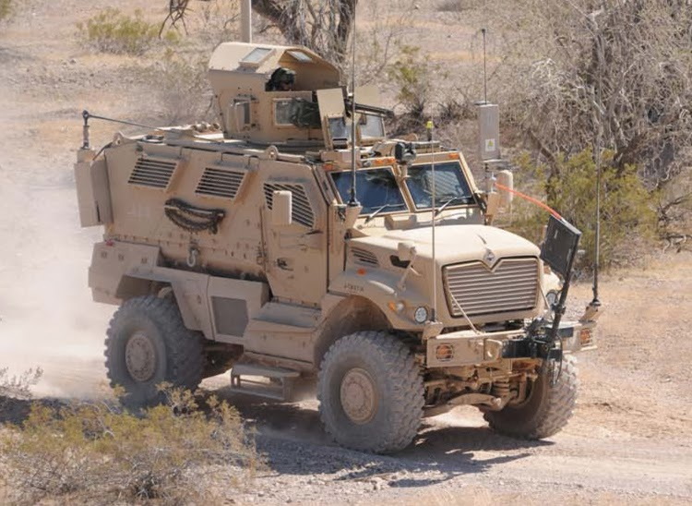
Precise EXECUTION through Superior training
M.R.A.P. Tactical Vehicle Training designed for local, state and federal law enforcement needs
When the Department of Defense Surplus Program started issuing state and local law enforcement, as well as police departments these tactical vehicles through the 1033 Program (SASP), we saw a need for specialized and skilled training on the operations of these vehicles, not only for tactical purposes, but for safety concerns. With an average of 40,000lbs and a cost of half a million dollars per vehicle, damage to personnel and equipment is a major concern. With our proven track record of instruction, we can help minimize the possibility of risk and injury to your organization and the public.
Our Training
Our professional instructors have a proven track record for safely implementing M.R.A.P. training all over the globe for Military and both Federal and Local Law Enforcement. Your organization will receive a thorough "Train the Trainer" class utilizing PowerPoint classroom time, hands on walk around detailing every aspect of the vehicle, and professional driving instruction. We will also provide Program of Instruction (POI) and Training Support Packages (TSP) for you to train future classes. We realize not all organizations require the same guidelines; therefore, we're able to tailor a training schedule to meet the customer’s individual needs.
Mobile Services
Smith Integrated Technologies combines technical and acquisition expertise with small business agility to maximize the optimal end result for our clients. Save your organization valuable time and resources by utilizing our mobile training team versus deploying your personnel. Obtain training on the exact vehicle your team will be utilizing for critical missions.
WHEN: June 14, 2014
WHERE: Yreka Police Department
TIME: 0700 to 1700

