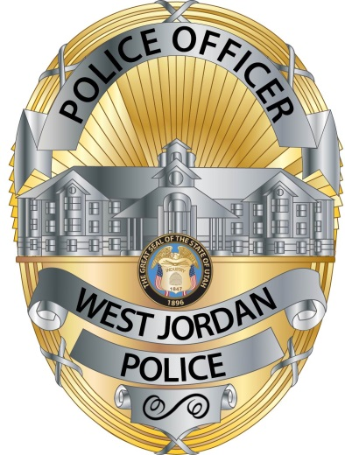
West Jordan Police
8040 South Redwood Road
West Jordan, Utah 84088
(801) 256-2000
Fax (801) 562-2105

Ken Wallentine
Chief of Police

West Jordan Police Department: Notice of Records Request Denial

To: Samuel Sinyangwe, MuckRock News
Address: DEPT MR 117809
411A Highland Ave
Somerville, MA 02144-2516
117809-76433368@requests.muckrock.com

Date: August 24, 2021

Thank you for your GRAMA request received on August 18, 2021.

Unfortunately, we will be denying this request for the following reasons:

Records are exempt from disclosure by the following:

X Statute, regulation, or ordinance:

Utah Code 63G-2-201(8)(b) – “In response to a request, a governmental entity is not required to: (b) compile, format, manipulate, package, summarize, or tailor information”

Based on the parameters of your request, we do not maintain these records in any pre-formatted and/or summarized report.

If you believe this response is improper or inadequate, you may appeal to the following administrative officer within 30 days:

- Korban Lee
- City Administrator
- 8000 S Redwood Rd
- West Jordan, UT 84088
- Korban.Lee@westjordan.utah.gov

Your appeal must contain your name, mailing address, daytime phone number, and an explanation of what you want the administrative officer to do. You may include a short statement of facts, reasons, and legal authority in support of your appeal.

Regards,
Tricia Breinholt

Tricia Breinholt
Police Records Supervisor

