**Resources**

**From Barbara Joyce**

**Regional Coordinator**

**Bureau of Immunization**

**New York State Department of Health**

Contact Info:

Barbara Joyce

Regional Coordinator

Bureau of Immunization

New York State Department Of Health

Empire State Plaza

Corning Tower Room 678

Albany, NY 12237

Phone (518) 473-4437

Fax (518) 474-5500

We have updated and posted the 2021-2022 School Immunization requirements chart at:

<https://www.health.ny.gov/publications/2370.pdf>

AND

The Q&A for 2021 - 2022:

<https://www.health.ny.gov/prevention/immunization/schools/school_survey/docs/questions_and_answers.pdf>.

* NYSIIS uses the ACIP schedule to determine valid doses and/or if completely immunized.  During the Tdap requirement roll out (refer to page 6 of Q & A), what is allowed for school attendance might not match with ACIP recommendations
* From Q & A :

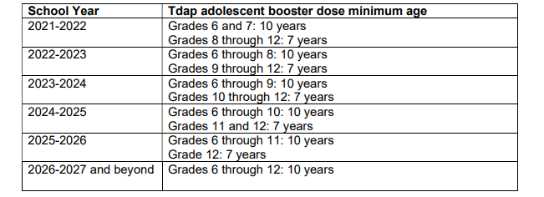

* The 2020 ACIP schedule specified that doses of DTaP or Tdap received at age 7-9 years may count as part of the catch-up series but not as the adolescent booster of Tdap, whereas that doses of DTaP and Tdap received at age 10 years or older count for both the catch-up series and the adolescent Tdap booster. In order to minimize disruption, the NYSDOH will roll out the new minimum age one grade per school year in the coming years, as described in the table above.

**(*Please also note the meningococcal requirements roll out on page 12 of the Q&A)**

* To determine if additional Tdap or Td is required, this job aid is helpful (<https://www.cdc.gov/vaccines/schedules/downloads/child/job-aids/tdap.pdf>) **but it is based on the ACIP schedule**.
* To best determine what is required for school attendance, a combination of resources might be necessary:

1. 2021-22 School Year New York State Immunization Requirements for School Entrance/Attendance:

<https://www.health.ny.gov/publications/2370.pdf>  **(use the footnotes on the back!)**

1. ACIP Catch up schedule (**see page 3**):

<https://www.cdc.gov/vaccines/schedules/downloads/child/0-18yrs-child-combined-schedule.pdf>

1. Q&A: <https://www.health.ny.gov/prevention/immunization/schools/school_survey/docs/questions_and_answers.pdf>