Voorheesville Central School District
Voorheesville, New York 12186

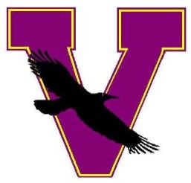

Board of Education

Cynthia M. Monaghan

President

C. James Coffin
Vice President

Rachel Gilker
Argi O’Leary
Timothy Kremer
Patricia Putman
Robert J. Samson

District Staff

Frank Macri
Superintendent

James Southard

Assistant Superintendent

For Finance & Operations

Karen Conroy
Director of Curriculum

Karen Jones
Director of Pupil Personnel Services

Joseph Sapienza
Director of Athletics

Robin Burch
Treasurer

Jessica Tabakian
District Clerk

December 14, 2021

Jackson Parker
122119-20965480@requests.muckrock.com

Re: Response to Foil Request received December 14, 2021

Dear Mr. Parker:

I am in receipt of your December 14, 2021 email pursuant to the “Freedom of Information Law (FOIL), Article 6 of the Public Officers Law (POL),” which requested the following:

Copies of oaths of offices for each of the current board members.

Copies of or information regarding surety of public school system faithful performance bonds and contact information for the bonding agent covering the board members as required by Subdivision 2 of Section 11 of the Public Officers Law and Subdivision 2(d) of Section 170 of the Commissioner’s Regulations.

We are in the process of reviewing your request and will formally respond within twenty (20) days. I will contact you with our response by email as soon as a decision has been made on your request.

You may appeal any decision to the Superintendent of Schools within 30 days of the date of the decision.

Very truly yours,

Robin Burch
Records Access Officer

Cc: Frank Macri

