Memo

TRENTON NJ POLICE DEPARTMENT
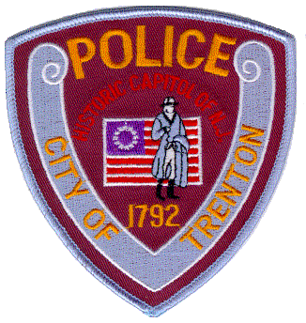
To: Lauren Pespisa
From: Sgt Miguel Acosta
Date: 4/23/2021
Re: OPRA request Floyd S Hardwick
I’m unable to locate any information on the requested party (Floyd S Hardwick) in our current and older database.

Respectfully submitted,
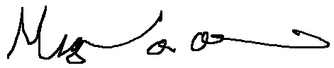
______________________
Sgt Miguel Acosta

