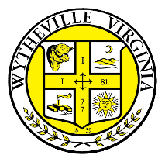
Request for Proposal
Compensation & Classification Study
Town of Wytheville, VA

The Town of Wytheville is seeking sealed proposals from qualified firms to perform a Compensation and Classification Study. Sealed proposals will be received at the Assistant Town Manager’s Office at the Town of Wytheville Municipal Building, until 4:00 p.m. on April 12, 2022. The Request for Proposal (RFP) is available at the Town of Wytheville website https://www.wytheville.org/rfp . Interested firms may contact the Assistant Town Manager at 276-223-3352 to request information regarding this proposal.
The Town of Wytheville prohibits discrimination on the basis of race, color, religion, faith- based organizations, gender identity, sexual orientation, political affiliation, age, disability, veteran status, national origin, or any other basis prohibited by state law relating to discrimination in employment. SWAM and DBE firms are encouraged to apply. The Town of Wytheville is an Equal Opportunity Employer.

Please place in the Wytheville Enterprise:
Saturday, March 19, 2022
One column width by 3”

