Instructions for WSPA Folder Project on Google Drive
- Please sign into Google with your first 2 letters of your first name, your full last name and @swsdonline.com. For example: daheisler@swsdonline.com, if you already have a google account, select “add account”
- The password is wspa2014 and then select “Sign In”
- Select “I accept. Continue to my account.” (You should only have to do this the first time you sign in)
- Select “Add to Drive” in the upper right hand corner the first time you sign on. (You should only have to do this the first time you sign in)
- Select “Open in Drive” in the upper right hand corner. (You should only have to do this the first time you sign in)
- Select “Download Drive” (You should only have to do this the first time you sign in)
- Select “Run” (You should only have to do this the first time you sign in)
- Select “Take me to Drive on the Web” (You should only have to do this the first time you sign in)
- You should now see the following:
  - 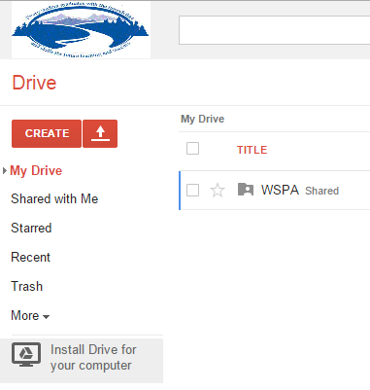
- Select “WSPA Shared”
- Select “Washington School Districts Shared”
- Find and Select your School District
- Select the folder that you want to upload files to
- Use the “Up Arrow” and select “Files”
- Browse through your computer to find where your files are and select the file you want to upload and select “Open”. You can also select several files at once by holding down the CTRL key while selecting several different files or if they are all in a row, you can select the first file and then hold down the Shift key and select the last file in the list. Now select “Open”
- Select “Upload and share”. Your files should begin uploading to your folder immediately.
- You can now load files into your other two folders or take a look at others files.

