October 1, 2018

Shawn Musgrave
MuckRock
411A Highland Avenue
Somerville, MA 02144-2516

RE: ICE FOIA Case Number 2018-ICFO-53106

Dear Mr. Musgrave:

This letter is the final response to your Freedom of Information Act (FOIA) request to U.S. Immigration and Customs Enforcement (ICE), dated July 16, 2018, for all records pertaining to OPERATION LONGARM.

You have requested records concerning a third party. Records pertaining to a third party generally cannot be released absent express authorization and consent of the third party, proof that the subject of your request is deceased, or a clear demonstration that the public interest in disclosure outweighs the personal privacy interest and that significant public benefit would result from the disclosure of the requested records. Since you have not furnished a release, death certificate, or public justification for release, release of the requested records concerning a third party would result in an unwarranted invasion of personal privacy in violation of the Privacy Act, 5 U.S.C. § 552a. In addition, third-party records are also generally exempt from disclosure pursuant to sections (b)( 6) and (b)(7)(C) of the Freedom of Information Act, 5 U.S.C. § 552.

Should you obtain the written authorization and consent from the third party referenced in your request for release of the records, please submit a new request for the documents accompanied by the written authorization and consent. A form is enclosed to assist you in providing us with the required authorization and consent. The authorization must be notarized or signed under penalty of perjury pursuant to 18 U.S. C. § 1001. Please send any such new request with the requisite authorization and consent to: ICE Freedom of Information Office, 500 12th Street, S.W., Stop 5009 Washington, D.C. 20536-5009.

If you are not satisfied with the response to this request, you have the right to appeal following the procedures outlined in the DHS regulations at 6 C.F.R. § 5.9. Should you wish to do so, you must send your appeal and a copy of this letter, within 90 days of the date of this letter, to:

U.S. Immigration and Customs Enforcement
Office of the Principal Legal Advisor
U.S. Department of Homeland Security
500 12th Street,, S.W., Mail Stop 5900
Washington, D.C. 20536-5900

Your envelope and letter should be marked “FOIA Appeal.” Copies of the FOIA and DHS regulations are available at www.dhs.gov/foia.

Provisions of the FOIA and Privacy Act allow us to recover part of the cost of complying with your request. In this instance, because the cost is below the $14 minimum, there is no charge.

If you need any further assistance or would like to discuss any aspect of your request, please contact ICE FOIA Office. You may send an e-mail to ice-foia@ice.dhs.gov, call toll free (866) 633-1182, or you may contact our FOIA Public Liaison, Fernando Pineiro, in the same manner. Please refer to FOIA case number 2018-ICFO-53106.

Sincerely,
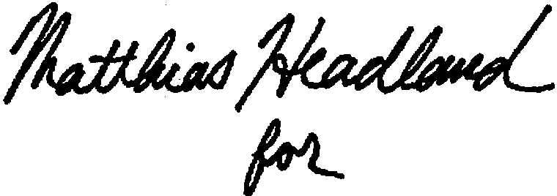
Catrina M. Pavlik-Keenan
FOIA Officer

6 CFR § 5.11(d)(4).

