**Last PIC at the end of the day will need to leave through Receiving Area to set the alarm.**

**Wash your hands. Throw away used PPE or place reusable face mask in a paper bag to take home.**

**Sign out of ProData. There will be a time clock station in the Meeting Room, or you can sign out at your desk.**

**Exit through Meeting Room. Make sure to maintain 6 feet social distancing if others are also leaving for the day.**

**Clean your workstation as needed. If using a shared space, take all personal items with you and discard trash.**

**Clean PPE supplies are available in the following locations:**

* **Receiving Area**
* **Volunteer (Virginia’s) Desk**
* **Staff Lounge**
* **By the Group Study/Tutor Rooms**

**Wash your hands frequently. Use soap and water or hand sanitizer.**

**Clean your workstation. Make sure to clean your area at the beginning of your shift and periodically throughout.**

**Complete Wellness Check.**

**Sign in to ProData on the time clock. This includes ALL staff. You can choose to sign in from another computer if you prefer.**

**Put on face mask (if not already wearing one). Gloves and face masks will be available in the Receiving Area.**

**Clean hands thoroughly with hand sanitizer.**

**Come in through staff entrance. Make sure to maintain 6 feet social distancing if others are also entering the building.**

**If you’re sick, stay home! Follow regular call-in procedures.**

Ending Your Shift

During Your Shift

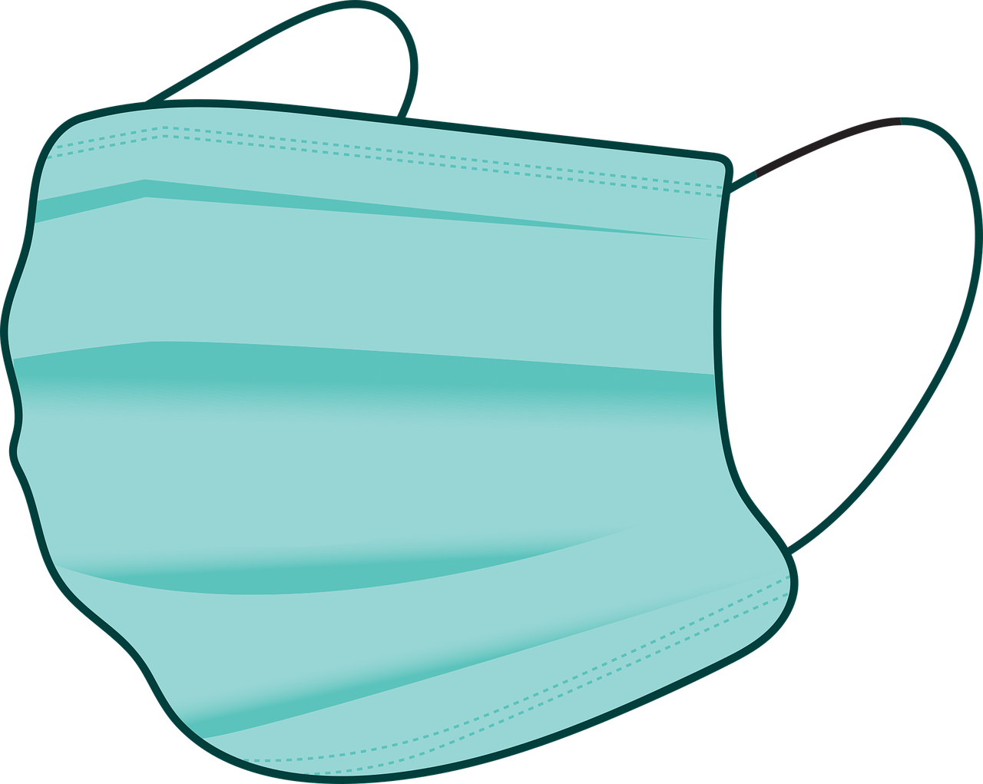 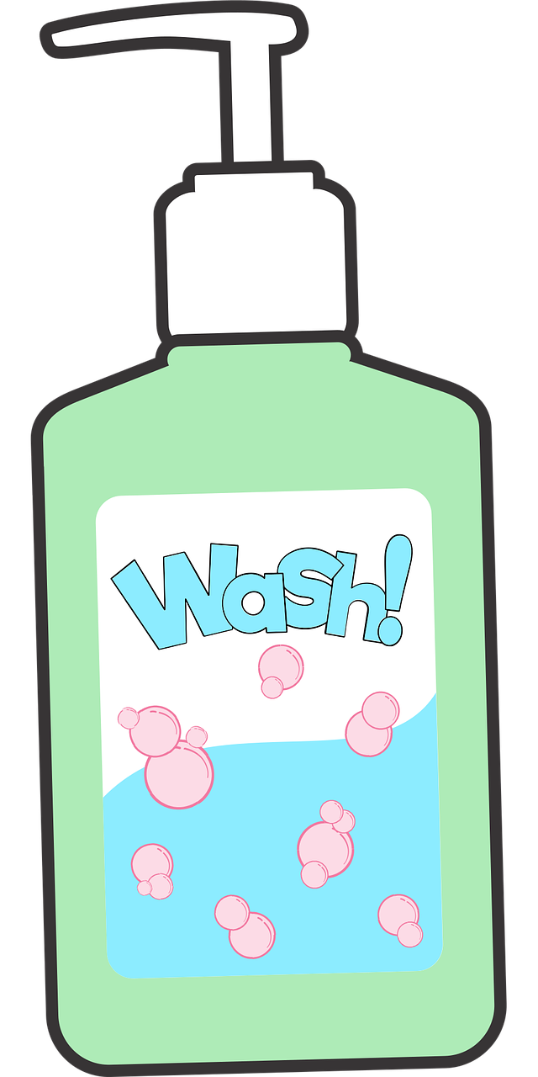

Beginning Your Shift

**Key Points for Returning to Work**

1. **Fresh PPE supplies will be available throughout the library:** Receiving Room, Volunteer Desk, Staff Lounge, and near the group study/tutor rooms in Adult Services.