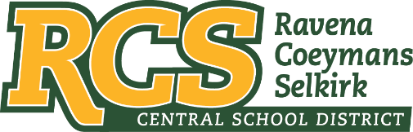
RAVENA-COEYMANS-SELKIRK CSD • PO Box 100, 15 Mountain Rd, Ravena, NY 12143 • Phone: 518-756-5200 • Fax: 518-756-4561

www.rcscsd.org
Dr. Brian Bailey, Superintendent of Schools, Ext. 6003
C. Fred Engelhardt Jr., Assistant Superintendent for C&I, Ext. 6003
Jonathan Boehme, Business Administrator, Ext.6000
Sue Starr, School District Clerk, Ext. 6000

April 3, 2023

VIA ELECTRONIC MAIL
MuckRock News
Attn: Mr. Jackson Parker
DEPT MR 142042
263 Huntington Ave
Boston, MA 02115

Re: Response to Freedom of Information Law Request

Dear MuckRock News:

This will respond to your New York State Freedom of Information Law (“FOIL”) request received by me on March 6, 2023. I am responding to your request as the Records Access Officer of Ravena-Coeymans-Selkirk Central School District (the “District”). In your request you seek:

All of the Holocaust Instruction Survey responses submitted since
August 10, 2022.

With regard to this FOIL, please see attached Holocaust Survey.

Any appeal of this decision should be made within thirty (30) days, in writing to the Superintendent
of School and can be contacted at Ravena-Coeymans-Selkirk CSD, P.O. Box 100, Ravena, NY
12143, email address: bbailey@rcscsd.org or 518-756-5200 Ext. 6003

Sincerely,
Suzanne Starr
Records Access Officer
:ss

