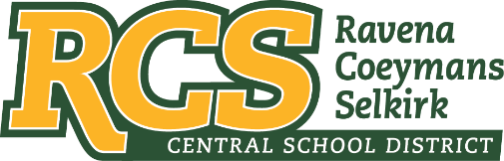
RAVENA-COEYMANS-SELKIRK CSD • PO Box 100, 15 Mountain Rd, Ravena, NY 12143 • Phone: 518-756-5200 • Fax: 518-756-4561

www.rcscsd.org
Dr. Brian Bailey, Superintendent of Schools, Ext. 6003
C. Fred Engelhardt Jr., Assistant Superintendent for C&I, Ext. 6003
Jonathan Boehme, Business Administrator, Ext.6000
Sue Starr, School District Clerk, Ext. 6000

March 31, 2023

VIA ELECTRONIC MAIL
MuckRock News
Attn: Mr. Jackson Parker
DEPT MR 142017
263 Huntington Ave
Boston, MA 02115

Re: Response to Freedom of Information Law Request

Dear MuckRock News:

This will respond to your New York State Freedom of Information Law (“FOIL”) request received by me on March 6, 2023. I am responding to your request as the Records Access Officer of Ravena-Coeymans-Selkirk Central School District (the “District”). In your request you seek:
All materials and correspondence between the district Board of Education, district Administration, District Equity Committee or Office, Faculty, Staff, Third Party Contractors and Consultants related to the following terms, subjects or concepts between April 2021 to the date this request is fulfilled:
Race Anti-racism
Racism Equity
Culturally Responsive Decolonize
Diversity Implicit Bias
Intersectionality Microaggression
Oppression Patriarchy
People of Color Privilege(d)
Safe Space Social Justice
Tokenism White Supremacy
This request shall also include any teachings of such curriculum mentioned above by any faculty employed within the school district, third party contractors, consultants or other third parties invited by the school or agents of the school.
This request shall also include any documents or materials accessed by the school district, but stored on third party service providers on behalf of the district, and links/references/credentials for access to such materials if present in emails or electronic systems or files stored in browser caches, cloud storage (i.e. Google Drive, Dropbox, OneDrive, etc), or local hard drives managed by the district. This request shall also include non-school email and texting services used by the district, board, administration and faculty to conduct activities and business related to the school district (i.e. Gmail, Outlook, etc).
This request shall also include any training material or supplemental information provided to district staff, whether required or suggested.

With regard to your FOIL request, your request to too broad. Please narrow your search.

Any appeal of this decision should be made within thirty (30) days, in writing to the Superintendent
of School and can be contacted at Ravena-Coeymans-Selkirk CSD, P.O. Box 100, Ravena, NY
12143, email address: bbailey@rcscsd.org or 518-756-5200 Ext. 6003

Sincerely,
Suzanne Starr
Records Access Officer
:ss

