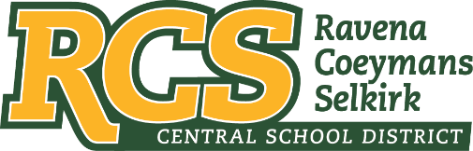
RAVENA-COEYMANS-SELKIRK CSD • PO Box 100, 15 Mountain Rd, Ravena, NY 12143 • Phone: 518-756-5200 • Fax: 518-756-4561

www.rcscsd.org
Dr. Brian Bailey, Superintendent of Schools, Ext. 6003
C. Fred Engelhardt Jr., Assistant Superintendent for C&I, Ext. 6003
Jonathan Boehme, Business Administrator, Ext.6000
Sue Starr, School District Clerk, Ext. 6000

June 20, 2023

VIA ELECTRONIC MAIL

MuckRock News
Attn: Jackson Parker
DEPT MR 142017
263 Huntington Ave
Boston, MA 02115

Re: Response to Freedom of Information Law Request

Dear Mr. Parker:

This will respond to your New York State Freedom of Information Law (“FOIL”) request received by me on April 14, 2023, and follows my initial response to you acknowledging receipt of that request dated April 18, 2023. I am responding to your request as the Records Access Officer of the Ravena-Coeymans-Selkirk Central School District. In your request, as revised, you seek:

All materials and correspondence between the district Board of Education, district Administration, district Equity Committee or Office, Faculty, Staff, Third Party Contractors and Consultants related to the following terms, subjects or concepts between January 1, 2022 to the date this request is fulfilled:
a. Equity
b. Culturally Responsive
c. Implicit Bias
d. People of Color
e. Social Justice
f. Diversity
g. Decolonize
h. Intersectionality

With regard to your pending appeal, please be advised that the District is continuing to work diligently with its IT department to determine whether it is able to comply with your request. To that end, the District is requesting additional time in which to respond to your appeal so that it may continue to better search and review the records you seek. If you are agreeable, the District would request an additional ten (10) school days in which to respond to you. Thank you for your anticipated courtesies.

Sincerely,
Suzanne Starr
Records Access Officer
:ss

