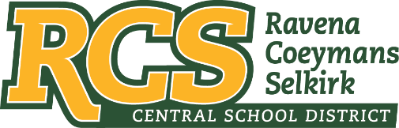
RAVENA-COEYMANS-SELKIRK CSD • PO Box 100, 15 Mountain Rd, Ravena, NY 12143 • Phone: 518-756-5200 • Fax: 518-756-4561

www.rcscsd.org
Dr. Brian Bailey, Superintendent of Schools, Ext. 6003
C. Fred Engelhardt Jr., Assistant Superintendent for C&I, Ext. 6003
Jonathan Boehme, Business Administrator, Ext.6000
Sue Starr, School District Clerk, Ext. 6000

March 31, 2023

VIA ELECTRONIC MAIL
MuckRock News
Attn: Mr. Jackson Parker
DEPT MR 141920
263 Huntington Ave
Boston, MA 02115

Re: Response to Freedom of Information Law Request

Dear MuckRock News:

This will respond to your New York State Freedom of Information Law (“FOIL”) request received by me on March 5, 2023. I am responding to your request as the Records Access Officer of Ravena-Coeymans-Selkirk Central School District (the “District”). In your request you seek:

All communications, reports, plans, documentations, calendar entries or agreements between district and BOCES and or third parties regarding school climate surveys (i.e. EDSCLS) for the previous 5 years.

With response to the above FOIL please see the attached link.

https://safesupportivelearning.ed.gov/edscls/administration

Any appeal of this decision should be made within thirty (30) days, in writing to the Superintendent
of School and can be contacted at Ravena-Coeymans-Selkirk CSD, P.O. Box 100, Ravena, NY
12143, email address: bbailey@rcscsd.org or 518-756-5200 Ext. 6003

Sincerely,
Suzanne Starr
Records Access Officer
:ss

