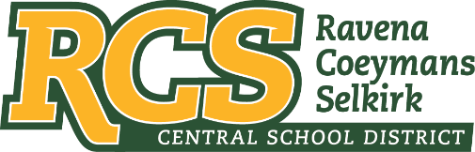
RAVENA-COEYMANS-SELKIRK CSD • PO Box 100, 15 Mountain Rd, Ravena, NY 12143 • Phone: 518-756-5200 • Fax: 518-756-4561

www.rcscsd.org
Dr. Brian Bailey, Superintendent of Schools, Ext. 6003
C. Fred Engelhardt Jr., Assistant Superintendent for C&I, Ext. 6003
Joanne Moran, School Business Manager, Ext.6000
Sue Starr, School District Clerk, Ext. 6000

VIA ELECTRONIC MAIL

Jackson Parker
132216-79544274@requests.mucrock.com

Re: Response to Freedom of Information Law Request

Dear Mr. Parker:

This will respond to your New York State Freedom of Information Law (“FOIL”) requests received by me on September 30, 2022 and follows my initial response to you acknowledging receipt of those request October 3, 2022. I am responding to your request as the Records Access Officer of the Ravena-Coeymans-Selkirk Central School District. In your requests you seek:

Any and all emails, paper communications, phone logs, text messages, receipts, invoices,
memorandum, meeting notes from/to/cc anyone with the following certifications/licenses/titles:
- School Building Leader
- School Administrator / Supervisor
- School District Leader
- School District Business Leader
- School Board Member
which contain the statement "next normal".
Please be advised that after a search and investigation, the District appears to be in possession of approximately 36 pieces of correspondence that may be responsive to your request, with the vast majority being unsolicited, commercial advertisements from various vendors. Given the scope of records within the District’s possession that may be responsive your request, as currently drafted, we respectfully ask that you consider refining your request, so that the District can narrow its response to provide you with only those records you are actually seeking, if the District is in possession of such records. Of course, should you still wish to proceed with your initial request set forth above, the District will have to print such records in order to review them appropriately and redact them, if necessary.

Therefore, it will be necessary for you to remit payment to the Ravena-Coeymans-Selkirk Central School District in the amount of $31.25 which is equal to 125 pages of records at $.25 per page. Upon receipt of your payment, the Ravena-Coeymans-Selkirk Central School District will make those records available to you.

Any appeal of this decision should be made within thirty (30) days, in writing to the Superintendent of School and can be contacted at Ravena-Coeymans-Selkirk CSD, P.O. Box 100, Ravena, NY 2143, email address: bbailey@rcscsd.org or 518-756-5200 Ext. 6003

Sincerely,
Suzanne Starr
Records Access Officer

:ss

