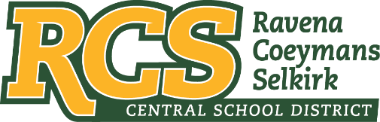
RAVENA-COEYMANS-SELKIRK CSD • PO Box 100, 15 Mountain Rd, Ravena, NY 12143 • Phone: 518-756-5200 • Fax: 518-756-4561

www.rcscsd.org
Dr. Brian Bailey, Superintendent of Schools, Ext. 6003
C. Fred Engelhardt Jr., Assistant Superintendent for C&I, Ext. 6003
Joanne Moran, School Business Manager, Ext.6000
Sue Starr, School District Clerk, Ext. 6000

August 30, 2022

VIA ELECTRONIC MAIL
MuckRock News
DEPT MR 129531
263 Huntington Ave
Boston, MA 02115

Re: Response to Freedom of Information Law Request

Dear MuckRock News:

This will respond to your New York State Freedom of Information Law (“FOIL”) request received by me on August 5, 2022. I am responding to your request as the Records Access Officer of Ravena-Coeymans-Selkirk Central School District (the “District”). In your request you seek:
Pursuant to the New York Freedom of Information Law, I hereby request the following records:
A log of, or records that reflect, all Freedom of Information Law requests submitted to the district since January 1, 2016 or as far back as such records are kept.

With response to the above FOIL, the District does not keep a log of FOIL Requests.

Any appeal of this decision should be made within thirty (30) days, in writing to the Superintendent
of School and can be contacted at Ravena-Coeymans-Selkirk CSD, P.O. Box 100, Ravena, NY
12143, email address: bbailey@rcscsd.org or 518-756-5200 Ext. 6003

Sincerely,
Suzanne Starr
Records Access Officer
:ss

