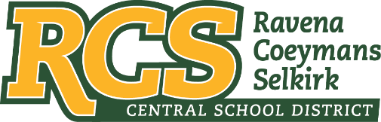
RAVENA-COEYMANS-SELKIRK CSD • PO Box 100, 15 Mountain Rd, Ravena, NY 12143 • Phone: 518-756-5200 • Fax: 518-756-4561

www.rcscsd.org
Dr. Brian Bailey, Superintendent of Schools, Ext. 6003
C. Fred Engelhardt Jr., Assistant Superintendent for C&I, Ext. 6003
Joanne Moran, School Business Manager, Ext.6000
Sue Starr, School District Clerk, Ext. 6000

August 8, 2022

MuckRock News
Attn: Jackson Parker
DEPT MR 129531
263 Huntington Ave
Boston, MA 02115

Dear Mr. Parker:

I am in receipt of your FOIL request dated August 5, 2022 pursuant to the New York State Freedom of Information Law regarding logs or records that reflect, all Freedom of Information Law requests submitted to the district since January 1, 2016.

Please be advised that the District is working to ascertain what documents, if any, exist that are responsive to your request. It is expected that your request will be responded to no later than twenty business days or before, from the date of this letter.

Sincerely,
Suzanne Starr
School District Clerk
Records Access Officer

:ss

