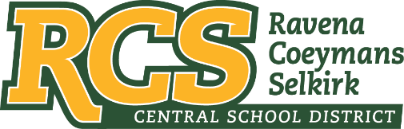
RAVENA-COEYMANS-SELKIRK CSD • PO Box 100, 15 Mountain Rd, Ravena, NY 12143 • Phone: 518-756-5200 • Fax: 518-756-4561

www.rcscsd.org
Dr. Brian Bailey, Superintendent of Schools, Ext. 6003
C. Fred Engelhardt Jr., Assistant Superintendent for C&I, Ext. 6003
Joanne Moran, School Business Manager, Ext.6000
Sue Starr, School District Clerk, Ext. 6000

August 8, 2022

VIA ELECTRONIC MAIL
MuckRock News
DEPT MR 129531
263 Huntington Ave
Boston, MA 02115

Re: Response to Freedom of Information Law Request

Dear MuckRock News:

This will respond to your New York State Freedom of Information Law (“FOIL”) request received by me on August 5, 2022. I am responding to your request as the Records Access Officer of Ravena-Coeymans-Selkirk Central School District (the “District”). In your request you seek:
Pursuant to the New York Freedom of Information Law, I hereby request the following records:
Copies of signed and notarized (if available) oaths of office for any and all district employees or contractors with the following credentials:
- School Building Leader
- School Administrator / Supervisor
- School District Leader
- School District Business Leader
From October 15, 2017 until the date this request is fulfilled.
With response to the above FOIL the District does not require School Building Leader, School Administrator / Supervisor, School District Leader or the School District Business Leader to take an Oath of Office.

Any appeal of this decision should be made within thirty (30) days, in writing to the Superintendent
of School and can be contacted at Ravena-Coeymans-Selkirk CSD, P.O. Box 100, Ravena, NY
12143, email address: bbailey@rcscsd.org or 518-756-5200 Ext. 6003

Sincerely,
Suzanne Starr
Records Access Officer
:ss

