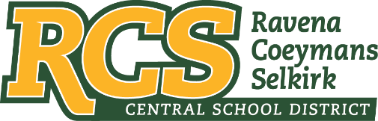
RAVENA-COEYMANS-SELKIRK CSD • PO Box 100, 15 Mountain Rd, Ravena, NY 12143 • Phone: 518-756-5200 • Fax: 518-756-4561

www.rcscsd.org
Dr. Brian Bailey, Superintendent of Schools, Ext. 6003
C. Fred Engelhardt Jr., Assistant Superintendent for C&I, Ext. 6003
Joanne Moran, School Business Manager, Ext.6000
Sue Starr, School District Clerk, Ext. 6000

August 30, 2022

MuckRock News
Attn: Jackson Parker
DEPT MR 129531
263 Huntington Ave
Boston, MA 02115

Dear Mr. Parker:

This will respond to your New York State Freedom of Information Law (“FOIL”) request received by me on August 5, 2022. I am responding to your request as the Records Access Officer of Ravena-Coeymans-Selkirk Central School District (the “District”). In your request you seek:
Pursuant to the New York Freedom of Information Law, I hereby request the following records:
Any and all emails, paper communications, phone logs, text messages, receipts, invoices, memorandum, meeting notes from/to/cc anyone with the following certifications/licenses/titles:
- School Building Leader
- School Administrator / Supervisor
- School District Leader
- School District Business Leader
- School Board Member
which contain the statement "moral panic".
With response to the above FOIL - No document exists in the possession of the District that indicate “moral panic”.

Please be advised that the District is working to ascertain what documents, if any, exist that are responsive to your request. It is expected that your request will be responded to no later than twenty business days or before, from the date of this letter.

Sincerely,
Suzanne Starr
School District Clerk
Records Access Officer

:ss

