March 1, 2022

Suzy Watkins, Harbor Director
Port San Luis Harbor District
P.O. Box 249
Avila Beach, CA 93424-0249

MuckRock News
DEPT MR 125313
411A Highland Ave.
Somerville, MA 02144-2516

RE: CA Public Records Act Request – Port San Luis Training Documents

Martinelli & Associates, Inc. is in receipt of a CPRA request for training documents used by the Port San Luis Harbor District to train their Harbor Patrol Officers. Specifically, MuckRock News’ is request for “All current standards, policies, practices, operating procedures, and education and training materials in use by the Port San Luis Harbor District Harbor Patrol Department.”

Martinelli & Associates, Inc., is a private, for-profit criminal justice/law enforcement training and consulting firm that provides fee-based and copyrighted training delivery services to municipal, state and federal agencies. Among our training offerings are courses in officer safety tactics and responses to critical incidents such as armed subjects and active shooters who pose significant deadly threats to officers and civilians at the port.

Martinelli & Associates, Inc.’s derives its income from highly competitive course offerings which involve proprietary, trade secret formulas, patterns, compilations, methods and techniques not known to the public or to other private, competitive training entities.

Our firm has been a contracted vendor to the Port San Luis Harbor District since 2007. In forming our business, training and consulting relationship with the Port San Luis Harbor District, the District agreed to abide by our proprietary copyrighted training methodologies and not divulge or reproduce them in any manner electronically, or in print.

It is the considered the steadfast opinion of Martinelli & Associates, Inc. and the Port San Luis Harbor District that the release of our proprietary officer safety and tactical response methodologies and training documents would significantly compromise the safety and security of Harbor Officers and the general public. The release of such critical and restricted training information clearly outweighs the anonymous public’s unspecified need to know, as well as that of any competitive private business entity who might gain an unfair economic advantage by plagiarizing and using our corporate secrets. Our firm’s position is consistent with CA Civil Codes and State Court Rulings.

MuckRock News’ request for Port San Luis Harbor District Harbor Patrol’s standards, policies and procedures used by the port and their Harbor Patrol Officers can be readily obtained from the Harbor District’s, as well as on the State of California Commission on Peace Officer Standards & Training (CA-POST) websites.

The legal concepts incorporated into the proprietary training methodologies provided by Martinelli & Associates, Inc. to the port district are consistent in every way with CA-POST standards, CA State Statutes and U.S. Federal Court rulings which are considered to be recognized, accepted, applied and trained codified law enforcement practices and standards of care used in CA and nationally.

In summary, Martinelli & Associates, Inc., as a private, non-governmental entity respectfully declines to comply with this CPRA request and will not provide the Port San Luis Harbor District with a waiver to share our proprietary training methodologies or lesson plans with any outside entity absent a subpoena.

Please feel free to contact our office with any question, comments or concerns.

Sincerely,

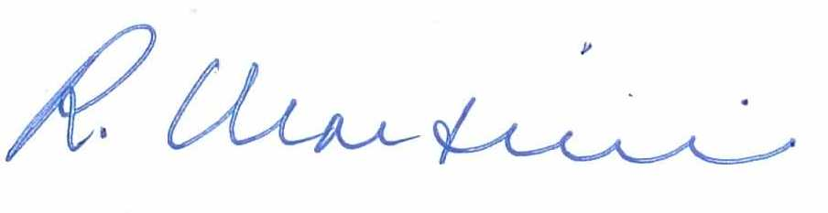
Ron Martinelli, Ph.D., CMI-V
CEO/President
Martinelli & Associates, Justice & Forensic Consultants, Inc.

Civ. Code §3426.1(d), “Uniform Trade Secrets Act”

