Save the Date ~ May 14

Everything Library Trustees Need to Know During COVID-19 Webinar

The Illinois Heartland Library System (IHLS), the Illinois Library Association (ILA), and the Reaching Across Illinois Library System (RAILS) invite all Illinois public library trustees to join us for a Zoom webinar:

WHEN: Thursday, May 14, from 2–4 p.m.
WHERE: Via Zoom. Please register

Library directors and other library staff are welcome to attend.

Here are just a few items on the agenda:
- IHLS, ILA, and RAILS staff will share resources available to help trustees help their libraries during COVID-19.
- ILA will discuss talking points trustees can use to let their communities know how essential the library is during the pandemic and after.
- Jamie Rachlin, President of Meristem Advisors, will talk about how libraries can handle budget implications as a result of COVID-19.
- Kelly Haden, Chief Legal Counsel for HR Source, will discuss employment issues, including unemployment, furloughs, and layoffs.

There will also be a Q&A with a panel including IHLS, ILA, and RAILS staff, and library trustees. Please submit any questions you have about any issues related to COVID-19 in advance to Joe Filapek. The deadline for submitting questions is Monday, May 11.

Register for Webinar!

Things to consider before reopening

- Check with your local County Health Department and get their opinion. Before you should even consider doing curbside service, make sure you have everything you need with regarding to PPE and cleaning supplies to protect staff and patrons. You might want to look at this helpful resource developed by our colleagues at the Reaching Across Illinois Library System (RAILS) regarding initiation of curbside services: https://www.railslibraries.info/issues/178451

- Here is a map by the Illinois Department of Public Health that shows activity for the virus across the state.(http://www.dph.illinois.gov/topics-services/diseases-and-conditions/diseases-a-z-list/coronavirus). Things to remember as you look at this map is that the information changes so check it frequently. Also since there is a shortage of testing there may be cases that are undiagnosed or unreported.

- As to legality, you might want to look at this part of our COVID-19 website: https://www.illinoisheartland.org/covid19/government-mandates. In the 1st paragraph, under April it outlines guidelines from the governor’s office regarding libraries and which agencies are regarded as essential services.

- Keep looking at the COVID-19 resources that are out there for libraries.
  - Illinois Heartland Library System: https://www.illinoisheartland.org/covid19
  - Illinois Library Association:
    - Coronavirus Resources: https://www.ila.org/advocacy/coronavirus-resources
    - Bigger Than a Building Campaign: https://www.ila.org/advocacy/bigger-than-a-building
  - Reaching Across Illinois Library System: https://www.railslibraries.info/issues/178451
.
- Contact the Illinois Heartland Library System with your concerns. If we do not have the answer but we will help you find them. Do not hesitate to reach out:

- SHARE (Online Catalog) Cassandra Thompson (cthompson@illinoisheartland.org)
- Delivery: Susan Palmer (spalmer@illinoisheartland.org)
- Membership (Questions that aren’t about the specific workings of your online catalog or delivery) contact Anna Yackle (ayackle@illinoisheartland.org) or Ellen Popit
- (epopit@illinoisheartland.org)
- IHLS Administration: Leslie Bednar (lbednar@illinoisheartland.org) or Ellen Popit
- (epopit@illinoisheartland.org)

Articles
- Why the Coronavirus Is So Confusing
https://www.theatlantic.com/health/archive/2020/04/pandemic-confusing-uncertainty/610819/?campaign_id=9&emc=edit_nn_20200505&instance_id=18228&nl=the-morning&regi_id=106800856&segment_id=26626&te=1&user_id=0282b9f8836a0649111656f7e546c0b1

- Three Potential Futures for Covid-19: Recurring Small Outbreaks, a Monster Wave, or a Persistent Crisis
https://www.statnews.com/2020/05/01/three-potential-futures-for-covid-19/?campaign_id=9&emc=edit_nn_20200505&instance_id=18228&nl=the-morning&regi_id=106800856&segment_id=26626&te=1&user_id=0282b9f8836a0649111656f7e546c0b1 Quote from article: And which scenario is most likely? Osterholm isn’t sure. “This virus is on its own time schedule,” he said. “But we will have some tough months ahead.”

- Why Summer Likely Won’t Save Us from the Coronavirus
https://www.vox.com/2020/4/29/21231906/coronavirus-pandemic-summer-weather-heat-humidity-uv-light

- The End of the Beginning Seattle Braces for the Next Phase of the Coronavirus Fight
https://www.newyorker.com/news/dispatch/the-end-of-the-beginning-seattle-braces-for-the-next-phase-of-the-coronavirus-fight

- Coronavrius: A Visual Guide to the Economic Impact
https://www.bbc.com/news/business-51706225

- Reopening Libraries: Not “When?” but “How?”
https://americanlibrariesmagazine.org/blogs/the-scoop/covid-19-reopening-libraries-not-when-but-how/

- COVID-19 and the Global Library Field
https://www.ifla.org/covid-19-and-libraries

- The New Normal Agenda for Librarianship
https://davidlankes.org/the-new-normal-agenda-for-librarianship

Graphs

U.S. deaths from wars, epidemics, attacks and disasters
Pearl Harbor 2,400
9/11 terrorist attacks 3,000
1906 San Francisco earthquake 3,000
1900 Galveston hurricane 8,000
Korean War 36,600
Vietnam War 58,200
COVID-19 64,500
World War I 116,500
World War II 405,500
Spanish flu 675,000

Numbers rounded. Times reporting by Scott Wilson.
National Park Service, National Archives, Centers for Disease Control and Prevention, Johns Hopkins University, Congressional Research Service

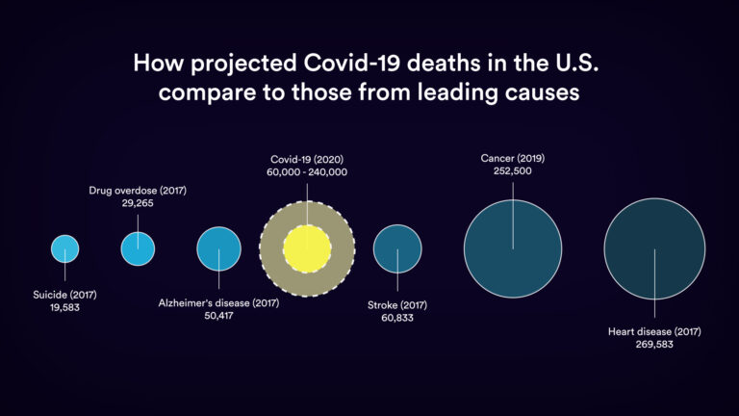
COVID-19 is now killing more Americans weekly than heart disease or cancer did on average per week in 2018.

