December 15, 2021

Patrick McNeill
2717 S. Arlington Rd.
Suite C
Akron, OH 44312

Re: 1002 Patriot Parkway, Reading, PA 19605

To whom it may concern:

As the duly appointed Zoning Officer for the Township of Muhlenberg, Berks County, Pennsylvania I am writing to provide the following information.

The above referenced property is located in the I-1 Limited Industrial District, Zoning District with no known Overlay Districts. The current “warehouse” use of the property is a permitted use. Please see the attached Zoning Hearing Board decision with respect to variances granted;
§ 355.115(B) – Off-Street Parking Areas and 355 Attachment 9 – Utility and Dimensional Requirements for the I-1 Zoning District. A copy of the Township Zoning Ordinance and Zoning Map can be found on our website at Muhlenbergtwp.com.

If you have any questions, please feel free to contact me at 610-929-4727 Ext #244

Sincerely,

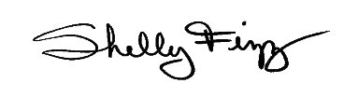
Shelly Fizz
Zoning and Codes Officer
Muhlenberg Township

