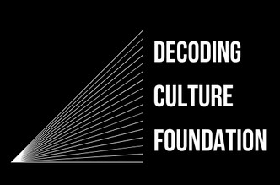

**TO: Whom It May Concern**

**DATE: 12/23/2023**

**Dear Sir or Madam,**

**I am a board member and Director of Research Operations of the Decoding Culture Foundation, a 501(c)(3) non-profit organization devoted to researching and studying the role of the entertainment industry in shaping culture. I request a waiver of all fees based on this status.**

Sincerely,

Brett Carollo

**Phone.**

719-207-0787

**Email.**

[brettcarollo@decoding-culture.com](mailto:brettcarollo@decoding-culture.com)

**Address.**

6557 Fieldmont Manor Drive Tobaccoville, NC 27050.

**Brett Carollo**

Director of Research Operations