**P O L I C E D E PAR T M E N T**

2018 ANNUAL REPORT

**BUREAU OF ADMINISTRATIVE SERVICES**

The calendar year of 2018 saw the eighth full calendar year in our new police station. The department again thanks the citizens of Watertown for this wonderful facility.

Our community room is the police department’s main training room and meeting room as it used almost daily. It also serves as our back-up emergency operation center & media press release area. It is popular for town meetings, Watertown community meetings, elections and related training activities. The community room was reserved in advance one hundred and eight-nine times over the year. The town generously funded new heavy duty/use and stackable tables for our community room. Our original tables could not handle the extensive use and fell into disrepair.

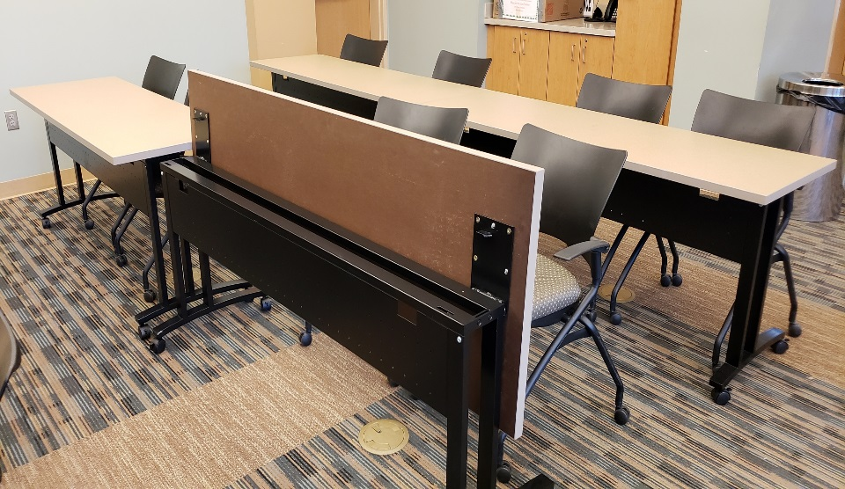

Police Department Community Room

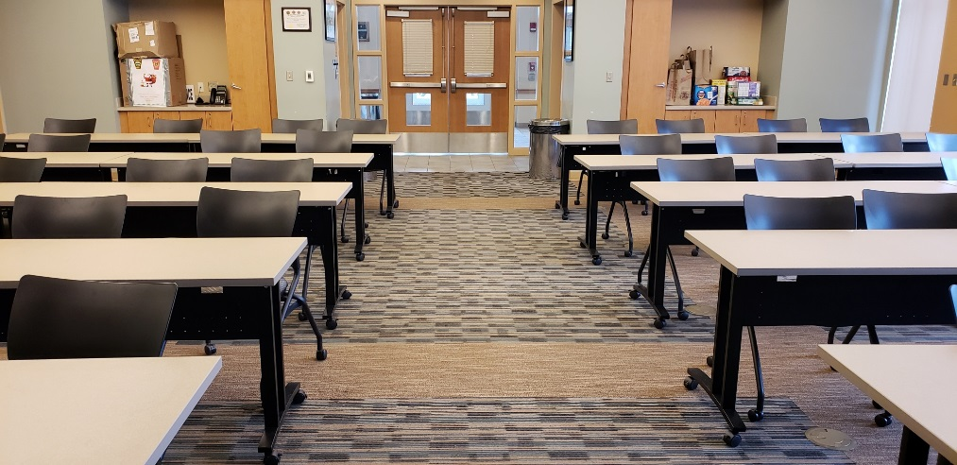

In 2018, The Governor’s Highway & Safety Bureau granted the Watertown Police Department a traffic enforcement grant to fund several mobilizations, such as: Winter Impaired Driving Focus,

Distracted Driving, Occupant Protection/Click It or Ticket, Summer Impaired Driving Focus

**CSD Updates Below (Blue new, red delete, track changes turned on)**

The department received a State 911 Department Training Grant. This grant allows the department to send our public safety dispatchers to mandatory and additional enhanced training. We also received a State 911 Incentive and Support grant. This grant is used to purchase dispatch support equipment or supplement personnel cost to improve and enhance our abilities to perform this service. This grant is enhanced because the department accepts 911 calls directly from cell phones. Currently, many police department’s 911 cell phone calls go to the state police first and then are re-directed to individual communities.

The police department continued its partnership with Advocates. (our state mandated health professional organization) The department has a multi-year Department of Mental Health grant to provide better services to our citizens who are experiencing a crisis due to mental health or substance abuse issues. The goal of this grant is to divert those persons experiencing a crisis from the criminal justice system and to treatment them with mental health/substance abuse professionals. This grant allows us to have a mental health professional work directly with our officers for 40 hours per week.

We have also partnered with Advocates to provide officers with Mental Health First Aid (MHFA) training in the hopes of training all officers over the next two years. This curriculum is designed to enhance the skill of officers in de-escalating tension-filled encounters with individuals suffering from mental health and substance use disorders. Since the beginning of the MHFA training program, we have trained 41 officers and are more than half way to our goal of 100% department trained.

End of Demos Edits – Continue to CSD sub header for more

The police department also continues to work very closely with Watertown’s Wayside Multi-Service Center in order to meet the needs of our juvenile citizens. The department has supported the Wayside Multi-Service Center in prevention, education efforts around substance use and making healthy decisions.

The department was officially awarded full re-accreditation in 2018 through the Massachusetts Police Accreditation Commission. To achieve this status the department had to meet three hundred and twenty-two carefully selected standards which address critical areas such as policy development, use of force, training requirements, emergency response planning, records & communications, property & evidence handling, vehicular pursuits, holding facilities and budgeting. Massachusetts is one of 25 states to offer an accreditation process for the police profession. The department is committed to maintaining this accreditation status and renewing its certification again in 2021. The department has been a fully accredited police department since 2015

The department has introduced Nuance Dragon Speaking Naturally Law Enforcement version software into our department. We plan on having our officers trained and able to narrate their police reports while out in their cruisers. This will promote a safer environment for the officer and a quicker response time to finish required written reports.

The department is continuing to use our Meggitt Training Systems virtual firearms training and judgement simulator for all our officers. Monies were gifted to the department to enable this purchase. This law enforcement virtual training simulation system effectively supports marksmanship, judgmental training needs and is designed to enhance the decision-making ability of all our officers. The single screen configuration includes the ability to conduct both marksmanship and video training modes to provide a multi-tiered training program. Marksmanship training ranges from basic to advanced. This type of judgmental training system enhances the understanding of shoot/don’t shoot situations as well as the officer’s corresponding use of force and type of force decision making process.

The system is capable of supporting training of multiple trainees simultaneously, using up to eight (8) system-controlled weapons, during judgmental video training, thus allowing them to engage in team training. During individual marksmanship training, the system emulates a range-type training environment where each trainee may shoot a different exercise, and in accordance with range safety/spacing guidelines, the system can support training of up to four (4) trainees simultaneously.

The Department is maintaining our prescription drug disposal box in the lobby of our station. This drop off box is available to our residents 24 hours a day, 365 days a year. In addition, the department also participated in the DEA’s 15th and 16th National Prescription Take-Back days in 2018. The department disposed of 300.5 pound of unwanted prescription drugs.

The department continued in its second full year as a member of the Critical Incident Stress Management Team. The CISM team serves as regional peer support officers to assist participating law enforcement agencies in responding to major critical events and those officers who have been affected by these incidents. Watertown Department CISM team members responded to sixteen callouts for services. Such services as; death of an officer, homicide, fatal accidents and grief debriefs.

The department again received generous monies from the Watertown Police Foundation to purchase an additional two traditional mountain bicycles for our patrol officers to use. These bicycles will be added to our two new electric assist bicycles purchase in 2017 with monies from the Watertown Police Foundation as well. This program has been well received by members of the community and participating officers

The department continues to participate in the Middlesex County Interagency Mutual Aid Agreement. This agreement allows the police officers of the communities who have signed the agreement to exercise police powers in any other community who is also part of this agreement, with some restrictions; mainly the police officer must be *on-duty* at the time. All violations of the law are covered under the agreement, including motor vehicle violations. Thus, a Watertown Police Officer can enforce the laws of the Commonwealth in any of the cities and towns within Middlesex County that sign this agreement.

The department continued its collaboration and partnership with the Organized Crime Drug Task Force (OCDETF - Federal) and Suburban Middlesex County Drug Task Force (Regional Municipal)

Maintaining these partnerships are ever more important as we battle the national opioid drug epidemic causing so much distress in our communities and families.

During 2018, the department continues to maintain emergency EPI-Pens for adults and juveniles. EPI-Pens are used for emergency medical reactions to allergic events. This equipment is carried in the patrol supervisor’s vehicle. All department patrol vehicles continue to carry Narcan for opioid overdoses.

The police facility had some repairs completed in 2018. A new front entrance walkway was completed, using pavers. The previous stamped concrete entrance way had heaved and cracked, causing a major tripping hazard. A new door way exit landing by our sally port and rear fenced driveway entrance was repaired as well.

In 2018, our Records Department answered 1,481 public records requests for various department records information. Such information as police incident, arrest, accident and statistical reports.

**SWORN PERSONNEL CHANGES - 2018**

**PROMOTIONS:**

Wayne C. Hoiseth – Lieutenant 2/26/18

Thomas C. Dicker – Sergeant 2/26/18

**APPOINTMENTS:**

Michael W. Dello Russo 03/02/18

Lauren A. Giordano 03/02/18

Don M. Pham 03/02/18

Kyle R. Rooney 03/02/18

Michael B. Stewart 03/02/18

Collin R. Geagan 03/30/18

Christopher M. Gaudet 10/26/18

**RETIREMENTS:**

Edward S. Kasabian 02/01/2018

Robert E. Knell 02/21/2018

David M. Gilchrist 07/31/2018

**RESIGNATIONS:**

Brandon M. O’Neill 06/07/2018

**DECEASED:** None

**CIVILIAN PERSONNEL CHANGES – 2018**

**PROMOTIONS:** None

**APPOINTMENTS:** None

**RETIREMENTS:** None

**RESIGNATIONS:** None

**DECEASED:** None

###### DETECTIVE DIVISION

The Detective Division is comprised of the Investigative Unit, Licensing Unit, Juvenile Unit, Domestic Violence Unit, Drug Unit, Fire/Arson Investigation Unit, and the Prosecutor’s Unit. Members of the division investigated numerous crimes, initiated investigations, and inspected licensed premises. Unit members were involved in programs for juveniles, the elderly, the business community and the public.

The Detective Division has continued to work closely with other area departments, including Federal agencies in the area of drugs, gaming, organized crime, sexual assault, financial crimes and firearms. Our detectives attend monthly detective meetings where they exchange information with area detectives. These meetings have provided us with valuable information on criminal activity in our area and have enabled us to establish relationships with detectives and agents from various departments. The NEMLEC task force detectives have set up an email system where information is shared on a daily basis. This tool has been exceptional in identifying suspects. The Watertown Police Department continues its association with COPLINK, an investigative tool, which gives us access from multiple data sources including identification of previously unknown relationships. This has become an invaluable resource for the Detective Division.

Throughout the year, there was a continued effort to scrutinize reported crimes. This strategy revealed that many crimes that were reported were unfounded or false and that many employees committed reported commercial larcenies.

In 2018, the Detective Division investigated/followed-up numerous cases, of these cases approximately 354 (+134) incidents were closed through criminal charges being sought (arrest, warrants, or summons), determining that the case was unfounded, closed after exhausting all possible leads or at the victim/involved persons request. Several crimes were solved and criminal charges sought, the following cases are a sample of significant crimes resulting in criminal prosecution:

* Mt. Auburn Hospital alerted both Watertown and Cambridge Police Departments that an unknown male later identified as a 24-year-old male resident of Watertown had been dropped off in their Emergency Room with multiple gunshot wounds. The victim was later transported to Beth Israel Hospital in Boston, surviving his injuries. In the days that followed, the Watertown Police Department Detective Division with the assistance of the Middlesex District Attorney’s Office conducted a thorough investigation that resulted in the arrest of a 19-year-old man from Hyde Park in Boston and a 21-year-old man from Randolph, MA. Both men have been indicted by a Grand Jury for multiple charges to include attempted murder. The matter is pending before the Middlesex Superior Court.

* Detectives investigated a stabbing that occurred subsequent to a fatal motor vehicle accident on Watertown St, where an adult male was stabbed approximately seven times. The victim survived his injuries, and criminal charges were sought on the adult suspect. Attempted murder charges are pending at Middlesex Superior Court.
* Detectives investigated an armed robbery, where suspects committed a violent armed robbery by means of a knife, overtook a store clerk, taking an undisclosed amount of U.S. currency. One suspect was identified and criminal charges are being sought.
* In conjunction with the Suburban Middlesex County Drug Task Force, Watertown Detectives conducted a narcotic/illegal firearms investigation. Search warrants were obtained and executed at a Riverside St. residence. This resulted in the arrest of four individuals and the seizure of two handguns, one shot gun, over two-hundred rounds of ammunition, and body armor. Criminal charges included, trafficking cocaine, trafficking methamphetamine, and trafficking MDMA.
* Several other crimes involving domestic violence and sex offenses were investigated; however, we are prohibited by law from releasing information pertaining to the cases.

The Detective Division also works closely with our outside partners in the social services field to aid and assist people we come in contact with or become aware of that may be in need. Helping people with addiction and/or other issues is a primary focus not only of the Detective Division but the department as a whole.

**PERSONNEL CHANGES**

* Officer Patricia Grady was transferred from the patrol division to the detective division (licensing & elder affairs).
* Officer Kevin McManus was transferred from the patrol division to the detective division (prosecutors’ unit)
* Detective Jennifer Connors was re-assigned from the licensing unit to the domestic violence/sex assault unit.
* Officer Lloyd Burke was assigned to the fire/arson investigation unit
* The division is still working understaffed as it is still down one position due to budget constraints.

**LICENSING UNIT**

In order to encourage cooperation between the Business owners of licensed establishments in the City and the Police Department, with the intent to detect possible violations of the laws and regulations governing licenses, members of this unit conducted inspections of various licensed establishments during both day and night time hours. Any irregularities observed during these inspections were investigated and appropriate action taken whenever deemed necessary.

In addition to their normal duties, the division also conducted alcohol-related sweeps aimed at curtailing teenage involvement in such activity. Package stores, clubs, and restaurants were monitored and youths questioned as to proper identification. The success of these operations is a result of the educational efforts of this division directed towards the liquor establishments and the strong enforcement action by the Watertown Licensing Board.

The following is a report from the Detective Licensing Division for the year of 2018 relative to license applications. These applications were submitted for investigation and report. The applications were generated by the Police Department as well as submitted by the Town Manager’s Office and the Watertown Licensing Board. (Note: the totals are an estimate and may or may not reflect the final total numbers.)

|  |  |  |  |  |  |  |  |
| --- | --- | --- | --- | --- | --- | --- | --- |
| **APPLICATIONS:** | ***Processed*** |  | ***Approved*** |  | ***Denied*** |  | ***Susp/Rev*** |
| **Firearm Applications** |  |  |  |  |  |  |  |
| License to Carry - CLA |  | 134 | 134 |  | 1 |  | 0 |
| FID CLC |  | 10 | 10 |  | 0 |  | 0 |
| FID CLD |  | 0 | 0 |  | 0 |  | 0 |
| ***TOTAL*** |  | ***144*** | ***144*** |  | ***1*** |  | ***0*** |
| **Alcohol Applications** |  |  |  |  |  |  |  |
| One Day Permits |  | 47 | 47 |  | 0 |  | 0 |
| Sunday Closings |  | 0 | 0 |  | 0 |  | 0 |
| Special Closing Hours |  | 2 | 2 |  | 0 |  | 0 |
| ***TOTAL*** |  | ***49*** | ***49*** |  | ***0*** |  | ***0*** |
| **Other Applications** |  |  |  |  |  |  |  |
| Auctioneers Special | 0 |  | 0 |  | 0 |  | 0 |
| Block Party | 21 |  | 21 |  | 0 |  | 0 |
| Constable | 1 |  | 1 |  | 0 |  | 0 |
| Entertainment | 18 |  | 18 |  | 0 |  | 0 |
| Fair/Carnival | 3 |  | 3 |  | 0 |  | 0 |
| Hackney Carriage | 14 |  | 14 |  | 0 |  | 0 |
| Hackney Driver | 62 |  | 54 |  | 8 |  | 0 |
| Ice Cream Drivers | 4 |  | 4 |  | 0 |  | 0 |
| Livery Drivers | 10 |  | 10 |  | 0 |  | 0 |
| Livery Vehicles | 18 |  | 18 |  | 0 |  | 0 |
| Motorcycle Ride | 1 |  | 1 |  | 0 |  | 0 |
| Outdoor Concert | 0 |  | 0 |  | 0 |  | 0 |
| Peddler | 8 |  | 8 |  | 0 |  | 0 |
| Raffle & Bazaar | 9 |  | 9 |  | 0 |  | 0 |
| Road Race/Walk-A-Thon | 10 |  | 10 |  | 0 |  | 0 |
| Solicitor | 46 |  | 44 |  | 2 |  | 0 |
| Tag Day | 1 |  | 1 |  | 0 |  | 0 |
| Texas Hold'em | 1 |  | 1 |  | 0 |  | 0 |
| ***TOTAL*** | ***227*** |  | ***217*** |  | ***10*** |  | ***0*** |
|  |  |  |  |  |  |  |  |

##### JUVENILE UNIT

During the year 2018, this department encountered youths for various incidents. There were 161 reports generated that involved juveniles with 4 (-12) being arrested and 15 (-6) juveniles summonsed to court.

Due to personnel cuts in the division, we currently do not have a detective solely assigned to juvenile issues.

### DOMESTIC VIOLENCE UNIT

The Domestic Violence Unit was established in 1992 and investigates over 200 cases a year.

The DV unit provides legal advice, support and assistance to other agencies and victims, with the emphasis being placed on the safety of the victim and prosecution of the abuser.

In 2018 the department investigated (292, -20) domestic related incidents, which resulted in the arrest /summons of (102, +20) individuals. This department also received and processed (111, -32) restraining orders during this year.

The DV Officer monitors all domestic related incidents and conducts follow-ups and contacts victims and defendants when necessary. The DV Officer also attends round-table discussions at on a monthly basis. These meetings are with representatives from the District Attorney’s Office, victim-witness advocates and domestic violence officers from surrounding cities and towns. The DV Officer also publishes a domestic “Hot Spots” list in the department’s weekly bulletin and through our e-mail system, which keeps officers updated with current domestic related issues within the Town.

TRAINING

Detectives attended numerous training courses throughout the year in specialized areas of law enforcement. Detectives also spoke to civic and public organizations on the topic of identity fraud, burglaries and crime prevention.

Detective Lieutenant James O’Connor graduated from the FBI National Academy, Class 271. The FBI National Academy is a professional course of study for U.S. and international law enforcement managers nominated by their agency heads because of demonstrated leadership qualities. The 10-week program—which provides coursework in intelligence theory, terrorism and terrorist mindsets, management science, law, behavioral science, law enforcement communication, and forensic science—serves to improve the administration of justice in police departments and agencies at home and abroad and to raise law enforcement standards, knowledge, and cooperation worldwide.

**PROSECUTORS UNIT**

The Prosecutor's Unit continues to work effectively with the Middlesex County District Attorney's Office.  The Prosecutor’s Unit was involved in handling over 736 cases in 2018.  The 736 cases are tracked from arraignment thru adjudication. Most cases are seen 4-5 times over the course of the year before adjudication.    This includes initial Arrests, Summonses and clerk magistrate hearings and all juvenile issues.   The Prosecutor’s office also handles scheduling officers for district court, superior court and juvenile court.   Prosecutor’s office also handles all evidence.  This includes identifying, storing, tracking and working with the MA State Police Lab for testing.  It is also responsible for the Town of Watertown Drug Take Back Program.

**COMMUNITY AND STAFF DEVELOPMENT DIVISION**

**DIVISION STAFFING**

In 2019, the Community and Staff Development Division consisted of one Lieutenant and one Sergeant overseeing four sworn officers, a civilian records clerk, one civilian contractor and volunteer civilian internship positions.

The School Resource Officer Unit consists of one officer at the High School and one officer at the Middle School.

The Crime Analysis Unit consists of one full time Crime Analysis & Data Integrity Officer.

The Information Technology Unit consists of one full time System Administrator position and one full time Technical Services Officer, which was unfilled during 2019. This position being vacant due to attrition in the department and is to be filled during 2020.

The Jail Diversion Program/Clinician is contracted to Advocates Inc. and staffed by a civilian clinician employed by Advocates through Department of Mental Health funding.

**SCHOOL RESOURCE OFFICERS AND COMMUNITY OUTREACH**

The School Resource Officers worked to build relationships with students, parents and school staff. These Officers contributed to a sense of security amongst the schools while providing guidance to students, parents and staff. They conducted sensitive investigations, they worked proactively to divert youths from the criminal justice system and they served as ombudsmen to needed services.

The School Resource Officers and Sergeant assigned to the Community and Staff Development Division regularly attended Community Based Justice meetings. This meeting is a collaborative between school personnel, public safety professionals, and social service providers to help identify at-risk youths and provide them with positive alternatives to steer them away from crime and violence, and work with the administration to assist in obtaining necessary services for students.

The School Resource Officers served as active members of the NEMLEC STARS (School Threat And Response System) team which serves school districts in over sixty communities. Officer Kerry Kelley continued as an Assistant Commander of this unit. The School Resource Officers developed and applied expertise in areas of addressing school threats and providing much needed services to students.

The Division uses surveys to measure citizen’s fear of crime and satisfaction with the Police Department. The survey also gives citizens an opportunity to make recommendations on how the Department can improve its quality of service. On a quarterly basis, 100 random surveys are mailed to citizens who have had law enforcement contact with the Department. The Department continues to receive a positive response to the survey.

The Division has continued oversight of the Jail Diversion Program and the Advocate’s clinician position. The purpose of the clinician is to allow the Department to provide better services to citizens who are experiencing a crisis due to mental health or substance use disorders. The program focuses on creating alternatives to arrest, or criminal charges for people whose criminal behavior is directly due to mental illness or substance use disorder. In recent years, a significant effort has been exerted to engage community members prior to a crisis stage.

The Watertown Police Department joined the Police Assisted Addiction Recovery Initiative. This organization provided the Department grant funding to support the Jail Diversion Clinician role. Subsequently overtime funds were made available for the Clinician to be conduct follow up work on opioid related cases.

Recognizing that Watertown, like most other communities in the Commonwealth experienced an increase in opioid overdoses in early 2015, the CSD Division played a significant role in establishing Watertown’s task force W.A.T.E.R.town (Watertown Access to Treatment Education and Resources). A collaborative effort with several municipal agencies, clergy, and service entities has been ongoing to enhance public awareness and prevent unnecessary suffering due to substance use disorder. Members of the Division, in conjunction with the task force work to coordinate regular community wide awareness meetings. Members of the Division have worked to update and maintain the task force social media presence via its web site: watertown-cares.com and a Facebook page: facebook/watertown.ma.cares.

The Division has continued its work as a member of the Metro West Collaborative. This organization is comprised of agencies from Waltham, Newton, Belmont, Weston, Lexington, Arlington and Watertown. The intent of the group is to share information amongst the police agencies and service providers to ensure residents of these communities struggling with an opioid addiction are receiving timely and effective support to recovery.

As part of the Department’s continued response to the impact of substance use disorder on our community, the CSD Division implemented a Nasal Narcan program. The department was able to maintain legal authorization from the Department of Public Health and its medical director to carry and dispense Narcan. The department has partnered with the Watertown Health Department to train all police officers in the proper administration of the drug. In 2018 Nasal Narcan was successfully used by the police department at the scene of 21 overdoses to save the life of individuals ranging from nineteen to fifty-seven years of age.

The Watertown Community Foundation issued the Department a $1500 grant to support the Free Community Narcan Program for the third consecutive year. This program has enabled the Watertown Police Department to put a life-saving drug in the homes of individuals and families in need, at no cost. In 2018 Narcan distributed through this program, was used on four occasions to save the life of opioid overdose victims.

Although a high number of opioid related overdoses continue to be reported to Watertown Public Safety, fatal overdoses dropped from a high of ten in 2017 to two in 2018, largely due to the expedient use of Narcan.





Officers from the Community and Staff Development Division continue to assist the Watertown Public School System with their crisis management protocols. Officers attend regular meetings with School personnel to discuss procedures to prevent and mitigate emergency situations which could occur on school property. The goal of this crisis management team is to provide a safe environment for students and to adequately prepare for a variety of potential emergencies that could affect school personnel or property.

As a result of these meetings, the Watertown Public Schools have continued with the ALICE (Alert-Lockdown-Inform-Counter-Evacuate) approach to active shooter threats. This program empowers teachers and students with more options in response to an armed intruder with an emphasis placed on evacuations rather than solely locking down and attempting to hide. ALICE Drills have been completed in all public schools with staff and students and will continue on a routine schedule.

Outreach and training in the A.L.I.C.E. program have been expanded to include several private schools and businesses in Watertown to include the Atrium School, the Jewish Community Day School, the Beacon School, St James School, Perkins School for the Blind, EFGB (French School of Greater Boston), Boys & Girls Club, Watertown Town Hall personnel, Advocates Inc., United Electric, the Arsenal Mall, Tufts Health, Care Group Parmenter and Athena Health.

**OTHER COMMUNITY POLICING PROGRAMS**

During the Summer of 2019, the CSD Division collaborated with the Recreation Department to coordinate street hockey and basketball athletic leagues. The “Cops & Rec” basketball and street hockey games were held on Tuesday and Wednesday evenings through the summer months. Watertown children ages eight through thirteen participated.

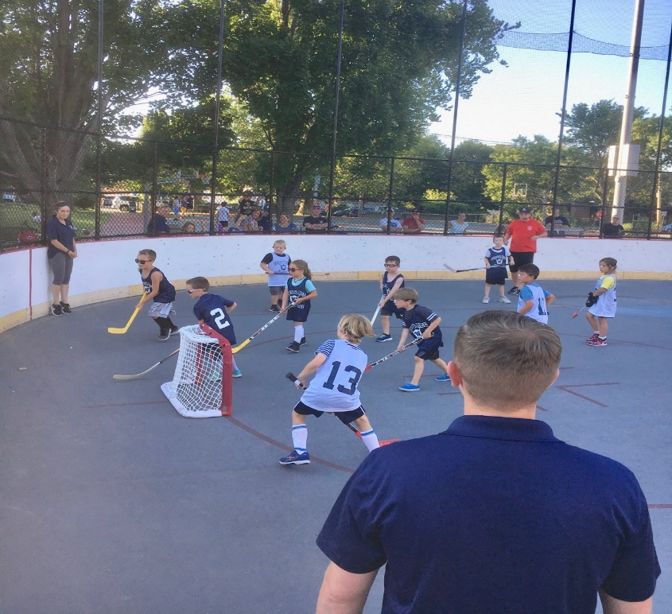

Cops and Rec Athletics summer 2018

The Division continued its collaboration with the Recreation Department to hold two “Family Movie Night” events at the park to the rear of the Watertown Police Department. The events were held in July and August. A Disney movie was played at each event. With funding from the Watertown Recreation Department and the Watertown Police Department; pizza, snow cones, popcorn and refreshments were made available. Preceding each movie, face painting, games and other activities were organized for attendees. Each event drew approximately 300 people.

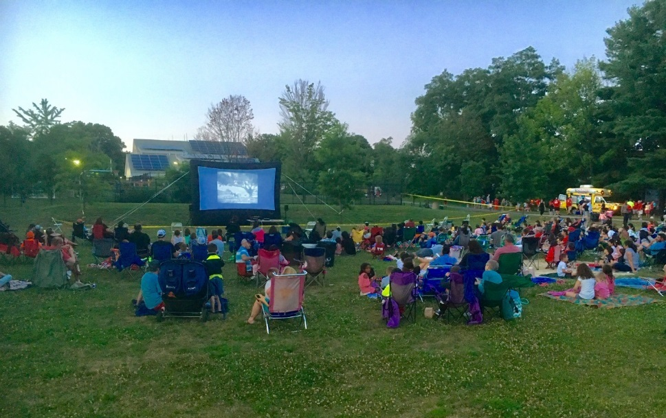

Cops and Rec Family Movie Nights in July and August 2018

The CSD Division continued its outreach at the annual Fair on the Square. Residents were provided with information regarding opiate assistance, our outreach activities and immigration information. We also conducted a free bike raffle for Watertown youths.

The CSD Division and the Recreation Department continued the Cops & Rec afterschool program at the Watertown Middle School. This program gave police officers an opportunity to interact with students while playing dodgeball, basketball, floor hockey and flag tag football after school on Wednesdays and Fridays throughout the school year.

The Division has continued its efforts in support of the Kingian Nonviolence community training. Officers provide instruction at two-day Kingian Nonviolence courses. Principles from the Kingian Nonviolence curriculum have also been shared with all members of the Watertown Police Department through annual training on the prevention of biased policing.

**ACCREDITATION**

As planned, the department underwent a successful re-accreditation assessment in June of 2018 and renewed our accredited status. The department has continued its review of the department’s policies and procedures. Hundreds of pages of written policy have been carefully combed through to ensure that they are up-to-date and consistent with the department’s facility and standards. This process shall continue to ensure that the policies remain updated and consistent with accreditation standards. A continual effort will be required in order for the department to maintain compliance with all three hundred and twenty-two standards and be re-accredited in 2021.

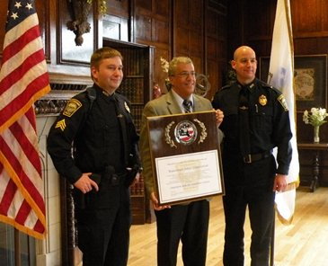

Successful re-accreditation assessment June 2018

**DEPARTMENT TRAINING**

The department ensured that its officers attained the legislative 40-hour minimum mandatory annual training requirement by contracting with the Lowell Police In-Service academy to provide in-service training to all Watertown Officers. In accordance with accreditation standards, the department ensures all members are further prepared for their roles by coordinating training on eighteen additional topics. The department continued its production of internal trainings which were incorporated into the department’s various software technology mediums (i.e. PMAM Training and Digital Headquarters information share program) to enhance and go beyond state mandated training.

The department also modified its firearm training regimen. By breaking the typical 8-hour training session into smaller two-hour blocks the department was able to qualify its officers in the various firearms (i.e. Glock 40 pistols, AR15 rifles and less-lethal shotguns) while minimizing overtime expenditures.

Effective July 1st, 2012, state regulations require that all 911 answering points begin following Emergency Medical Dispatch (EMD) procedures. EMD allows the 911 call-taker to provide life-saving instructions to the caller over the telephone increasing the chance of survival and reducing the severity of injuries while the patient waits for emergency personnel to arrive on scene. The department has contracted with Armstrong Ambulance Service to provide EMD support for medical 911 calls. Under this contract Armstrong handles the medical call while WPD civilian dispatchers deploy police and fire assets to the scene of the emergency.

Also, effective July 1st, 2012 all 911 call-takers must receive 16 hours of State 911 approved training per year. The department’s Training Division has been working tirelessly to ensure that all of these new requirements are met.

The Division also continued training with the Meggitt L7 Firearms Training Simulator. The FATS machine is a firearms virtual training simulator that emulates the workings of an actual firearm without the cost of ammunition. The machine is able to render real world judgment scenarios with variable outcomes to help train officers in use of force encounters and how to appropriately make those judgment calls. All members of the department have experienced training on the FATS machine. The training is designed to re-enforce knowledge of the department’s policy on Use of Force and Response to Mental Health Calls. The training also emphasized the use of de-escalation techniques.

All members of the department underwent training to reinforce understanding of the “Response to Active Threats” policy. This training was coordinated by the CSD Division and two members of the department who have served with the NEMLEC SWAT team for over ten years. The curriculum included reinforcement of de-escalation tactics, reinforcement of the key components of the Incident Command System, a review of the evolution on response to “active shooter” scenarios, tactics to help enhance officer’s safety and instruction on the ALICE program to dovetail with the training received by the schools and businesses in Watertown.

In addition to the aforementioned training, various officers have also attended training sessions in the following areas: street drugs, drug interdiction vehicle stops, evidence collection and preservation, community policing, ALICE/school safety, active shooter response, legal updates, anti-bias, sexual harassment and many other type trainings.

**INTERNSHIP PROGRAM**

The college internship program continued successfully in 2019 with a total of 3 interns going through the program by the end of the year. The Department has partnered with Northeastern University, UMass Boston, Westfield State University and other area colleges to greatly expand its internship program. College students interested in a law enforcement career are carefully selected to work with the department, under the guidance of the Community & Staff Development Division. These interns are unpaid and help augment many of the department’s endeavors while gaining important knowledge and insight into the law enforcement profession.

**INFORMATION TECHNOLOGY UNIT**

In September of 2017, the department successfully completed its transition to the new 911 system managed by General Dynamics. As a result of this transition all 911 trained staff required to undergo recertification training ahead of deployment. The training was completed successfully and was funded through the State 911 Department.

As part of the 911 upgrade process, the department expanded its E911 service to Watertown by accepting 911 cellular calls. Previously, 911 cell calls would be received by Massachusetts State Police and then routed to dispatch. This switchover will improve response time to emergency events. In addition, in December of 2018 we began our 911 enhancements to accept text-to-911 features.

The department went live with its new website design in December of 2017 and continues to train personnel in it use and roll out content changes. However, in 2019, due to a lack of IT personnel several projects for the website are not being worked on.

In February of 2019 the IT Unit replaced the department’s aging Wi-Fi system to accommodate additional users from the events that occur in the Community Room. The new Wi-Fi system replaced the gaining Wi-Fi access points with next generation equipment with extended range and improved speed. The Wi-Fi firewall was also replaced with new equipment to improve overall security of the Wi-Fi network. In addition, the new Wi-Fi system is now managed entirely by WPD IT staff and we no longer require contract with a private tech company for maintenance, thereby saving money.

In June of 2019, the IT Unit replaced the department’s off site emergency backup equipment with new higher capacity network attached storage so that critical data can remain protected in the event of catastrophic physical system failure or Cyber-attacks on PD infrastructure.

In the Summer of 2019, the IT Unit migrated the department over to the new mobile data system. The Windows 10 machines were deployed in all marked department vehicles. The new units are faster than the previous generation and are now on the newest operating system to be in compliance with CJIS/FBI rules. The new terminals also allow for the integration of new voice recognition technology that was not possible with the older units.

Also, in the Summer of 2019, WPD IT assisted with the setup and deployment of the Taser 7 units. This required the installation of charging stations and unit programming. The CSD Division as a whole took on the deployment angle from policy development, IT and training.

In September of 2019, the IT Unit worked with AdTech to upgrade the AV systems of the dispatch center using State 911 grant for equipment. The upgrade allowed for the inclusion of improved connections to the main dispatch screen since newer computers no longer support the older connections that have been present since the station was constructed. Plans are in progress for repeating the upgrade in the other meeting rooms to improve compatibility for public events and department trainings if funding allows.

On September 16th, 2019 CJIS conducted an on-site Audit of the Watertown Police Department. This audit investigated the department’s compliance with CJIS/FBI rules & regulations regarding protected CORI records. The audit covers handling of criminal record information, secure storage of data, protection of our IT environment, record accuracy, record completeness, record validations and department training. As a result of the audit we were found to be in compliance.

In late 2019, the WPD IT Unit began updating department computers to Windows 10 and replacing their hard drives. This will improve the life span of our current machines with little expense to the town and allow for the machines to maintain secure operations until the devices reach hardware end of life. This process was delayed as WPD IT is dependent on a town owned domain controller which requires replacement in order to be compatible with Windows 10. Users not effected by the compatibility issue had their PC upgraded to Windows 10, while the remaining machine will be upgraded in February 2020 when the new Domain Controller is installed by Town IT.

At the end of 2019, the IT Unit worked with a private contractor to begin updating the department’s intranet server used for internal information sharing. By updating the server’s operating system and hard drives, we will be able to extend the operational life of the server and gain further functionality from the SharePoint system.

Also, at the end of 2019, WPD IT in coordination with the Traffic Division, began researching E-Citations. This would augment, rather than replace, the hand written Civil Motor Vehicle citation books currently in place. The current plan is to have two demonstration units installed in the traffic cars and if the program meets the approval of Traffic and IT staff, then the equipment will be installed in the remaining marked patrol units. E-Citations would provide an officer safety and efficiency benefit to the agency. With less writing at the scene, officers can pay more attention to the motorist as most of the data is prefilled by the computer. Citation entry in our internal records system will also be simplified as computer records are easier to read.

Throughout 2019, the WPD IT unit along with the Fire Department and DPW, continued long term planning of the town’s first responder radio network. Much of our efforts faced uncertainty due to the effects of FirstNet and the process faced delays.

The First Responder Network Authority (FirstNet) of the United States was created under the Middle Class Tax Relief and Job Creation Act of 2012 (MCTRJCA) as an independent authority within the National Telecommunications and Information Administration (NTIA). To create FirstNet, the T-Band radio frequency range will be auctioned off, which is the radio frequency group of Watertown and many other major cities/towns across the country, including Boston PD and Boston Area Police Emergency Radio Network (BAPERN). FirstNet was created as a result of the 9/11 Commission findings to improve Public Safety interoperability. However, the Boston area already has an excellent interoperability plan in place through BAPERN, which will effectively be destroyed if the frequency range is sold.

Based on pushback from major metro police/fire agencies across the country, the sale of the T-Band is expected to fail. With that in mind, Police/Fire/DPW have come together to plan the future radio infrastructure of the three critical departments based off our current T-Band frequencies. This has resulted in hiring a consultant to help us identify radio needs, plan our network design and help oversee the eventual construction.

###### BUREAU OF FIELD OPERATIONS

### PATROL DIVISION

The primary mission of the Patrol Division is to serve Watertown’s citizens through a cooperative effort and to protect their property through enforcement of laws and highly visible deterrent activities. The officers of the Patrol Division represent the department’s first response to all emergencies and most calls for service. In 2018 the department was able to fill six existing opening by hiring Michael Stewart, Kyle Rooney, Don Pham, Lauren Giordano, Michael Dello Russo and Collin Geagan. Ms. Giordano will be the twelfth female officer on the department.

During 2018, the Patrol Division responded to 26,096 calls for service and or motor vehicle stops. These calls-initiated investigations and events that resulted in 306 arrests, 79 persons being placed in Protective Custody and 373 summonses being issued. These numbers do not reflect all of the officer-initiated contacts made by patrol officers during the course of routine patrol. Officers also responded to 197 calls involving mental health issues. Officers also responded to 50 opioid related over doses. This does not take into account over doses by other drugs.

Heavy emphasis by the Patrol Division was also placed in the enforcement of traffic regulations in keeping with the goal of moving traffic safely and efficiently on the streets of Watertown. Officers and equipment were assigned to monitor and enforce traffic rules and orders when necessary in keeping with this goal.

Officers were also assigned to “hot spots” for enforcement. These locations are where a large number of accidents or violations occur, or where there are numerous complaints by citizens.

Patrols were adjusted during the course of the year to address increased activity due to crime trends, holidays, special events, and recreational events at parks and playgrounds. Patrols were increased during peak shopping periods in the business districts of Watertown. This was accomplished by using motor patrol, foot patrol, and the use of motorcycles and bicycles. The Patrol Division works in concert with other divisions in the Police Department and outside public and private agencies within the area to accomplish the objective of providing the most effective deployment of personnel possible. Computer data is analyzed to assist in the deployment of police officers to areas in need of police attention.

The Patrol Division, as well as the entire Police Department, is committed to Community Policing. One of the goals of Community Policing is to build a partnership between the police and the community, encouraging interaction between the two so that we can solve community problems together. This partnership also allows the community to let the police know what concerns they have and which issues they feel are important and would like addressed. Officers receive training in Community Policing and are encouraged to increase their interaction with the citizens on their respective patrol routes. Officers are also relieved of their assignment for a portion of their shift to work with the community on various issues and problems.

When Chief Lawn was appointed Chief of Police, one of his first priorities and changes he made was bringing back community policing programs. Chief Lawn is committed to these programs and improving upon the close relationship the department has built with the community.

In 2018, the department once again offered a Citizen’s Police Academy to its residents. This eight-week program “Understanding through Education” is designed to educate residents about what their police do and why they do it. Residents also get to meet many officers during the class and both get to know each other. The department and its officers also get to learn what issues the residents see as important. This is all intended to bring about a closer working relationship.

The department also brought back mountain bikes for officers to use. This allows officers the ability to access locations a police vehicle cannot navigate and makes officers more approachable by its residents, rather than being in a car where residents may be reluctant to approach and interact with officers.

Off. David Cobe with an electric police mountain bike.

# Bike 1 Image 2017

# **NORTH EASTERN MASSACHUSETTS LAW ENFORCEMENT COUNCIL (N.E.M.L.E.C.)**

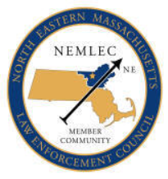

The Watertown Police Department continues its membership and commitment with the North Eastern Massachusetts Law Enforcement Council (NEMLEC). NEMLEC is a group of **61** cities and towns that share resources. These NEMLEC cities and towns have a combined SWAT Team (Special Weapons and Tactics), RRT Team (Regional Response Team), a School Threat Assessment Response team (STARS) and a motorcycle unit that will respond to any member community on a moment’s notice. NEMLEC Motor Cycle Unit, RRT & SWAT teams train monthly and are on call to NEMLEC communities to assist with emergency situations. In the past, Watertown Police Officers assigned to these units, assisted the Boston Police Department with security for the Democratic National Convention, Boston Red Sox World Series games and parades. They also assisted Boston Police with Patriots Super Bowl Parades. The RRT officers have also participated in two Presidential Inauguration security details in Washington D.C.

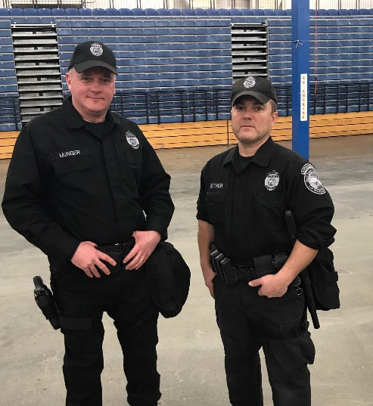

NEMLEC RRT Unit Off. Rick Munger and Off. Mark Leitner.

In 2018 the following NEMLEC units were called upon the number of times listed below;

SWAT 4 Call Outs

RRT 4 Call Outs

Motorcycle 4 Call Outs

STARS 3 Call Outs

# **PUBLIC SAFETY DISPATCHERS**

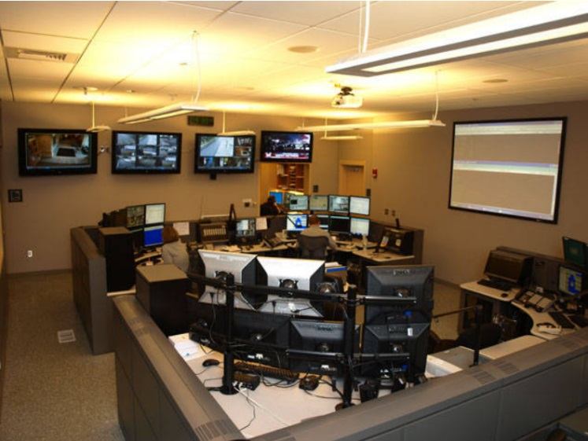

There are nine Public Safety Dispatchers that answered over 26,096 calls on 2018. The dispatchers answer all calls for assistance for both the Watertown Fire Department and Police Department. The dispatchers come under the Patrol Division of the Police Department. They are the first point of contact for all citizens requesting assistance or directions from either department. The dispatchers answer all E-911 calls, which totaled 7,417 calls in 2018 and are responsible for dispatching all fire apparatus and ambulances when required. They also dispatch all police cars to service and emergency calls. These dispatchers are also required to make contact with the Registry of Motor Vehicles to obtain and check license and registration status vehicle information and confirm warrants on wanted individuals.

Of the E911 calls received by Watertown dispatches, 7,417 were answered. There were 313 “abandoned” meaning the caller hung up prior to the call being answered. Of the E911 calls 7 were text to 911,

# **TRAFFIC DIVISION**

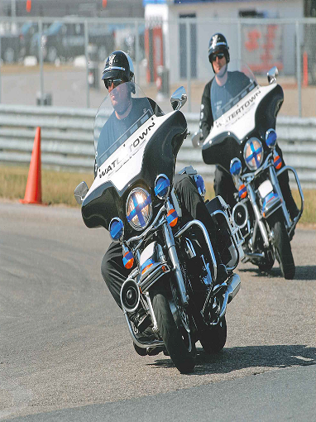

**Motorcycle officers Off. Charles Samios and Off. Rod Mendez at NEMLEC Unit training.**

In 2018 the Watertown Police Department Traffic Division conducted traffic enforcement activities throughout the Town at a reduced capacity of two patrolman positions due to budget cuts.

The Traffic Division has two patrol cars and four Harley Davidson motorcycles assigned to it. Officers operating these motorcycles attended either forty hours of instruction at the Boston Police Motorcycle Training Academy, the M.B.T.A. Motorcycle Training Academy or an eighty-hour course sponsored by the Northeast Massachusetts Law Enforcement Council (NEMLEC).

The Traffic Division has a Commercial Vehicle Enforcement Unit. This unit increases the safety of the motoring public and contributes to maintaining the integrity of the town roadways by inspecting commercial vehicles and their drivers for safety, equipment, and weight compliance. This unit consists of one officer who is trained and certified by the U.S. Department of Transportation (D.O.T.) as a federal motor carrier inspector. This officer is also trained and certified by the U.S. Department of Transportation to conduct inspections of commercial vehicles carrying Hazardous Materials.

The Traffic Division is responsible for the Detail Office. The Detail Office consists of one officer who is responsible for scheduling details and overtimes, billing companies and collecting money owed. This Officer also covers routes during personnel shortages, conducts community policing activities and is available to respond to emergency situations as needed.

The Traffic Division supervises one full-time and one part-time civilian parking enforcement officers. These civilian positions allow police officers to dedicate their time to other police duties.

Between January and December 2018, the Traffic Division conducted surveys, studied speed and traffic flows, and conducted investigations for the Watertown Traffic Commission. This information was used by the Traffic Commission in their determination for the addition, replacement, or deletion of traffic signs, rules and regulations.

The Traffic Division has three portable RADAR speed display signs. These signs are portable speed feedback units that display the target vehicle speed on a 3’ x 3’ display window. In addition to speed measurement, these trailers also measure traffic volume. The reports generated by these radar units are used to aid the Traffic Commission in their efforts as well as to determine the level of traffic compliance in particular areas. The speed signs have been effective tools in reducing vehicle speeds in problem areas. The Traffic Division also uses a portable electronic variable message sign to display important traffic and safety information to motorists.

The Traffic Division also supervises twenty-one full time and three alternate school crossing guards. These supervisors are responsible for traffic control and the safe passage of schoolchildren and families in and around the public schools.

In 2018, The Traffic Division received $12,000 in Grants from the Executive Office of Public Safety and The Governor’s Highway Safety Bureau to conduct one “Click it or Ticket” mobilization that allowed the department to conduct high visibility enforcement in an effort to increase seat belt usage. The Department also participated in two “Drive Sober or Get Pulled Over” mobilizations to target and reduce drunk driving and one ‘Distracted Driver’ mobilization focused on people texting while driving.

In the Year 208, the department issued the following motor vehicle citations:

**TRAFFIC**

23,989 Parking citations

6,618 Total moving citations

**2018 Data**

**6,618 Citations**

111 Arrests

230 Criminal Complaints

1979 Civil Fines

4297 Warnings

51 OUI:

* 34 OUI Liquor
* 12 OUI Liquor 2nd Offense
* 4 OUI Liquor 3rd Offense
* 1 OUI Liquor 4th Offense

88 Suspended/Revoked Licenses

103 Operating W/O License

**384 Major Accidents and 588 Minor Accidents**

**Major Accident Include:**

* 244 MV in transport
* 4 Collision with another movable object
* 64 Collision with Parked Vehicle
* 5 Collision with Curb
* 6 Collision with Tree
* 9 Collison with Utility Pole
* 9 Collision with pole or support
* 1 Collision with median barrier
* 1 Collision with Ditch
* *18 Collision with Pedestrian
* 10 Collision with unknown/fixed object
* 7 Collision with Bicyclist
* 3 Other Non-Collision
* 2 Other

***\*One fatal pedestrian accident***