P O L I C E D E PAR T M E N T

2021 ANNUAL REPORT

## BUREAU OF ADMINISTRATIVE SERVICES

The calendar year of 2021 saw the eleventh full calendar year in our new police station. The department again thanks the citizens of Watertown for this wonderful facility.

Our community room is the police department’s main training room and meeting room as it used almost daily. It also serves as our back-up emergency operation center & media press release area. It is popular for town meetings, Watertown community meetings, elections and related training activities. In 2021, the COVID-19 pandemic & subsequent variants limited the use of the community room. The police department had to restrict access to the public to ensure police personnel did not get sick due to COVID-19. The community room was used several times as a city public site for vaccinations in early 2021. Despite the pandemic the community room was reserved eighty-four times over the year.

Police Department Community Room

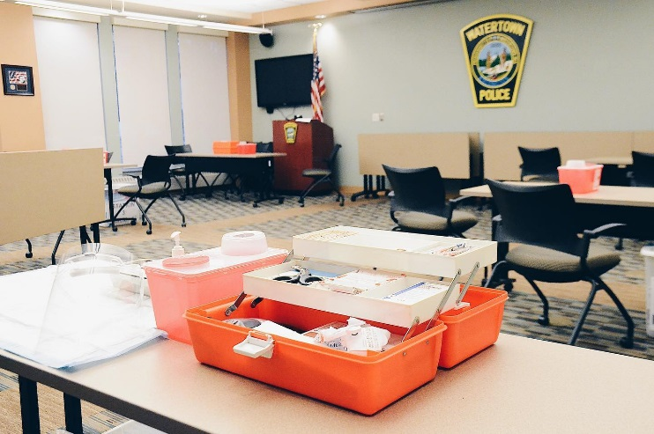

In 2021, it was the department’s second year live with the ability to receive emergency communication through a text message. The department received thirteen 911 text messages. Text to 911 allows those in need of emergency services to use their cellular device to contact 911 when they are unable to place a voice call.  To contact emergency services by text message, simply enter 911 in the “To” field of your mobile device and then type your message into the message field. It is the same process that is used for sending a regular text message from your mobile device. It is important to make every effort to begin the text message indicating the town you are in and provide the best location information that you can.

It is important to note that the 911 call center may not always have your exact location when they receive your text. For this reason, when sending a Text to 911 it is important to make every effort to begin the text message indicating the town you are in and provide the best location information that you can.

The State 911 Department encourages citizens to Text to 911 only when a voice call is not possible.

**Remember: “Call if you can, text if you can’t.”**

The Governor’s Highway & Safety Bureau granted the Watertown Police Department a traffic enforcement grant to fund several mobilizations, which were: Winter Impaired Driving/ Drive Sober or Get Pulled Over, Spring Speed Enforcement, Distracted Driving, Occupant Protection/Click It or Ticket, Summer Speed & Summer Impaired Driving. The department was also able to purchase two solar powered pole mounted speed signs, which can also display messages.

The department received a State 911 Department Training Grant. This grant allows the department to send our public safety dispatchers to mandatory and additional enhanced training. We also received a State 911 Incentive and Support grant. This grant is used to purchase dispatch support equipment or supplement personnel cost to improve and enhance our abilities to perform this service. As an example, the department received funding to update all our dispatch/security computers and monitors located within our dispatch area.

The police department continued our funding of an expanded partnership with Advocates. (our state mandated health professional organization) The Town funded a second full-time Jail Diversion clinician. Along with this second full-time clinician the department has a multi-year Department of Mental Health grant. The goal of having these clinicians is to provide better services to our citizens who are experiencing a crisis due to mental health or substance abuse issues. As well as, to divert those persons experiencing a crisis from the criminal justice system and to treatment with mental health/substance abuse professionals. They are now both working closely with our officers.

We have also partnered with Advocates to also provide officers with Mental Health First Aid (MHFA) training in the hopes of training all officers over the next two years. This curriculum is designed to enhance the skill of officers in de-escalating tension-filled encounters with individuals suffering from mental health and substance use disorders. Since the beginning of the MHFA training program, we continue to train our officers and are two-thirds to our goal of 100% department trained.

The police department also continues to work very closely with Watertown’s Wayside Multi-Service Center in order to meet the needs of our juvenile citizens. The department has supported the Wayside Multi-Service Center in prevention, education efforts around substance use and making healthy decisions.

Despite the pandemic, the department sought and was officially awarded full re-accreditation in 2021 through the Massachusetts Police Accreditation Commission. To achieve this status the department met three hundred and thirty-two carefully selected standards which address critical areas such as policy development, use of force, training requirements, emergency response planning, records & communications, property & evidence handling, vehicular pursuits, holding facilities and budgeting. Massachusetts is one of 25 states to offer an accreditation process for the police profession. The department has been a fully accredited police department since 2015

As de-escalation training is of the utmost importance, the department is continuing to use our Meggitt Training Systems virtual firearms training and judgement simulator for all our officers. Monies were gifted to the department to enable this purchase. This law enforcement virtual training simulation system effectively supports marksmanship, judgmental training needs and is designed to enhance the decision-making ability of all our officers. The single screen configuration includes the ability to conduct both marksmanship and video training modes to provide a multi-tiered training program. Marksmanship training ranges from basic to advanced. This type of judgmental training system enhances the understanding of shoot/don’t shoot situations and the corresponding use of force decision making process.

The system can support training of multiple trainees simultaneously, using up to eight (8) system-controlled weapons, during judgmental video training, thus allowing them to engage in team training.

In 2021 the department enabled limited access to our prescription drug disposal box in the lobby of our station. Along with the prescription drug box, the department participated in two DEA’s National Prescription Take-Back days in 2021. The department disposed of 269.5 pounds of unwanted prescription drugs.

The department continued in its fifth full year as a member of the Critical Incident Stress Management Team. The CISM team serves as regional peer support officers to assist participating law enforcement agencies in responding to major critical events and those officers who have been affected by these incidents. Watertown Police Department’s CISM team members responded to fourteen (14) callouts for services. Such services as; death of an officer, homicide, fatal accidents and grief debriefs.

The department continues to participate in the Middlesex County Interagency Mutual Aid Agreement. This agreement allows the police officers of the communities who have signed the agreement to exercise police powers in any other community who is also part of this agreement, with some restrictions; mainly the police officer must be *on-duty* at the time. All violations of the law are covered under the agreement, including motor vehicle violations. Thus, a Watertown Police Officer can enforce the laws of the Commonwealth in any of the cities and towns within Middlesex County that sign this agreement.

The department continued its collaboration and partnership with the Organized Crime Drug Task Force (OCDETF - Federal) and Suburban Middlesex County Drug Task Force. (Regional Municipal) Maintaining these partnerships are ever more important as we battle the national opioid drug epidemic causing so much distress in our communities and families.

During 2021, the department continues to maintain emergency EPI-Pens for adults and juveniles. EPI-Pens are used for emergency reactions to allergic events. This equipment is carried in the patrol supervisor’s vehicle. All department patrol vehicles continue to carry Narcan for opioid overdoses.

Utilizing our FY 21 911 Support & Incentive grant in the spring of 2021 we completed our install of an AtmosAir bi-polar ionization unit to the entire building’s HVAC air filtration system. This ionization system proactively emits bi-polar ions that attack and neutralizes coronavirus as well as other particles in a continuous process.

After an exhaustive public safety radio infrastructure & needs study, conducted in 2019 through 2020, the city approved two bond fundings (FY21 & FY22) totaling $4,147,000. Major deficiencies this study identified included: serious radio coverage issues, aging & failing radio equipment 17-21 years of age, unsupported and outdated Verizon copper telephone lines, lack of redundancy and interoperability within town departments and the possible loss of our frequencies due to a since repealed federal law.

Since this approval, we have begun upgrading and establishing our new radio transmit and receive sites, purchasing equipment, and resources for the new system. These upgrades will provide complete public safety coverage, redundancy in our system, as well as extra frequencies for police and fire, upgrades to the DPW radio system and an interoperability frequency for city-wide use. We believe we should be operational by November/December 2022

In 2021 the city granted funding for the exterior painting of the police building. Being in our eleventh year and wanting to preserve and protect our community’s investment, during the fall a complete painting of the building exterior took place as well as repairs to trim and gutters. We additionally placed gutter guards on all our gutters to keep them clear and prevent water damage to the building.

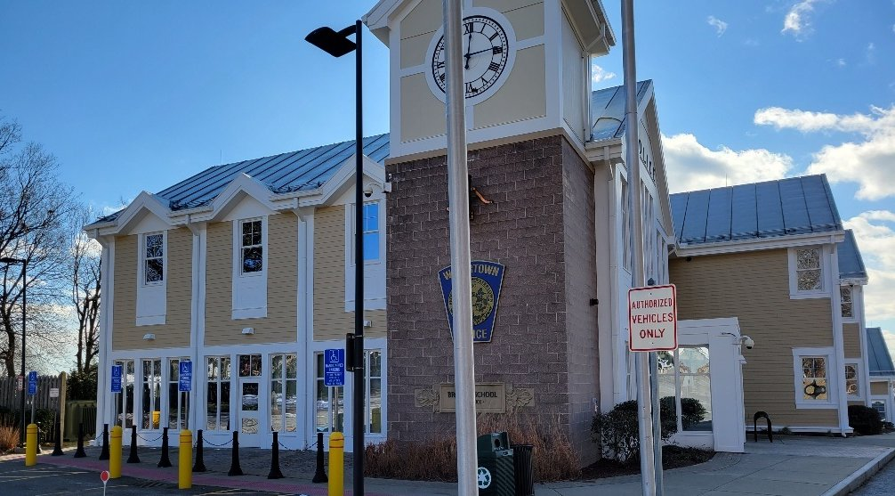

The department in 2020 purchased a new Kawasaki Mule Pro-FXT All-Terrain Vehicle. This vehicle can patrol on all our walking and bicycle paths. It’s an important critical incident vehicle as it can transport supplies and manpower. This year we had funding to have a shed built to garage our new vehicle as well as surplus found bicycles.

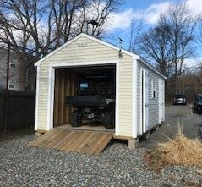

In 2021, our Records Department answered 1,397 public records requests for various department records information. Such information as police incident, arrest, accident and statistical reports.

**SWORN PERSONNEL - 2021**

**PROMOTIONS:**

Thomas F. Grady (to Lieutenant) 5/21/2021

Eric Garabedian (to Sergeant) 5/21/2021

Jean S. Sarkissian (to Sergeant) 6/01/2021

**APPOINTMENTS:**

**RETIREMENTS:**

Christopher M. Munger 4/29/2021  
Jeffrey J. Pugliese 5/31/2021

**RESIGNATIONS:**

Lauren A. Giordano 8/06/2021

**DECEASED:** None

**CIVILIAN PERSONNEL – 2021**

**REINSTATEMENS:**

Judith F. Patenaude 2/24/2021

**APPOINTMENTS:**

Jane C. Grzelcyk 1/18/2021

Devon F. Shatkin 7/19/2021

Dina C. Costanzo 10/12/2021

**RETIREMENTS:**

David M. Sheehan 7/07/2021

**RESIGNATIONS:**

Judith F. Patenaude 1/29/2021

Michael C. Sunde 9/09/2021

**DECEASED:** None

**DETECTIVE DIVISION**

**COMMUNITY AND STAFF DEVELOPMENT DIVISION**

**DIVISION STAFFING**

In 2021, the Community and Staff Development Division consisted of one Lieutenant and one Sergeant overseeing four sworn officers, a civilian records clerk, two civilian contractors. The volunteer civilian internship program was suspended due to COVID-19 and will resume in 2022.

The School Resource Officer Unit consists of one officer at the High School and one officer at the Middle School. In September of 2020 Officer Michael Stewart was assigned as the new School Resource Officer at the Middle School. Officer Stewart underwent significant training with members of the school faculty, with the National Association of School Resource Officers prior to taking on this new role. Officer Kerry Kelley has served as the School Resource Officer at the Watertown High School for eleven years

The Crime Analysis Unit consists of one full time Crime Analysis & Data Integrity Officer. Officer Michael Comick is responsible for the review, quality control and analysis of police reports generated by officers that respond to approximately 25,000 calls for service annually. This role assists the department to better observe trends and patterns that inform future policing efforts.

The Information Technology Unit consists of one full time System Administrator position and one full time Technical Services Officer, which has been unfilled since 2017. The Technical Services Officer position is vacant due to attrition in the department and has impacted the department’s web, social media, and daily maintenance activities.

The Jail Diversion Program/Clinician is contracted to Advocates Inc. and staffed by a civilian clinician employed by Advocates through Department of Mental Health funding and a second position funded by the Town of Watertown. A new Advocates Clinician, Colleen Murray, joined Melissa Duarte in the summer of 2020 to fill the new position. Ms. Murray received extensive training through Advocates Inc. and further training to dovetail her efforts with the Watertown Police Department. During the last quarter of 2021 Melissa Duarte was reassigned to a supervisory role with Advocates. She has maintained a smaller case load in support of the department while Advocates seeks to recruit a new full-time replacement.

**SCHOOL RESOURCE OFFICERS**

The School Resource Officers worked to build relationships with students, parents and school staff. These Officers contributed to a sense of security amongst the schools while providing guidance to students, parents and staff. They conducted sensitive investigations, they worked proactively to divert youths from the criminal justice system and they served as a resource for needed services.

The School Resource Officers and Sergeant assigned to the Community and Staff Development Division regularly attended Community Based Justice meetings. This meeting is a collaborative between school personnel, public safety professionals, and social service providers to help identify at-risk youths and provide them with positive alternatives to steer them away from crime and violence, and work with the administration to assist in obtaining necessary services for students.

The School Resource Officers served as active members of the NEMLEC STARS (School Threat Assessment and Response System) team which serves school districts in over sixty communities. Officer Kerry Kelley continued as an Assistant Commander of this unit. The School Resource Officers develop and apply expertise in areas of addressing school threats and providing much needed services to students.

Officer Kerry Kelley has also taken on a leadership role with the Massachusetts Juvenile Police Officers Association. In this role she has supported training efforts that reach school resource officers across the Commonwealth.

The 2021 calendar year required that the School Resource Officers adopt several new responsibilities in support of the school community as it grappled with the COVID-19 pandemic. The School Resource Officers were involved with planning efforts as the School Department adjusted the school year structure and day to day schedule for students. The School Resource Officers played a key role in planning, providing logistical support and traffic control as the School Department administered its district-wide COVID-19 testing program. The School Resource Officers provided guidance and support to school staff, students, and parents as they adapted to the ever-changing environment due to the pandemic. Both officers attended training specific to pandemic-related stress and anxiety to help prepare them for this new challenge.

**COMMUNITY OUTREACH**

The Division uses surveys to measure citizen’s fear of crime and satisfaction with the Police Department. The survey also gives citizens an opportunity to make recommendations on how the Department can improve its quality of service. On a quarterly basis, 100 random surveys are mailed to citizens who have had law enforcement contact with the Department. The Department continued to receive a positive response to the survey for the 2019 calendar year, but this was suspended in 2020-2021 due to COVID hazards. It will resume in 2022.

The Division has continued oversight of the Jail Diversion Program and the Advocate’s clinician position. The purpose of the clinician is to allow the Department to provide better services to citizens who are experiencing a crisis due to mental health or substance use disorders. The program focuses on creating alternatives to arrest, or criminal charges for people whose criminal behavior is directly due to mental illness or substance use disorder. In recent years, a significant effort has been exerted to engage community members prior to a crisis stage.

A total of 1,113 individuals were referred to the Jail Diversion clinicians by police officers during the 2021 calendar year.

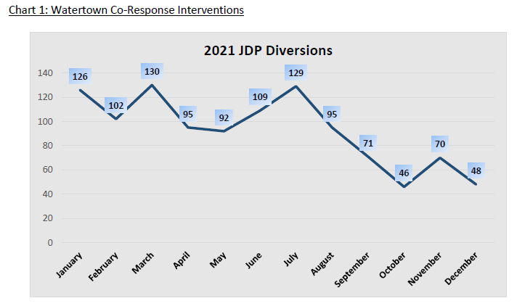

A total of 51 individuals were diverted from arrest by police officers and into treatment by clinicians during the calendar year. The percentage of those eligible for arrest diversion whom were diverted is 79%

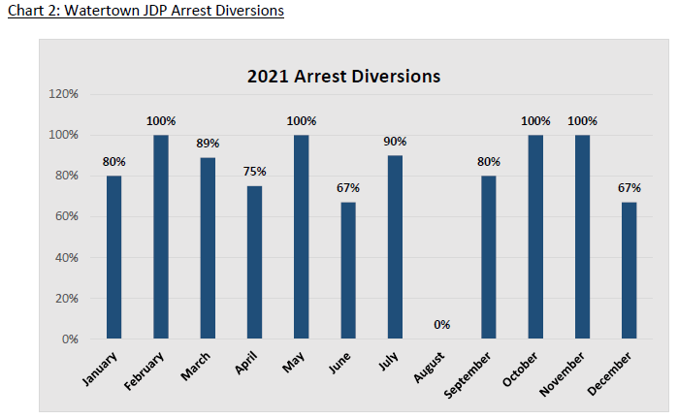

For 2021, evaluations between genders showed a higher rate of females encountered by clinicians than males compared to the town population.

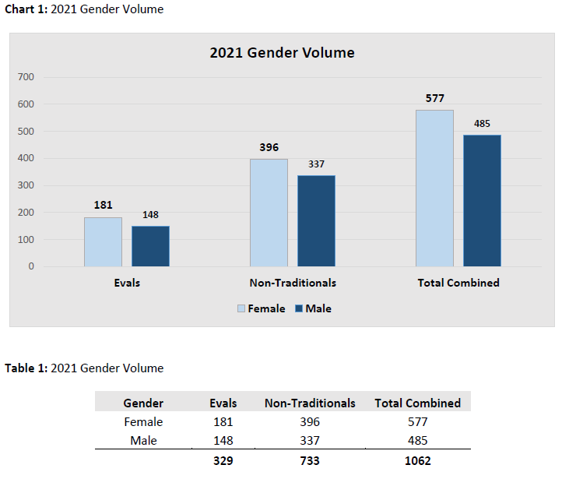

In 2021, there was also a higher rate of encounters with African Americans compared to the town population and an underrepresentation of Asians.

|  |  |  |  |  |  |  |  |  |
| --- | --- | --- | --- | --- | --- | --- | --- | --- |
| Race/Ethnicity | Evals | % |  | Non-Traditional | % |  | **Total** | **%** |
| White | 257 | 78% | 616 | 84% | **873** | 82% |
| Black | 30 | 9% | 61 | 8% | **91** | 9% |
| Hispanic | 27 | 8% | 24 | 3% | **51** | 5% |
| Asian | 14 | 4% | 26 | 4% | **40** | 4% |
| Other | 1 | 0% | 5 | 1% | **6** | 1% |
| Indian | 0 | 0% | 1 | 0% | **1** | 0% |
| **Total** | **329** | **100%** | **733** | **100%** | **1062** | **100%** |

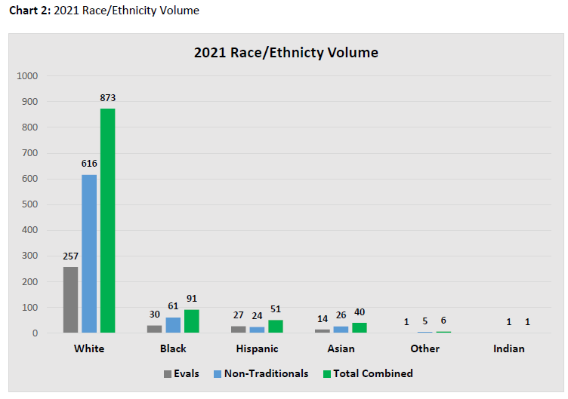

The Watertown Police Department joined the Police Assisted Addiction Recovery Initiative. This organization has supported the Department through grant funding and providing training opportunities that keep us abreast of best practices in response to substance use disorder and specifically the opioid epidemic.

Recognizing that Watertown, like most other communities in the Commonwealth experienced an increase in opioid overdoses in early 2015, the CSD Division played a significant role in establishing Watertown’s task force W.A.T.E.R.town (Watertown Access to Treatment Education and Resources). The group, now referred to as the Watertown Cares Network, is a collaborative effort with several municipal agencies, clergy, and service entities to enhance public awareness and prevent unnecessary suffering due to substance use disorder. Members of the Division, in conjunction with the task force work to coordinate community wide awareness for the challenge poses by substance use disorder. This effort continued throughout the COVID-19 pandemic via social media messaging to the community.

As part of the Department’s continued response to the impact of substance use disorder on our community, the CSD Division implemented a Nasal Narcan program. The department was able to maintain legal authorization from the Department of Public Health and its medical director to carry and dispense Narcan. The department has partnered with the Watertown Health Department to train all police officers in the proper administration of the drug. In 2021 Nasal Narcan was successfully used by the police department at the scene of 12 overdoses to save the life of individuals ranging from nineteen to sixty-two years of age.

The Watertown Police department has continued its support of the Free Community Narcan Program. This program has enabled the Watertown Police Department to put the life-saving drug in the homes of individuals and families in need, at no cost.

During the 2017 calendar year, ten opioid related overdose deaths occurred in our community, the highest on record. In 2021 the number of confirmed opioid related overdoses was 32, up slightly from 26 the previous year. Five of these overdoses were fatal, matching the previous year exactly. These trends are indicating progress but the need for continued outreach efforts and the distribution of Narcan to those at risk.

Officers from the Community and Staff Development Division continue to assist the Watertown Public School System with their crisis management protocols. Officers attend regular meetings with school personnel to discuss procedures to prevent and mitigate emergency situations which could occur on school property. The goal of this crisis management team is to provide a safe environment for students and to adequately prepare for a variety of potential emergencies that could affect school personnel or property.

As a result of these meetings, the Watertown Public Schools have continued with the A.L.I.C.E. (Alert-Lockdown-Inform-Counter-Evacuate) approach to active shooter threats. This program empowers teachers and students with more options in response to an armed intruder with an emphasis placed on evacuations rather than solely locking down and attempting to hide. A.L.I.C.E. Drills have been completed in all public schools with staff and students and will continue on a routine schedule.

Outreach and training in the A.L.I.C.E. program have been expanded to include several private schools and businesses in Watertown to include the Atrium School, the Jewish Community Day School, the Beacon School, St James School, Perkins School for the Blind, EFGB (French School of Greater Boston), Boys & Girls Club, Watertown Town Hall personnel, Advocates Inc., United Electric, the Arsenal Yards, Care Group Parmenter, and Tarveda Therapeutics.

As a result of COVID 19, live drills for ALICE have been suspended. The CSD continued its work with school CIT to prepare for resumption of normal operations.

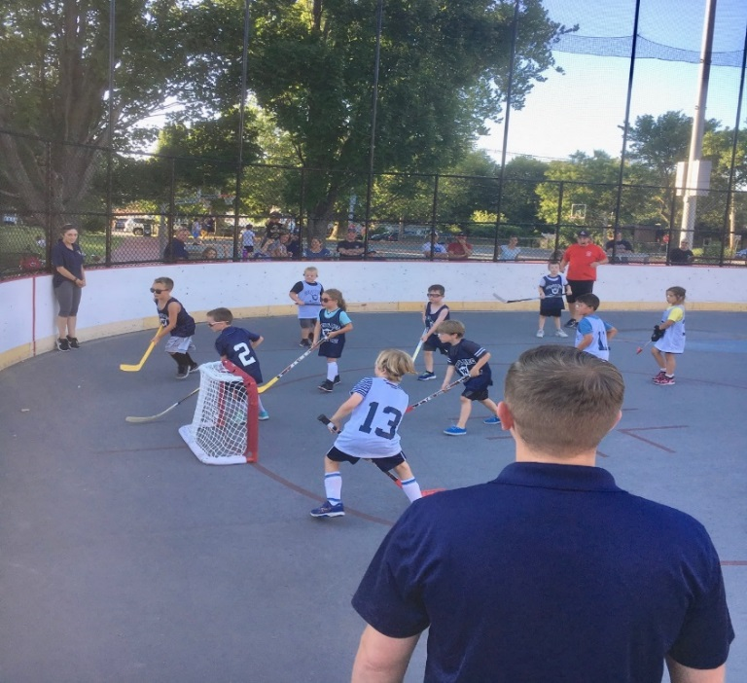**OTHER COMMUNITY POLICING PROGRAMS**

The Division has continued collaboration through the 2021 calendar year with the Watertown Recreation Department to operate Cops & Rec programming. Members of the department working in conjunction with Recreation staff ran after-school basketball, floor hockey and volleyball events at the Watertown Middle School. The two departments also coordinated volleyball and street hockey programming through the summer months, reaching elementary to high school aged students.

The Division has established a working relationship with staff at Grace Chapel resulting in multiple collaborations during the 2021 calendar year. Members of the department supported a family pizza and movie night on the front lawn of Grace Chapel. Officers also supported Grace Chapel at a fall festival and again at a holiday festival.

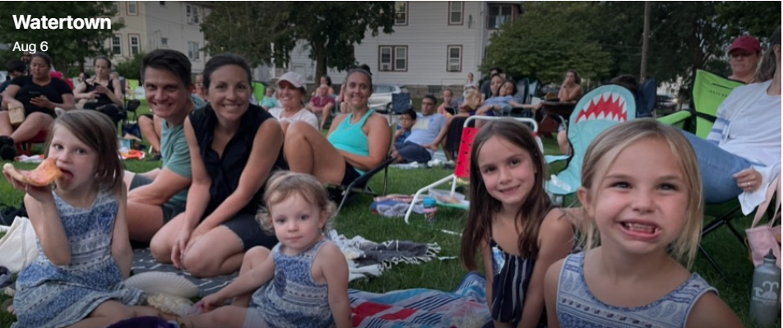

With the re-emergence of social justice concerns during the 2020 and 2021 calendar year members of the Division have spent a significant amount of time communicating with community members in virtual and in-person round tables and forums to share ideas on this topic. Annually a review of statistical data pertaining to field contacts by police officers is conducted. The intent of the review is to identify patterns of biased policing and to eliminate it. In 2021 a more significant investigation into the 2018 to 2020 calendar years was conducted. Much of this data and subsequent findings were shared publicly in an effort to demonstrate transparency with members of the community especially concerned about the criminal justice system’s impact on people of color.

**ACCREDITATION**

As planned, the department underwent a successful re-accreditation assessment in June of 2021 and renewed our accredited status. The department has continued its review of the department’s policies and procedures. Hundreds of pages of written policy have been carefully combed through to ensure that they are up-to-date and consistent with the department’s facility and standards. This process shall continue to ensure that training standards are maintained or improved, and policies remain updated and consistent with accreditation standards and legal requirements. A continual effort will be required in order for the department to maintain compliance with all three hundred and twenty-two standards and be re-accredited in 2024.

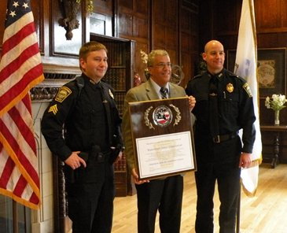

Successful re-accreditation assessment certificate

**DEPARTMENT TRAINING**

The department ensured that its officers attained the legislative 40-hour minimum mandatory annual training requirement by contracting with the Lowell Police In-Service academy to provide in-service training to all Watertown Officers. In accordance with accreditation standards, the department ensures all members are further prepared for their roles by coordinating training on eighteen additional topics. The department continued its production of internal trainings which were incorporated into the department’s various software technology mediums (i.e., PMAM Training and Digital Headquarters information SharePoint program) to enhance and go beyond state mandated training.

The social justice movement beginning in 2020 and the police reform bill signed into law in December of 2020 had several impacts on the department’s approach to training.

Training for all members of the department in the prevention of biased policing has been ongoing for several years. Through this training, principles from Kingian Nonviolent Conflict Reconciliation curriculum have been shared with all members of the Watertown Police Department.

A review of several policies was required to ensure the department maintains strict compliance with all newly established mandates established by the Police Reform Bill. All members of the department, regardless of their roles are impacted by these mandates. Members of each division required training specific to their roles and responsibilities to ensure understanding of the new mandates and compliance. Specific areas requiring adjustments and training included: administrative functions such as hiring, disciplinary procedures, emergency operations procedures, use of force practices, prevention of biased policing and documentation and reporting functions.

All members of the department underwent training to reinforce understanding of the department’s Use of Force policy, Emergency Operations policy, defensive tactics, and de-escalation tactics. This training was coordinated by the CSD Division and two members of the department who have served with the NEMLEC SWAT team for over ten years. The curriculum included reinforcement of de-escalation tactics, reinforcement of the key components of the Incident Command System, a review of the evolution on response to “active shooter” scenarios, tactics to help enhance officer’s safety and instruction on the A.L.I.C.E. program to dovetail with the training received by the schools and businesses in Watertown. An important component of this and other training sessions this year was to impart an understanding of how police officer’s actions are perceived in context with the re-emergence of social justice concerns and the Police Reform Bill.

All members of the Watertown Police Department completed an enhanced ethics training to reinforce the department’s Mission Statement and Rules and Regulations. The training encompassed officer’s involvement with political activity, rules pertaining to gifts offered, proper conduct towards the public, restraint in use of force encounters, the matter of “duty to intervene” and the importance of honesty.

In addition to the aforementioned training, various officers have also attended training sessions in the following areas: interpretation of the Police Reform Bill mandates, enhanced emergency medical treatment, Mental Health First Aid, investigative skills, bicycle patrol training, enhanced de-escalation training, street drugs recognition, drug interdiction vehicle stops, evidence collection and preservation, community policing, active shooter response, legal updates, fair and impartial policing, hiring and retention of personnel, sexual harassment and many other type trainings.

**USE OF FORCE**

The Division is responsible for coordination of use-of-force training, the monitoring of use-of-force incidents and the recommendation of adjustments to the program.

The Taser 7 weapon system has been in use for a second full calendar year. In 2021 the weapon was displayed on four occasions. One incident required the deployment of probes to stop an individual who approached officers and threatened them with a knife. The suspect was taken into custody with only minor scratches, an outstanding outcome given the dangerous nature of that encounter. During the three remaining incidents, display of the Taser alone was enough to gain cooperation from the threatening individuals.

Of significant note is that no officers have been injured in-the-course of making an arrest, since the adoption of the Taser 7 weapon system into the department’s use-of-force policy. Also of note is that no weaponless strikes to subdue an individual have taken place in this timeframe.

On four separate occasions during 2021 officers were faced with an individual who threatened them with a knife or other weapon in an apparent attempt to commit “suicide by cop”. In a fifth incident an individual falsely claimed to possess a firearm and refused to remove his hands from his pockets. In each of these cases officers demonstrated calmness, patience, and restraint. In only one of these incidents did an individual suffer injury - minor scratches.

Despite the exceptional performance of officers in these circumstances, the volume of such encounters indicates a need for continual training to enhance skills in the areas of negotiations, de-escalation, emergency operations, the Incident Command System and use-of-force.

**INTERNSHIP PROGRAM**

The college internship program was paused in early 2020 due to COVID restrictions. We aim to resume normal operations in early 2021.

**INFORMATION TECHNOLOGY UNIT**

Throughout 2021, the WPD IT unit along with the Fire Department and DPW, continued long term planning of the town’s first responder radio network. This replacement network is expected to near completion at the end of 2022.

In June of 2021, the WPD began accepting “Phase 1” 911 calls. Previously, calls with limited location data, called Phase 1, would be routed to the nearest State Police 911 center, and get transferred if not in MSP jurisdiction. This would often cause delays getting calls to the appropriate jurisdiction. By taking these calls, we have greatly increased response time efficiency to emergencies by an average of one minute and six seconds. In 2021, there were a total of 10,007 emergency calls in our 911 center.

**BUREAU OF FIELD OPERATIONS**

**PATROL DIVISION**

The primary mission of the Patrol Division is to serve Watertown’s citizens through a cooperative effort and to protect their property through enforcement of laws and highly visible deterrent activities. The officers of the Patrol Division represent the department’s first response to all emergencies and most calls for service. In 2021, the department did not hire any new officers.

During 2021, the Patrol Division responded to 25,095 calls for service and or motor vehicle stops. These call-initiated investigations and events resulted in 165 arrests, 12 persons being placed in Protective Custody and 214 summonses being issued. These numbers do not reflect all of the officer-initiated contacts made by patrol officers during the course of routine patrol. Officers also responded to 253 calls involving mental health issues, and 33 overdoses with 5 of these being fatal. The most common calls for service in 2021 were medical calls with a total of 3,465.

Heavy emphasis by the Patrol Division was also placed in the enforcement of traffic regulations in keeping with the goal of moving traffic safely and efficiently on the streets of Watertown. Officers and equipment were assigned to monitor and enforce traffic rules and orders when necessary, in keeping with this goal.

Officers were also assigned to “hot spots” for enforcement. These locations are where a large number of accidents or violations occur, or where there are numerous complaints by citizens.

Patrols were adjusted during the course of the year to address increased activity due to crime trends, holidays, special events, and recreational events at parks and playgrounds. Patrols were increased during peak shopping periods in the business districts of Watertown. This was accomplished by using motor patrol, foot patrol, and the use of motorcycles and bicycles. The Patrol Division works in concert with other divisions in the Police Department and outside public and private agencies within the area to accomplish the objective of providing the most effective deployment of personnel possible. Computer data is analyzed to assist in the deployment of police officers to areas in need of police attention.

The Patrol Division, as well as the entire Police Department, is committed to Community Policing. One of the goals of Community Policing is to build a partnership between the police and the community, encouraging interaction between the two so that we can solve community problems together. This partnership also allows the community to let the police know what concerns they have, and which issues they feel are important and would like addressed. Officers receive training in Community Policing and are encouraged to increase their interaction with the citizens on their respective patrol routes. Officers are also relieved of their assignment for a portion of their shift to work with the community on various issues and problems.

When Chief Lawn was appointed Chief of Police, one of his first priorities and changes he made was bringing back community policing programs. Chief Lawn is committed to these programs and improving upon the close relationship the department has built with the community.

In 2021 due to the ongoing COVID-19 pandemic, the department was unable to again offer a Citizen’s Police Academy to our residents. This ten-week program “Understanding through Education” is designed to educate residents about what their police do and why they do it. Residents also get to meet many officers during the class, and both get to know each other. The department and its officers also get to learn what issues the residents see as important. This is all intended to bring about a closer working relationship and build trust. The department anticipates being able to offer this course again soon.

The department is continuing its use of mountain bikes for officers. This allows them the ability to access locations a police vehicle cannot navigate and makes officers more approachable by its residents, rather than being in a car where residents may be reluctant to approach and interact with officers.

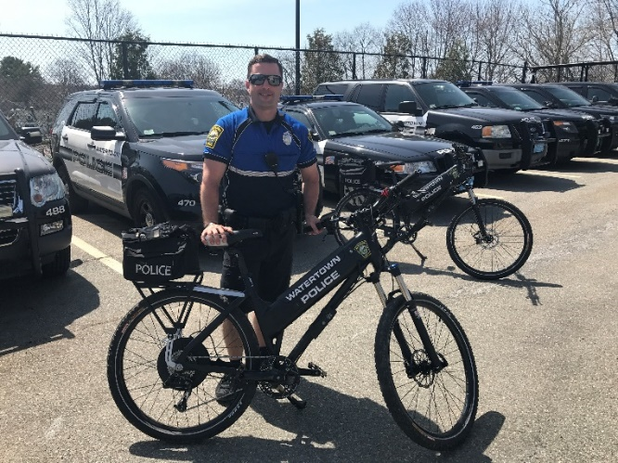

*Off. David Cobe with an electric police mountain bike.*

The department is also now utilizing a seasonal Utility Terrain Vehicle (UTV), a four seat Kawasaki Mule to help further its community policing efforts. The UTV not only allows for officers to be more approachable, but also provides quicker access down rough terrain should an emergency call arise. Pictured below is the department’s UTV vehicle with Officer Wojtowicz.

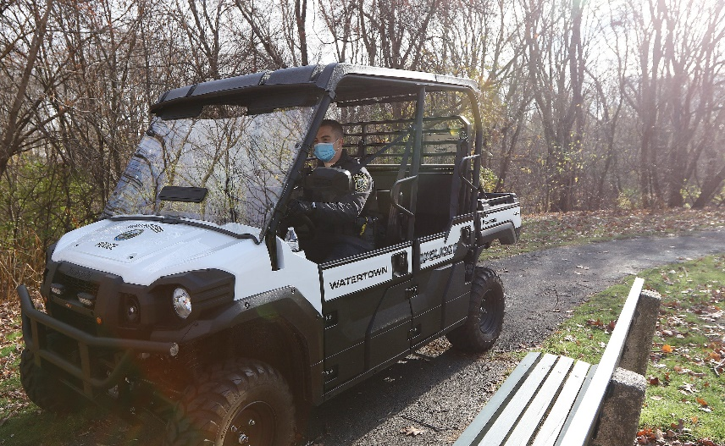

*Officer Brendan Wojtowicz patrolling a community path in the UTV*

**NORTH EASTERN MASSACHUSETTS LAW ENFORCEMENT COUNCIL (N.E.M.L.E.C.)**

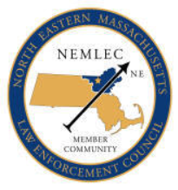

The Watertown Police Department continues its membership and commitment with the North Eastern Massachusetts Law Enforcement Council (NEMLEC). NEMLEC is a group of 61 cities and towns that share resources. These NEMLEC cities and towns have a combined SWAT Team (Special Weapons and Tactics), RRT Team (Regional Response Team), a School Threat Assessment Response team (STARS), a K-9 unit, and a motorcycle unit that will respond to any member community on a moment’s notice. NEMLEC Motorcycle Unit, K-9 Unit, RRT & SWAT teams train monthly and are on call to NEMLEC communities to assist with emergency situations. In the past, Watertown Police Officers assigned to these units, assisted the Boston Police Department with security for the Democratic National Convention, Boston Red Sox World Series games and parades. They also assisted Boston Police with Patriots Super Bowl Parades. The RRT officers have also participated in two Presidential Inauguration security details in Washington D.C

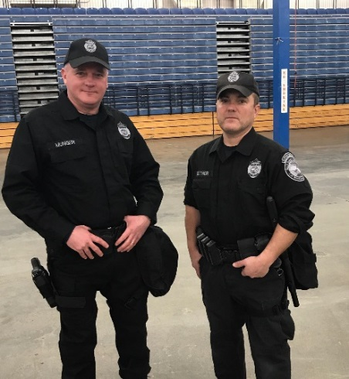

*NEMLEC RRT Unit Off. Rick Munger and Off. Mark Leitner.*

**DEPARTMENT’S CANINE UNIT**

The department recognizes that canines are a valuable law enforcement tool due to their superior sense of smell, hearing and tracking ability. The department welcomed its first canine in 25 years in 2019. The department’s canine, named “Kato”, has been a valuable resource to not only this department, but to other communities too through NEMLEC. Kato has assisted in locating missing persons, conducting building searches, apprehending suspects, and locating illegal narcotics. Kato was successful at seizing a total of 12043.6 grams of Cocaine this year. Kato and Officer Civetti were also able to provide K9 assistance to various communities throughout the year . Below are two pictures of Kato. The first photo is with his handler, Officer Andrew Civetti.

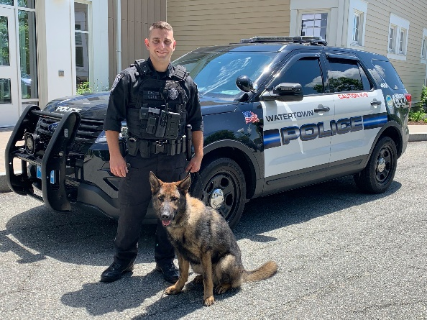 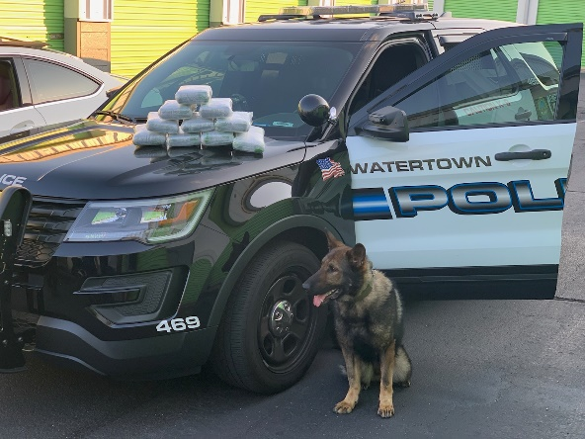

In 2021, the department had 60 NEMLEC call outs. The following NEMLEC units were called upon the number of times listed below;

K- 9 Unit 12 Call outs

SWAT 33 Call Outs

RRT 0 Call Outs

Motorcycle 15 Call Outs

STARS 0 Call Outs

**PUBLIC SAFETY DISPATCHERS**

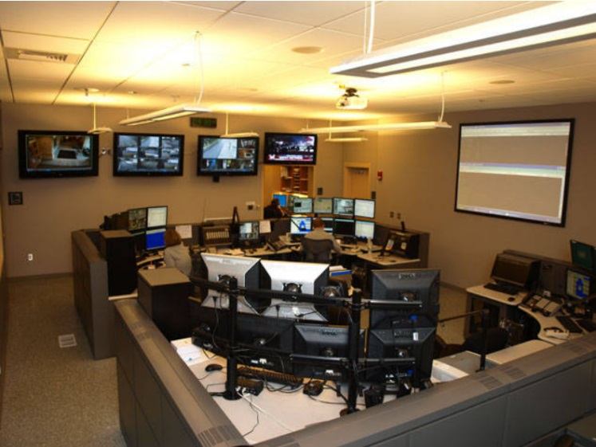

There are nine Public Safety Dispatchers that answered a total of 10,007 calls in 2021. This consisted of 7,382 voice calls, 13 texts, and 2,608 outbound calls. The dispatchers answer all calls for assistance for both the Watertown Fire Department and Police Department. Below is a chart which depicts these statistics.

The dispatchers come under the Patrol Division of the Police Department. They are the first point of contact for all citizens requesting assistance or directions from either department. The dispatchers answer all E-911 calls and are responsible for dispatching all fire apparatus and ambulances when required. They also dispatch all police cars to service and emergency calls. These dispatchers are also required to make contact with the Registry of Motor Vehicles to obtain and check license and registration status vehicle information and confirm warrants on wanted individuals.

**TRAFFIC DIVISION**

***Motorcycle officers Off. Charles Samios and Off. Rod Mendez at NEMLEC Unit training***

In 2021 the Watertown Police Department Traffic Division conducted traffic enforcement activities throughout the Town with three patrol officers assigned to this division.

The Traffic Division has two patrol cars and four Harley Davidson motorcycles assigned to it. Officers operating these motorcycles attended either forty hours of instruction at the Boston Police Motorcycle Training Academy, the M.B.T.A. Motorcycle Training Academy or an eighty-hour course sponsored by the Northeast Massachusetts Law Enforcement Council (NEMLEC).

The Traffic Division has a Commercial Vehicle Enforcement Unit. This unit increases the safety of the motoring public and contributes to maintaining the integrity of the town roadways by inspecting commercial vehicles and their drivers for safety, equipment, and weight compliance. This unit consists of one officer who is trained and certified by the U.S. Department of Transportation (D.O.T.) as a federal motor carrier inspector. This officer is also trained and certified by the U.S. Department of Transportation to conduct inspections of commercial vehicles carrying Hazardous Materials.

The Traffic Division is responsible for the Detail Office. The Detail Office consists of one officer who is responsible for scheduling details and overtimes, billing companies and collecting money owed. This Officer also covers routes during personnel shortages, conducts community policing activities and is available to respond to emergency situations as needed.

The Traffic Division supervises one full-time and one part-time civilian parking enforcement officers. These civilian positions allow police officers to dedicate their time to other police duties.

Between January and December 2021, the Traffic Division conducted surveys, studied speed and traffic flows, and conducted investigations for the Watertown Traffic Commission. This information was used by the Traffic Commission in their determination for the addition, replacement, or deletion of traffic signs, rules and regulations.

In December 2021, the Traffic Division purchased a fourth portable RADAR speed display sign. These signs are portable speed feedback units that display target vehicle speeds on a 3’ x 3’ display window. In addition to speed measurement, these units also measure traffic volume. The reports generated by these radar units are used to aid the Traffic Commission in their efforts as well as to determine the level of traffic compliance in particular areas. The speed signs have been effective tools in reducing vehicle speeds in problem areas. The Traffic Division also uses a portable electronic variable message sign to display important traffic and safety information to motorists.

The Traffic Division also supervised sixteen full time and five alternate school crossing guards. These supervisors are responsible for traffic control and the safe passage of schoolchildren and families in and around the public schools. Many post assignments were modified in 2021 due to staffing levels and Watertown Public Schools building construction projects. These projects are expected to impact crossing guard operations for the next several years.

In 2021, the Department issued the following motor vehicle citations:

**TRAFFIC**

16,362 Parking citations

491 Total moving citations

**2021 Data**

**491 Citations**

21 Arrests

62 Criminal Complaints

62 Civil Fines

346 Warnings

16 OUI:

* 13 OUI Liquor
* 1 OUI Liquor 2nd Offense
* 0 OUI Liquor 3rd Offense
* 0 OUI Liquor 4th Offense
* 1 OUI Liquor 5th Offense
* 1 OUI Drugs

18 Suspended/Revoked Licenses

29 Operating W/O License

**288 Major Accidents and 431 Minor Accidents**

**Major Accidents Include:**

* 175 Collision with MV in transport
* 0 Collision with other movable object
* 45 Collision with Parked Motor Vehicle
* 10 Collision with Curb
* 2 Collision with Tree
* 11 Collison with Utility Pole
* 7 Collision with light pole or support
* 1 Collision with median barrier
* 0 Collision with Ditch
* 15 Collision with Pedestrian
* 12 Collision with unknown/fixed object
* 7 Collision with Bicyclist
* 1 Other Non-Collision
* 2 Collision with moped
* 0 Other