WATERTOWN

P O L I C E D E PAR T M E N T

2022 ANNUAL REPORT

Memorial Day 2022

**Department Overview**

The Watertown Police Department is staffed by seventy-one full-time sworn police officers and fourteen civilian employees. In recent years our agency, like the community it serves, has become more diverse in race, ethnicity, gender and language. Amongst our ranks are employees that speak Spanish, Vietnamese, Cantonese and multiple dialects of Armenian. Our agency is youthful, having hired twelve new sworn police officers since the start of 2020 and almost half of our agency has been hired within the past ten years.

## Department Culture

**Service**

The Watertown Police Department strives to instill a service ethos into all members of the agency. We understand that to provide excellent service, our efforts must be tailored to meet the needs of an ever-changing community. We count on our command staff and veteran personnel to exemplify a commitment to community service. Strong role models and thoughtful training on agency expectations guide our new personnel to success.

**Integrity**

Ethical conduct serves as a foundation for a solid and trusting relationship with our community. We strive to hire personnel that are capable, kind and honorable. We believe individuals with these traits can be trained to serve as excellent team members and community servants. During the course of their careers, our department members will face many difficult decisions. The Watertown Police Department recognizes this challenge. In response, we have enhanced our training in recent years to ensure all members of the Watertown Police Department have the knowledge and skills to make sound, ethical decisions.

**Empathy**

The infusion of empathy into all efforts of the Watertown Police Department is key to serving a diverse community. Members of the department encounter and serve individuals with widely varying religious, ethnic, cultural and racial identities. We serve a community diverse in socioeconomic status. Our community encompasses individuals especially vulnerable due to their immigration status, gender status, a mental health disorder or a substance use disorder. Provision of service to these community members calls for tact and compassion. Members of the department require a high level of emotional intelligence to adapt their style of service and meet the needs of individuals from all corners of the community. In response, department members are trained to better understand and identify with the people they serve.

**All Efforts of The Watertown Police Department**

**Are Guided by Our Mission Statement as Follows**

The Watertown Police Department is dedicated to serving the community by protecting life and property; by preventing crime; by enforcing the law; and by maintaining order for all citizens, in accordance with the constitutions and laws of the United States and the Commonwealth of Massachusetts.

The Watertown Police Department is committed to training and professionalism. With the support of our citizens, we strive to work in unity with our community to anticipate, prevent and help solve problems.

With compassion and respect, we strive to maintain a partnership of trust with our community by upholding the highest moral and ethical standards.

With community policing and community service as our foundation, we dedicate ourselves to ensuring the highest quality of life in our community both now and for future generations.

**BUREAU OF ADMINISTRATIVE SERVICES**

2022 marked the twelfth full calendar year in our new police station at 552 Main St. The department again thanks the citizens of Watertown for this wonderful facility that has served our agency and our community so well.

**Community Room**

Our community room serves as a centerpiece to the department. It hosts members of our agency for large-scale trainings and meetings. It also serves as our back-up emergency operation center & media press release area. It is a popular space for town meetings, community functions, and training activities. This room also serves as a polling location. In 2021, the COVID-19 pandemic resulted in less public congregation and subsequently less use of the community room. This space importantly, did serve as a city public vaccination site. The community room was reserved forty-one times during the 2022 calendar year.

Watertown Police Department Community Room May 2022

**Public Safety Dispatch**

The 2022 calendar year was the third year in which the Watertown Police Department was able to receive emergency communications via text message. The department received sixteen 911 text messages. Text to 911 allows those in need of emergency services to use their cellular device to contact 911 when they are unable to place a voice call.  To contact emergency services by text message, simply enter 911 in the “To” field of your mobile device and then type your message into the message field. It is the same process that is used for sending a regular text message from your mobile device. It is important to make every effort to begin the text message indicating the town you are in and provide the best location information that you can.

It is important to note that the 911 call center may not always have your exact location when they receive your text. For this reason, when sending a Text to 911 it is important to make every effort to begin the text message indicating the town you are in and provide the best location information that you can.

The State 911 Department encourages citizens to Text to 911 only when a voice call is not possible.

**Remember: “Call if you can, text if you can’t.”**

The department received a State 911 Department Training Grant. This grant allows the department to send our public safety dispatchers to mandatory and additional enhanced training. We also received a State 911 Incentive and Support grant. This grant is used to purchase dispatch support equipment or supplement personnel cost to improve and enhance our abilities to perform this service. As an example, the department received funding to update all of our dispatch/security computers and monitors located within our dispatch area.

**Response to Substance Use and Mental Health Disorders**

The Watertown Police Department and the City continued our funding of an expanded partnership with Advocates Inc. The department has maintained a “Jail Diversion Program” grant through the Department of Mental Health to provide funds for one full-time imbedded clinician. Recognizing the impact of this rile, the City has funded a second full-time Jail Diversion clinician. The clinicians are deployed to provide better services to our citizens who are experiencing a crisis due to mental health or substance use disorders. Another important goal of this program is to divert individuals experiencing a crisis from the criminal justice system towards treatment with mental health and/or substance abuse professionals. They are now both working closely with our officers to do work that preserves life and enhances the quality of life for many community members.

We have also partnered with Advocates Inc. to provide officers with Mental Health First Aid (MHFA) training. Nearly every sworn officer has been exposed to this training, which is a key in establishing the Department’s approach to those suffering with mental health and substance use disorders. This curriculum is designed to enhance the skill of officers in de-escalating tension-filled encounters and in identifying the underlying causes of individuals in crisis.

The police department also continues to work very closely with Watertown’s Wayside Multi-Service Center in order to meet the needs of our juvenile community members. The department has supported the Wayside Multi-Service Center in prevention and education efforts around substance use and making healthy decisions.

All department patrol vehicles continue to carry Narcan for opioid related overdoses. In 2022 the department responded to 21 opioid related overdoses. Officers deployed this life-saving drug at the scene of 13 of these incidents. Thanks to support and grant funding from the Watertown Community Foundation, the department also continues to issue vouchers for free Narcan kits to Watertown community members who have a friend or family member suffering with substance use disorder.

In 2022 the department continued public access to our prescription drug disposal box in the lobby of our station. Along with the prescription drug box, the department participated in two DEA’s National Prescription Take-Back days in 2022. The department disposed of 420 pounds of unwanted prescription drugs in the 2022 calendar year.

**Accreditation Standards**

Despite the pandemic, the department sought and was officially awarded full re-accreditation in 2021 through the Massachusetts Police Accreditation Commission. To achieve this status the department met three hundred and thirty-two carefully selected standards which address critical areas such as policy development, use of force, training requirements, emergency response planning, records & communications, property & evidence handling, vehicular pursuits, holding facilities and budgeting. Massachusetts is one of 25 states to offer an accreditation process for the police profession. The department has been a fully accredited police department since 2015. The enactment of the Police Reform Bill in December of 2020 resulted in more than 25 new accreditations standards being established. The department is in compliance with all of these standards. Preparation is ongoing to adjust all department policy and practices to comply with a new edition of the Massachusetts Police Accreditation Commission Standards and subsequently have a successful assessment in June of 2024.

**Training**

The department’s training program constantly evolves to meet legal requirements, to meet the needs of our community and to prepare our officers for success.

As de-escalation training is of the utmost importance, the department has used our Meggitt Training Systems virtual firearms training and judgement simulator for several years. Monies were gifted to the department to enable this purchase. This law enforcement virtual training simulation system effectively supports marksmanship, judgmental training needs and is designed to enhance the decision-making ability of all officers. The 12 foot by 7 foot screen configuration allows officers to experience realistic video scenarios. This type of judgmental training system enhances each officer’s understanding of the use of force decision making process and very importantly, how to avoid the need for force.

To further enhance our officer’s de-escalations skills and understanding of emergency operation procedures, all officers have been exposed to training with simunition weapons. Simunition weapons are modified to discharge small paintball-like projectiles. The use of this equipment allows our trainers to conduct life-like training scenarios that reinforce knowledge of policy, safety tactics and discretion in potential use of force encounters.

**Officer wellness**

The department continued in its sixth full year as a member of the Critical Incident Stress Management Team. The CISM team serves as regional peer support officers to assist participating law enforcement agencies in responding to major critical events and those officers who have been affected by these incidents. Watertown Police Department’s CISM team members responded to fourteen (19) callouts for services. Such services as; death of an officer, homicide, fatal accidents and grief debriefs.

**Mutual aid collaborations**

The department continues to participate in the Middlesex County Interagency Mutual Aid Agreement. This agreement allows the police officers of the communities who have signed the agreement to exercise police powers in any other community who is also part of this agreement, with some restrictions; mainly the police officer must be *on-duty* at the time. All violations of the law are covered under the agreement, including motor vehicle violations. Thus, a Watertown Police Officer can enforce the laws of the Commonwealth in any of the cities and towns within Middlesex County that sign this agreement.

The department continued its collaboration and partnership with the Organized Crime Drug Task Force (OCDETF - Federal) and Suburban Middlesex County Drug Task Force. (Regional Municipal) Maintaining these partnerships are ever more important as we battle the national opioid drug epidemic causing so much distress in our communities and families.

The department continued its collaboration with the Newton Police Department, the Waltham Police Department and the Massachusetts State Police to forward “Operation safe Summer”. The program calls for the four agencies to work together in an effort to enhance police presence and a sense of safety on the bike paths along the Charles River. Law Enforcement Officers from all four agencies deployed personnel on foot, on bicycles, on motorcycles and all-terrain vehicles to access all areas along the river and to enhance approachability.

**Department infrastructure**

After an exhaustive public safety radio infrastructure & needs study, conducted in 2019 through 2020, the city approved two bond fundings (FY21 & FY22) totaling $4,147,000. This study identified major deficiencies to include: serious radio coverage issues, aging & failing radio equipment 17-21 years of age, unsupported and outdated Verizon copper telephone lines, lack of redundancy and interoperability within town departments and the possible loss of our frequencies due to a since repealed federal law. Since this approval, we have upgraded current radio transmit and receive sites and established new sites. All necessary equipment has been acquired and installed for the new system. These upgrades will provide complete public safety coverage, redundancy in our system, as well as extra frequencies for police and fire, upgrades to the DPW radio system and an interoperability frequency for city-wide use. We believe we should be operational by November/December 2023

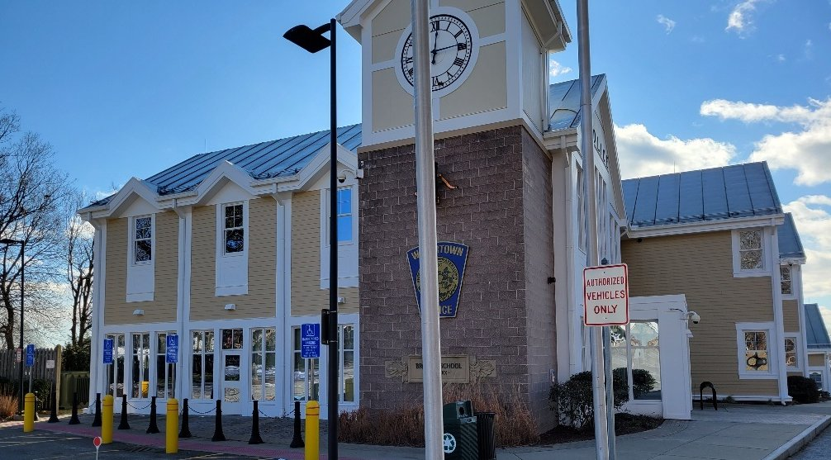

Watertown Police Department December 2021

**Community Policing**

The philosophy of community policing is at the heart of all department efforts.

While the department coordinates community policing programs and events, each member of the department is responsible for infusing this philosophy into all aspects of their work.

A primary focus of the Watertown Police Department is to collaborate with our residents, our business community and other agencies to address quality of life issues.

In 2020 the department purchased a new Kawasaki Mule Pro-FXT All-Terrain Vehicle. This vehicle can patrol on all our walking and bicycle paths. It gives us better access to tight spaces in the city and it opens the door for more interaction with our community members. The department also has a fleet of four bicycles to be used by trained officers who greatly enhance our community policing and engagement efforts.

Officer Comick, Officer Reynolds and Officer Grzelcyk Spring 2022

**SWORN PERSONNEL - 2022**

**PROMOTIONS:**

Mark A. Lewis (to Sergeant) 05/24/2022

**APPOINTMENTS:**

Andrew J. DiDuca 01/14/2022

Devon Shatkin 05/06/2022

Matthew S. Donnell 05/06/2022

Joseph V. Farrar 11/10/2022

Christopher Petersen 11/10/2022

**RETIREMENTS:**

Michael P. Lawn 06/03/2022

**RESIGNATIONS:**

**DECEASED:** None

**CIVILIAN PERSONNEL – 2021**

**REINSTATEMENS:**

**APPOINTMENTS:**

Diane M. Hairston (Account Payable Clerk) 04/04/2022

Natthia Petit-Frere (PS Dispatch) 07/11/2022

Cynthia C. Collin (Principal Acct Clerk) 08/08/2022

William D. Bellis (PS Dispatch) 08/29/2022

Antonio M. Galang (PS Dispatch) 10/11/2022

Meghan C. Mullane (PS Dispatch) 10/27/2022

**RETIREMENTS:**

Brock A. Kennedy 08/07/2022

John C. Selig 10/08/2022

**RESIGNATIONS:**

**DECEASED:** None

**COMMUNITY AND STAFF DEVELOPMENT DIVISION**

**Division Staffing**

In 2022, the Community and Staff Development Division consisted of one Lieutenant and two Sergeants overseeing five sworn officers, a civilian records clerk, a newly appointed principal account clerk and two civilian contractors (Advocates Inc. Clinicians).

The School Resource Officer Unit consists of one officer at the High School and one officer at the Middle School. In September of 2022 Officer Anna Margaryan was assigned as the new School Resource Officer at the Middle School. Officer Margaryan underwent significant training with members of the school faculty, with the National Association of School Resource Officers prior to taking on this new role. Officer Margaryan also had the benefit of valuable experience serving in the City’s after school program for several years prior to becoming a police officer. Officer Kerry Kelley has served as the School Resource Officer at the Watertown High School for twelve years.

In 2022 an Information Technology Unit was formally established. The Unit consists of one Sergeant to oversee a full-time Crime Analysis & Data Integrity Officer, a Technical services and Social Media Officer and a Communication and Security System Administrator. Officer Michael Comick is responsible for the review, quality control and analysis of police reports generated by officers that respond to approximately 25,000 calls for service annually. This role assists the department to better observe trends and patterns that inform future policing efforts. Officer Charles Samios maintains the department’s public presence via its website and multiple social media outlets. Officer Samios also assists with an ever increasing and evolving series of tasks related to technical services. Officer King Lam serves as the department’s System Administrator and is ultimately responsible for maintaining the department’s IT infrastructure.

The two Jail Diversion Program Clinician roles are contracted to Advocates Inc. The positions are staffed by civilian clinicians employed by Advocates Inc. One position is funded through the Department of Mental Health “Jail Diversion” grant and a second position is funded by the City of Watertown. Advocates Clinician, Eli Miller joined our team in the summer of 2022. Mr. Miller received extensive training through Advocates Inc. and further training to dovetail his efforts with the Watertown Police Department. Advocates Clinician Colleen Murray has served in the role since the summer of 2020. Together Mrs. Murray and Mr. Miller have been doing excellent work to lessen the impact of mental health and substance use disorders on our community members.

**School Resource Officers**

The School Resource Officers worked to build relationships with students, parents and school staff. These Officers contributed to a sense of security amongst the schools while providing guidance to students, parents and staff. They conducted sensitive investigations, they worked proactively to divert youths from the criminal justice system and they served as a resource for needed services.

The School Resource Officers and Sergeant assigned to the Community and Staff Development Division regularly attended Community Based Justice meetings. This meeting is a collaborative between school personnel, public safety professionals, and social service providers to help identify at-risk youths and provide them with positive alternatives to steer them away from crime and violence, and work with the administration to assist in obtaining necessary services for students.

The School Resource Officers served as active members of the NEMLEC STARS (School Threat Assessment and Response System) team which serves school districts in over sixty communities. Officer Kerry Kelley continued as an Assistant Commander of this unit. The School Resource Officers develop and apply expertise in areas of addressing school threats and providing much needed services to students.

Officer Kerry Kelley has also taken on a leadership role with the Massachusetts Juvenile Police Officers Association. In this role she has supported training efforts that reach school resource officers across the Commonwealth.

Officers from the Community and Staff Development Division continue to assist the Watertown Public School System with their crisis management protocols. Officers attend regular meetings with school personnel to discuss procedures to prevent and mitigate emergency situations which could occur on school property. The goal of this crisis management team is to provide a safe environment for students and to adequately prepare for a variety of potential emergencies that could affect school personnel or property.

To advance these efforts, the Watertown Public Schools have continued with the A.L.I.C.E. (Alert-Lockdown-Inform-Counter-Evacuate) approach to active shooter threats. This program empowers teachers and students with more options in response to an armed intruder with an emphasis placed on evacuations rather than solely locking down and attempting to hide. A.L.I.C.E. Drills have been completed in all public schools with staff and students and will continue on a routine schedule. The instruction for this program is conducted jointly by Watertown Public Schools staff and School Resource Officers.

Outreach and training in the A.L.I.C.E. program have been expanded to include several private schools and businesses in Watertown to include the Atrium School, the Jewish Community Day School, the Beacon School, St James School, Perkins School for the Blind, EFGB (French School of Greater Boston), Watertown Boys & Girls Club, Watertown City Hall personnel, Advocates Inc., United Electric, the Arsenal Yards, and Tarveda Therapeutics.

**Community Outreach**

The Division uses surveys to measure citizen’s fear of crime and satisfaction with the Police Department. The survey also gives citizens an opportunity to make recommendations on how the Department can improve its quality of service. On a quarterly basis, 100 random surveys are mailed to citizens who have had law enforcement contact with the Department. The department has consistently received high satisfaction ratings. During the 2022 calendar year, survey results indicated a 95.9% overall satisfaction score.

The Division has continued oversight of the Jail Diversion Program and the Advocate’s clinician positions. The purpose of the clinicians is to allow the Department to provide better services to citizens who are experiencing a crisis due to mental health or substance use disorders. The program focuses on creating alternatives to arrest, or criminal charges for people whose criminal behavior is directly due to mental illness or substance use disorder. In recent years, a significant effort has been exerted to engage community members prior to a crisis stage and encourage them to treatment.

A total of 790 individuals were referred to the Jail Diversion clinicians by police officers during the 2022 calendar year.

In 2022, a total of 15 individuals with behavioral health conditions were diverted from arrest. In addition to the obvious benefit of diverting individuals in crisis from arrest, these diversions represent an estimated cost savings of $44,850 to the criminal justice system ($2,990 per incident).

In 2022, a total of 180 individuals with behavioral health conditions were diverted from a hospital emergency department. These diversions represent an estimated health care cost savings of $486,000 ($2,700 per incident).

In 2015 the Watertown Police Department joined the Police Assisted Addiction Recovery Initiative. This organization has supported the Department through grant funding and providing training opportunities that keep us abreast of best practices in response to substance use disorders and specifically the opioid epidemic.

Recognizing that Watertown, like most other communities in the Commonwealth experienced an increase in opioid overdoses in early 2015, the CSD Division played a significant role in establishing Watertown’s task force W.A.T.E.R.town (Watertown Access to Treatment Education and Resources). The group, now referred to as the Watertown Cares Network, is a collaborative effort with several municipal agencies, clergy, and service entities to enhance public awareness and prevent unnecessary suffering due to substance use disorder. Members of the Division, in conjunction with the task force work to coordinate community wide awareness for the challenge poses by substance use disorder.

As part of the Department’s continued response to the impact of substance use disorder on our community, the CSD Division implemented a Nasal Narcan program. The department was able to maintain legal authorization from the Department of Public Health and its medical director to carry and dispense Narcan. The department has partnered with the Watertown Health Department to train all police officers in the proper administration of the drug. In 2022 Nasal Narcan was successfully used by the police department at the scene of 13 overdoses to save the life of individuals ranging from twenty-four to sixty-one years of age.

The Watertown Police department has continued its support of the Free Community Narcan Program. This program has enabled the Watertown Police Department to put the life-saving drug in the homes of individuals and families in need, at no cost. This program came to fruition out of a collaborative effort with the Watertown Health Department, the Watertown Fire Department, and the City of Watertown’s Social Service Resource Specialist. The program is financially supported by a key partner, the Watertown Community Foundation.

During the 2017 calendar year, ten opioid related overdose deaths occurred in our community, the highest on record. In 2022 the number of confirmed opioid related overdoses was twenty-one. Two of these overdoses were fatal. These trends indicate progress, but the need exists for continued outreach efforts and the distribution of Narcan to those at risk.

Watertown Police in support of the Watertown Community Foundation May 2022

**Other Community Policing Programs**

The Division has continued collaboration through the 2022 calendar year with the Watertown Recreation Department to operate Cops & Rec programming. Members of the department working in conjunction with Recreation staff ran after-school basketball, floor hockey and volleyball events at the Watertown Middle School.

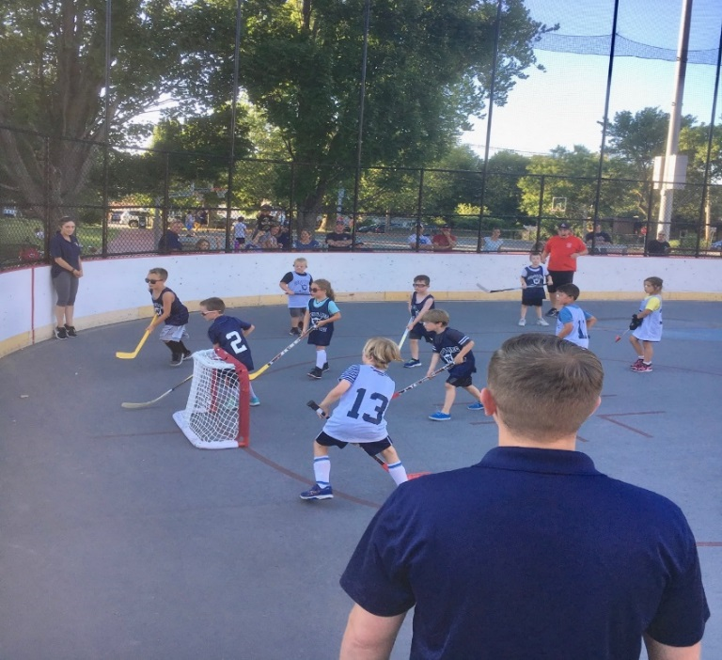

Officer Comick and Detective DelloRusso Cops & Rec Program Summer 2021

The Division has established a working relationship with staff at Grace Chapel resulting in multiple collaborations during the 2022 calendar year. Members of the department supported a family pizza and movie night on the front lawn of Grace Chapel. Officers also supported Grace Chapel at a fall festival and again at a holiday festival.

Officer Devon Shatkin Grace Chapel Fall Festival 2022

Pastor Stephen Nykairu of Grace Chapel in support of the John Sonny Whooley Foundation December 2022

**Accreditation**

As planned, the department underwent a successful re-accreditation assessment in June of 2021 and renewed our accredited status. The department has continued its review of the department’s policies and procedures. Hundreds of pages of written policy have been carefully combed through to ensure that they are up-to-date and consistent with the department’s facility and standards. This process shall continue to ensure that training standards are maintained or improved, and policies remain updated and consistent with accreditation standards and legal requirements. A continual effort will be required in order for the department to maintain compliance with all standards and be re-accredited in 2024.

Successful re-accreditation assessment certificate Fall 2021

Then Captain Rocca, Lieutenant Unsworth and Sergeant Demos

**Department Training**

The department ensured that its officers attained the legislative 40-hour minimum mandatory annual training requirement by contracting with the Lowell Police In-Service academy to provide in-service training to all Watertown Officers. In accordance with accreditation standards, the department ensures all members are further prepared for their roles by coordinating training on eighteen additional topics. The department continued its production of internal trainings which were incorporated into the department’s various software technology mediums (i.e., PMAM Training and Digital Headquarters information SharePoint program) to enhance and go beyond state mandated training.

The social justice movement beginning in 2020 and the police reform bill signed into law in December of 2020 had several impacts on the department’s approach to training.

Training for all members of the department in the prevention of biased policing has been ongoing for several years. Through this training, principles from Kingian Nonviolent Conflict Reconciliation curriculum have been shared with all members of the Watertown Police Department.

A review of several policies was required to ensure the department maintains strict compliance with all newly established mandates established by the Police Reform Bill. All members of the department, regardless of their roles are impacted by these mandates. Members of each division required training specific to their roles and responsibilities to ensure understanding of the new mandates and compliance. Specific areas requiring adjustments and training included: administrative functions such as hiring, disciplinary procedures, emergency operations procedures, use of force practices, prevention of biased policing and documentation and reporting functions.

All members of the department underwent training to reinforce understanding of the department’s Use of Force policy, Emergency Operations policy, defensive tactics, and de-escalation tactics. This training was coordinated by the CSD Division and two members of the department who have served with the NEMLEC SWAT team for over ten years. The curriculum included reinforcement of de-escalation tactics, reinforcement of the key components of the Incident Command System, a review of the evolution on response to “active shooter” scenarios, tactics to help enhance officer’s safety and instruction on the A.L.I.C.E. program to dovetail with the training received by the schools and businesses in Watertown. An important component of this and other training sessions this year was to impart an understanding of how police officer’s actions are perceived in context with the re-emergence of social justice concerns and the Police Reform Bill.

All members of the Watertown Police Department completed an enhanced ethics training to reinforce the department’s Mission Statement and Rules and Regulations. The training encompassed officer’s involvement with political activity, rules pertaining to gifts offered, proper conduct towards the public, restraint in use of force encounters, the matter of “duty to intervene” and the importance of honesty.

In addition to the aforementioned training, various officers have also attended training sessions in the following areas: interpretation of the Police Reform Bill mandates, enhanced emergency medical treatment, Mental Health First Aid, investigative skills, bicycle patrol training, enhanced de-escalation training, street drugs recognition, drug interdiction vehicle stops, evidence collection and preservation, community policing, active shooter response, legal updates, fair and impartial policing, hiring and retention of personnel, sexual harassment and many other type trainings.

**Use of Force**

The Division is responsible for coordination of use-of-force training, the monitoring of use-of-force incidents and the recommendation of adjustments to the program. Each use-of-force incident is reviewed, and an annual review of all incidents is conducted to evaluate needs for adjustment in practices, policy or training.

In 2022 eight use-of-force incidents were recorded. In two of these incidents individuals suffered minor injury.

The Taser 7 weapon system has been in use for a second full calendar year. In 2022 the weapon was displayed on four occasions. One incident required the deployment of probes to stop an individual who assaulted a police officer. The suspect was taken into custody with only minor scratches, an outstanding outcome given the dangerous nature of that encounter. During the three remaining incidents, display of the Taser alone was enough to gain cooperation from the threatening individuals.

Of significant note is that only one officer has been injured in the course of making an arrest, since the adoption of the Taser 7 weapon system into the department’s use-of-force policy.

Despite the exceptional performance of officers in these circumstances, the volume of such encounters indicates a need for continual training to enhance skills in the areas of negotiations, de-escalation, emergency operations, the Incident Command System and use-of-force.

**Information Technology Unit**

Throughout 2022, the Watertown Police Department’s IT unit along with the Fire Department and Department of Public Works, continued long term planning of the town’s first responder radio network. This replacement network is expected to near completion at the end of 2023.

During the 2022 calendar year, the IT unit took on several other significant projects. Approximately half of the department’s ninety desktop computers were replaced. In conjunction with the City of Watertown’s IT Department an upgraded phone system has been deployed. A major upgrade to the department’s audio and video infrastructure took place to allow for enhanced conferencing and training. Research has begun to identify a new records management system, replacement of security servers and the department’s digital fingerprint machine.

**Records**

Mrs. Catalina Gonzalez serves as the department’s records custodian. In 2022, our Records Department answered 1,023 public records requests for various department records and information. Records shared include police incident, arrest, accident and statistical reports.

**DETECTIVE DIVISION**

The Detective Division is comprised of the Investigative Unit, Licensing Unit, Juvenile Unit, Domestic Violence Unit, Drug Unit, Fire/Arson Investigation Unit, the Prosecutor’s Unit, New Employee Processing and Background Investigations and the Public Information Officer. Members of the division investigated numerous crimes, initiated investigations, and inspected licensed premises. Unit members are involved in programs for juveniles, the elderly, the business community, and the public.

The Detective Division has continued to work closely with other area departments, including Federal agencies in the area of drugs, gaming, organized crime, sexual assault, financial crimes and firearms. Our detectives attend meetings where they exchange information with area detectives. These meetings have provided us with valuable information on criminal activity in our area and have enabled us to establish relationships with detectives and agents from various departments and agencies. The NEMLEC task force detectives have set up an email system (MaCrimeNet) where information is shared daily. This tool has been exceptional in identifying suspects. The Watertown Police Department continues its association with COPLINK, an investigative tool, which gives us access to multiple data sources including identification of previously unknown relationships. This has become an invaluable resource for the Detective Division.

Throughout the year, there was a continued effort to scrutinize reported crimes.

In 2022, the Detective Division investigated/followed-up numerous cases, of these cases approximately 469 incidents were closed through criminal charges being sought (arrest, warrants, or summons), determining that the case was unfounded, closed after exhausting all possible leads or at the victim/involved persons’ request.

The Detective Division also works closely with our outside partners in the social services field to aid and assist people we encounter or become aware of that may be in need. Helping people with addiction, mental health, and/or other issues is a primary focus not only of the Detective Division but the department as a whole.

In addition to their regular investigative duties, members of the detective division routinely participate in community outreach and community policing initiatives. These efforts had been somewhat altered due to taking necessary safety precautions during the National Covid-19 Pandemic. Detectives were actively involved with the “Whooley Foundation”, delivering holiday presents to needy Watertown Families as well as WPD’s monthly coffee hour with members of our senior community, as well as our “Shop with a Cop” program. Our largest community policing initiative in 2022 was our catalytic converter program. In 2022 there was an increase in catalytic converter thefts in the Greater Boston area, including Watertown. Along with our investigative efforts, the detective division launched an innovative community wide deterrent program. We partnered with Toyota of Watertown and offered, free of charge for any Watertown resident, to have their catalytic converter inscribed with “Property of Watertown Police”. We believe that this will deter the initial theft of the catalytic converter and certainly deter the after-market sale of the product. This initiative proved to be a success, to date over 100 Watertown residents took advantage of this program.

**

Watertown PD, Boston PD and Toyota of Watertown staff December 2022

**PERSONNEL CHANGES**

* Officer Brendan Wojtowicz was transferred to the Detective Division from the Patrol Division.
* Detective Mark Lewis was transferred from the Detective Division to the Patrol Division (promotion to sergeant).

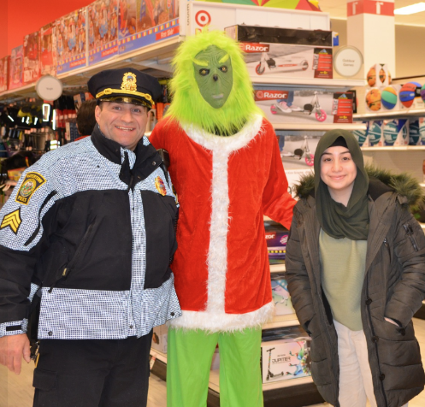

Shop with a Cop at Target: Watertown PD, Boys & Girls Club staff, Target staff and the Grinch December2022

**LICENSING UNIT**

In order to encourage cooperation between the business owners of licensed establishments in the City and the Police Department, with the intent to detect possible violations of the laws and regulations governing licenses, members of this unit conducted inspections of various licensed

establishments during both day and nighttime hours. Any irregularities observed during these inspections were investigated and appropriate action taken whenever deemed necessary.

In addition to their normal duties, the division also conducted alcohol-related sweeps aimed at curtailing teenage involvement in such activity. Package stores, clubs, and restaurants were monitored, and youths questioned as to proper identification. The success of these operations is a result of the educational efforts of this division directed towards the liquor establishments and the strong enforcement action by the Watertown Licensing Board.

The following is a report from the Detective Licensing Division for the year of 2022 relative to license applications. These applications were submitted for investigation and report. The applications were generated by the Police Department as well as submitted by the City Manager’s Office and the Watertown Licensing Board. (Note: the totals are an estimate and may or may not reflect the final total numbers.)

|  |  |  |  |  |  |  |  |  |  |
| --- | --- | --- | --- | --- | --- | --- | --- | --- | --- |
| **APPLICATIONS:** | ***Processed*** |  |  | ***Approved*** |  | ***Denied*** |  | ***Susp/Rev*** | |
| **Firearm Applications** |  |  |  |  |  |  |  |  | |
| License to Carry - CLA | 153 |  |  | 153 |  | 0 |  | 0 | |
| FID CLC | 4 |  |  | 4 |  | 0 |  | 0 | |
| FID CLD | 0 |  |  | 0 |  | 0 |  | 0 | |
| ***TOTAL*** | ***157*** |  |  | ***157*** |  | ***0*** |  | ***0*** |
|  |  |  |  |  |  |  |  |  |
|  |  |  |  |  |  |  |  |  |
|  |  |  |  |  |  |  |  |  |
|  |  |  |  |  |  |  |  |  |
|  |  |  |  |  |  |  |  |  |
|  |  |  |  |  |  |  |  |  |
| **APPLICATIONS:** | ***Processed*** |  |  | ***Approved*** |  | ***Denied*** |  | ***Susp/Rev*** |
| One Day Permits | 29 |  |  | 29 |  | 0 |  | 0 | |
| Sunday Closings | 0 |  |  | 0 |  | 0 |  | 0 | |
| Special Closing Hours | 1 |  |  | 1 |  | 0 |  | 0 | |
| ***TOTAL*** | ***30*** |  |  | ***30*** |  | ***0*** |  | ***0*** | |
| **Other Applications** |  |  |  |  |  |  |  |  | |
| Auctioneers Special | 0 |  |  | 0 |  | 0 |  | 0 | |
| Block Party | 23 |  |  | 23 |  | 0 |  | 0 | |
| Constable | 7 |  |  | 7 |  | 0 |  | 0 | |
| Entertainment | 11 |  |  | 11 |  | 0 |  | 0 | |
| Fair/Carnival | 0 |  |  | 0 |  | 0 |  | 0 | |
| Hackney Carriage | 2 |  |  | 2 |  | 0 |  | 0 | |
| Hackney Driver | 5 |  |  | 5 |  | 0 |  | 0 | |
| Ice Cream Drivers | 3 |  |  | 3 |  | 0 |  | 0 | |
| Livery Drivers | 3 |  |  | 3 |  | 0 |  | 0 | |
| Livery Vehicles | 3 |  |  | 3 |  | 0 |  | 0 | |
| Motorcycle Ride | 0 |  |  | 0 |  | 0 |  | 0 | |
| Outdoor Concert | 0 |  |  | 0 |  | 0 |  | 0 | |
| Peddler | 3 |  |  | 3 |  | 0 |  | 0 | |
|  |  |  |  |  |  |  |  |  | |
| Raffle & Bazaar | 9 |  |  | 9 |  | 0 |  | 0 | |
| Road Race/Walk-A-Thon | 5 |  |  | 5 |  | 0 |  | 0 | |
| Solicitor | 9 |  |  | 9 |  | 0 |  | 0 | |
| Tag Day | 0 |  |  | 0 |  | 0 |  | 0 | |
| Texas Hold'em | 0 |  |  | 0 |  | 0 |  | 0 | |
| ***TOTAL*** | ***83*** |  |  | ***83*** |  | ***0*** |  | ***0*** | |
|  |  |  |  |  |  |  |  |  | |

**JUVENILE UNIT**

During the year 2022, this department encountered youths for various incidents. There were 210 reports generated that involved juveniles with 6 being arrested and 22 juveniles summoned to court.

Due to personnel cuts in the division, we currently do not have a detective solely assigned to juvenile issues.

**DOMESTIC VIOLENCE UNIT**

The Domestic Violence Unit was established in 1992 and investigates over 300 cases a year.

The DV unit provides legal advice, support and assistance to other agencies and victims, with the emphasis being placed on the safety of the victim and prosecution of the abuser.

In 2022 the department investigated 325 domestic related incidents, which resulted in the arrest/summons of 109 individuals. This department also received and processed 131 restraining & harassment orders during this year.

The DV Officer monitors all domestic related incidents and conducts follow-ups and contacts victims and defendants when necessary. The DV Officer also attends round-table discussions at on a monthly basis. These meetings are with representatives from the District Attorney’s Office, victim-witness advocates and domestic violence officers from surrounding cities and towns. The DV Officer also publishes a domestic “Hot Spots” list in the department’s internal shareware software Digital Headquarters and through our e-mail system, which keeps officers updated with current domestic related issues within the Town.

**SPECIALIZED TRAINING**

Detectives typically attend numerous training courses throughout the year in specialized areas of law enforcement and investigations. Due to the National Covid-19 Pandemic, many training courses were significantly reduced.

**PROSECUTORS UNIT**

The Prosecutor's Unit continues to work effectively with the Middlesex County District Attorney's Office, Massachusetts Attorney General’s Office, and The Middlesex Probation Department.  The Prosecutor’s Unit was involved in handling over 469 cases in 2022. The 469 cases are all tracked from arraignment through adjudication. Most cases are presented at court 4-5 times over the course of the year before adjudication. This includes initial arrests, summonses for both police officers and civilian witnesses, clerk magistrate hearings, and all juvenile issues including juvenile diversion. The Prosecutor’s office also handles scheduling officers for district court, superior court, and juvenile court.  The prosecutor’s office maintains and stores all evidence involving criminal cases. The evidence room conducts an annual audit as well as quarterly inspections to ensure everything is accurate and up to date.   This entails identifying, storing, tracking, and working with the MA State Police Lab for testing.  It is also responsible for the Town of Watertown Drug Take Back Program. The prosecutor’s unit continues to attend regional meetings to discuss best practices for evidence maintenance and storage as well as virtual meetings with other prosecutor’s divisions in Middlesex County. We also maintain yearly training focusing on Mass General Law and best practices regarding evidence.

**BUREAU OF FIELD OPERATIONS**

**PATROL DIVISION**

The primary mission of the Patrol Division is to serve & protect Watertown’s citizens & its visitors through a cooperative effort with the community. The officers of the Patrol Division represent the department’s first response to all emergencies and handle the vast majority of calls for service. The men and woman of the patrol division serve the City of Watertown 365 days a year, 24 hours a day.

In 2022, the City’s 911 Dispatch Center received more than 9,860 911 emergency calls. That averages to more than 27 emergency 911 calls per day. Nearly every 911 call requires a police response. The Patrol Division handles all the City’s 911 responses.

In 2022, the Patrol Division handled 26,888 calls for service and made 216, more than a 30% increase in arrests from 2021.

The patrol division, along with the traffic division, is charged with maintaining safe roadways throughout the City primarily through the enforcement and education of traffic related laws, rules and ordinances. Officers are frequently assigned to “hot spots” for traffic enforcement. These locations are where a large number of accidents or violations occur, or where there are numerous complaints voiced by citizens. In 2022, the department issued 2,033 motor vehicle related citations.

Patrols are frequently adjusted during the course of the year to address increased activity due to crime trends, special events, and recreational events throughout the City.

The patrol division does not rely solely on motor vehicle patrol to serve its residents and visitors. The patrol division frequently utilizes, in addition to motor patrol, foot patrols, bicycle patrols, motorcycles and even all-terrain vehicles, in order to patrol areas that are not conducive to traditional motor patrol and also to enhance positive personal contacts with Watertown’s citizens and visitors.

The Patrol Division, as well as the entire Police Department, is committed to Community Policing. One of the goals of Community Policing is to build a partnership between the police and the community, encouraging interaction between the two so that we can solve community problems together. This partnership also allows the community to let the police know what concerns they have, and which issues they feel are important and would like addressed. Officers receive training in Community Policing and are encouraged to increase their interaction with the citizens on their respective patrol routes. Officers are also relieved of their assignment for a portion of their shift to work with the community on various issues and problems.

In 2022, the department hired three additional police officers who have been assigned to the patrol division; the department welcomes Officers Andrew Diduca, Devon Shatkin and Matthew Donnell to the ranks.

**NORTH EASTERN MASSACHUSETTS LAW ENFORCEMENT COUNCIL (N.E.M.L.E.C.)**

The Watertown Police Department continues its membership and commitment with the North Eastern Massachusetts Law Enforcement Council (NEMLEC). NEMLEC is a group of 61 cities and towns that share resources. These NEMLEC cities and towns have a combined SWAT Team (Special Weapons and Tactics), RRT Team (Regional Response Team), a School Threat Assessment Response team (STARS), a K-9 unit, and a motorcycle unit that will respond to any member community on a moment’s notice. NEMLEC Motorcycle Unit, K-9 Unit, RRT & SWAT teams train monthly and are on call to NEMLEC communities to assist with emergency situations. In the past, Watertown Police Officers assigned to these units, assisted the Boston Police Department with security for the Democratic National Convention, Boston Red Sox World Series games and parades. They also assisted Boston Police with Patriots Super Bowl Parades.

Membership in NEMLEC has afforded the Watertown Police Department with skilled support and resources that extend far beyond what a lone law enforcement agency could provide. Access to the skilled, experienced, and well-equipped NEMLEC units has served the City of Watertown well on many occasions. Members of the Watertown Police Department who serve on many of the NEMLEC units develop significant skills and experience. These talented individuals support enhanced in-house training for other members of our department and ultimately bring a higher level of service to our community.

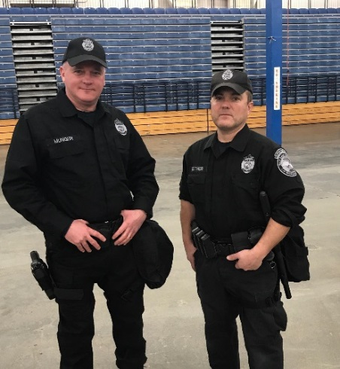

NEMLEC RRT Unit Off. Rick Munger and Off. Mark Leitner Spring 2021

**DEPARTMENT’S CANINE UNIT**

Tragically, the department lost its first canine in more than three decades, Kato, after Kato suffered a medical emergency while training. Fortunately, the department now has a new canine member, Zane.

Zane is an eighteen-month-old Belgian Malinois.  Zane and his partner, Officer Andrew Civetti, completed 14 weeks of training through the Boston Police K9 Academy were certified as a Patrol K9 Team in obedience, tracking, area searches, building searches, evidence searches, criminal apprehension, and handler protection.  Additionally, Kato and Officer Civetti received a national certification as a Patrol K9 through the North American Police Working Dog Association.  Training in secondary specialty detection is forthcoming.

The Stanton Foundation provided the department with the funding to purchase and train Zane.  Massachusetts Vest-a-Dog provided funding for a bullet and stab resistant vest for Zane, as well as purchasing training equipment.  Fromm Family Pet Food is kind enough to provide Zane's food at no cost to the department.

Officer Civetti and K9 Zane Fall 2022

**PUBLIC SAFETY DISPATCHERS**

Watertown Police Department - Police and Fire Communications Fall 2021

Watertown’s Public Safety Dispatchers serve as a lifeline to the City’s residents dealing with emergencies. Our Public Safety Dispatchers handle both police, medical and fire related emergencies. In 2022, Watertown’s Public Safety Dispatchers handled 9,863 911 emergency calls. That was nearly 2,500 more calls than received in 2021; a more than 33% increase from 2021.

The dispatchers work under the Patrol Division of the Police Department. They are the first point of contact for all citizens requesting assistance or directions from either department. The dispatchers answer all E-911 calls and are responsible for dispatching all fire apparatus and ambulances when required. They also dispatch all police cars to service and emergency calls. These dispatchers are also required to contact the Registry of Motor Vehicles to obtain and check license and registration status vehicle information and confirm warrants on wanted individuals.

**TRAFFIC DIVISION**

Motorcycle officers Off. Charles Samios Off. Rod Mendez, Off. Vaughan, and Off. Pham May 2021

In 2022 the Watertown Police Department Traffic Division conducted traffic enforcement activities throughout the Town with three patrol officers assigned to the division.

The Traffic Division has two patrol cars and four Harley Davidson motorcycles assigned to it. Motorcycle officers are assigned to both the Traffic and Patrol divisions. These officers attended either forty hours of instruction at the Boston Police Motorcycle Training Academy, the M.B.T.A. Motorcycle Training Academy or an eighty-hour course sponsored by the Northeast Massachusetts Law Enforcement Council (NEMLEC).

The Traffic Division has a Commercial Vehicle Enforcement Unit. This unit increases the safety of the motoring public and contributes to maintaining the integrity of the town roadways by inspecting commercial vehicles and their drivers for safety, equipment, and weight compliance. This unit consists of one officer who is trained and certified by the U.S. Department of Transportation (D.O.T.) as a federal motor carrier inspector. This officer is also trained and certified by the U.S. Department of Transportation to conduct inspections of commercial vehicles carrying Hazardous Materials.

The Traffic Division is responsible for the Detail Office. The Detail Office consists of one officer who is responsible for scheduling details and overtimes, billing companies and collecting money owed. This Officer also covers routes during personnel shortages, conducts community policing activities and is available to respond to emergency situations as needed.

The Traffic Division supervises one full-time and one part-time civilian parking enforcement officer. These civilian positions allow police officers to dedicate their time to other police duties.

Between January and December 2022, the Traffic Division conducted surveys, studied speed and traffic flows, and conducted investigations for the Watertown Traffic Commission. This information was used by the Traffic Commission in their determination for the addition, replacement, or deletion of traffic signs, rules and regulations.

The Traffic Division has four portable RADAR speed display signs. These signs are portable speed feedback units that display target vehicle speeds on a 3’ x 3’ display window. In addition to speed measurement, these units also measure traffic volume. The reports generated by these radar units are used to aid the Traffic Commission in their efforts as well as to determine the level of traffic compliance in particular areas. The speed signs have been effective tools in reducing vehicle speeds in problem areas. The Traffic Division also uses a portable electronic variable message sign to display important traffic and safety information to motorists.

The Traffic Division also supervised sixteen full-time and five alternate school crossing guards. These supervisors are responsible for traffic control and the safe passage of schoolchildren and families in and around the public schools. Many post assignments were modified in 2022 due to staffing levels and Watertown Public Schools building construction projects. These projects are expected to impact crossing guard operations for the next several years.

In 2022, the Department issued the following motor vehicle citations:

**TRAFFIC**

14,416 Parking citations

2,033 Total moving citations

**2022 Data**

**2033 Citations**

* 41 Arrests
* 151 Criminal Complaints
* 840 Civil Fines
* 999 Warnings
* 2 Municipal Violations

28 OUI:

* 21 OUI Liquor
* 4 OUI Liquor 2nd Offense
* 0 OUI Liquor 3rd Offense
* 0 OUI Liquor 4th Offense
* 1 OUI Liquor 5th Offense
* 3 OUI Drugs

37 Suspended/Revoked Licenses

71 Unlicensed Operation of a Motor Vehicle

**333 Major Accidents and 573 Minor Accidents**

**Major Accidents Include:**

* 196 Collision with MV in transport
* 3 Collision with other movable object
* 67 Collision with Parked Motor Vehicle
* 14 Collision with Curb
* 3 Collision with Tree
* 4 Collison with Utility Pole
* 9 Collision with light pole or support
* 1 Collision with median barrier
* 1 Collision with Ditch
* 1 Collision with Embankment
* 13 Collision with Pedestrian
* 10 Collision with unknown/fixed object
* *6 Collision with Bicyclist
* 3 Other Non-Collision
* 2 Collision with moped
* 0 Other

*One collision involving a bicyclist resulted in a fatality

Fifty Five percent of all reported major collisions occurred on the following arterial roadways:

* Arsenal Street
* Galen Street
* Main Street
* Mount Auburn Street
* Pleasant Street
* Watertown Street