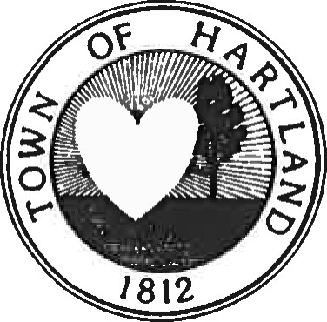TOWN OF HARTLAND

Caitlin Clark

Town Clerk & Tax Collector

PHONE-716-735-7179

FAX- 716-735-3061

EMAIL-

8942 RIDGE RD

GASPORT NY 14067

January 24, 2024

The Riford Family

Dear Riford Family,

This letter is to advise you the Town is in receipt of your F.O.I.L. request dated January 24, 2024 requesting the following:

1. Most recent Town of Hartland Employee Manual

Please be advised that pursuant to Freedom of Information Law, a search of documents requested will be conducted. It is estimated that your request will be granted, granted in part, or denied within twenty business days.



Caitlin Clark

Hartland Town Clerk