Date: 03/21/2024

Re: FOIL Request regarding 19-935433 – Murder – 111 Ebling Ave.

I have received your request for records regarding a murder that occurred at 111 Ebling Ave., on 08/27/2019, in the Town of Tonawanda. This incident is currently being prosecuted by the Erie County District Attorney’s Office. Any release of information could deprive a person of a right to a fair trial or impartial adjudication.

New York State Public Officers Law Article VI, Section 87.2(e)(Ii) exempts from release any records (aside from the fact the Town of Tonawanda Police Department commenced a criminal investigation resulting from the department’s response to 111 Ebling Ave. on 08/27/2019 at 1:45 A.M..) as this information could deprive a person of a right to a fair trial or impartial adjudication.

In a grave matter such as this, the case as it relates to all defendants must be fully adjudicated (including the exhaustion of all legal appeals) before records that could deprive a person to the right to a fair trial or impartial adjudication can be released.

You have the right to appeal this decision within 30 days by filing a written notice of appeal with the Town of Tonawanda’s F.O.I.L. Appeals Officer. It should be sent to:

Michael Kooshoian, Esq.
2919 Delaware Ave.
Room 2
Kenmore, NY 14217

Sincerely,

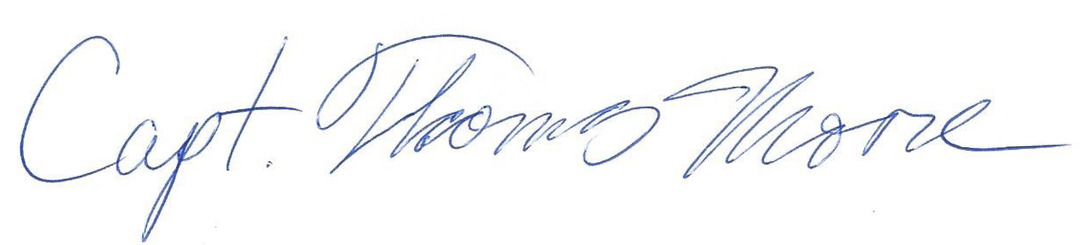
Captain T. Moore
Commander Records Department
Town of Tonawanda Police Department

