PEMBINA COUNTY SHERIFF’S OFFICE

308 Courthouse Drive #2 Cavalier, North Dakota 58220
Phone: 701-265-4122 Fax: 701-265-3194

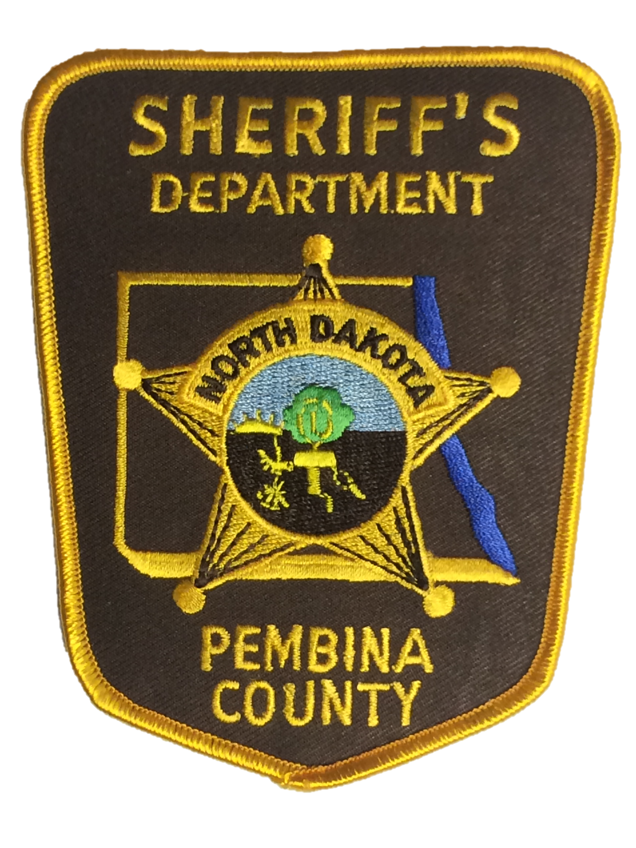

#1
Year | Total | Corrections | Field Services
2017 | N/A | N/A | N/A
2018
2019
2020
2021
2022

#2
Year | Taser | OC | Firearm | Physical Control | Restraint Chair | Baton
2017 | 1 | 0 | 0 | 3 | N/A | 0
2018 | 0 | 0 | 0 | 2 | N/A | 0
2019 | 1 | 0 | 0 | 4 | 0 | 0
2020 | 0 | 0 | 0 | 2 | 1 | 0
2021 | 2 | 0 | 0 | 3 | 3 | 0
2022 | 2 | 0 | 0 | 3 | 1 | 0

#3
year | Civilian complaints alleging police misconduct | Complaints sustained
2017 | N/A | N/A
2018 | 0
2019 | 0
2020 | 0
2021 | 0
2022 | 0

#4
Year | Civilian Complaints alleging police use of excessive force | Complaints sustained
2017 | N/A | N/A
2018 | 0 | 0
2019 | 0 | 0
2020 | 0 | 0
2021 | 0 | 0
2022 | 0 | 0

#5
Year | Civilian complaints alleging biased based policing or racial profiling | Complaint sustained
2017 | N/A | N/A
2018 | 0 | 0
2019 | 0 | 0
2020 | 0 | 0
2021 | 0 | 0
2022 | 0 | 0

#6
Year | Civilian Complaints Alleging Criminal Conduct | Complaints Sustained
2017 | N/A | N/A
2018 | 0 | 0
2019 | 0 | 0
2020 | 0 | 0
2021 | 0 | 0
2022 | 0 | 0

#7
year | Office Involved Shootings (fatal and non-fatal)
2017 | 0
2018 | 0
2019 | 0
2020 | 0
2021 | 0
2022 | 0

#8
year | Total number use of force against | White | Black | American Indian | Hispanic | Asian | Other
2022 | 5 | 5 | 0 | 0 | 0 | 0 | 0

