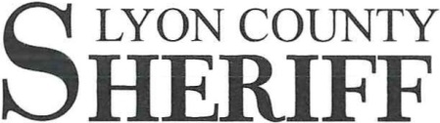
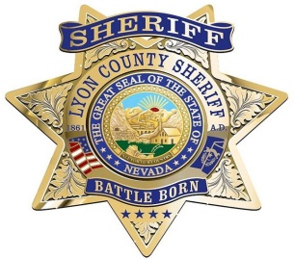
Brad Pope
Sheriff

TO: MuckRock News

ATT: Dept. MR 154958

FROM: Lt. Bret D. Willey

SUBJ: FOIA Request Use of Force

DATE: 01/24/2024

To Whom It May Concern:

The following our response and data for the FOIA request you originally sent on 11/23/2023.

Total Use of Force Incidents:
- 58
Patrol Use of Force Incidents:
- 48
Jail Use of Force Incidents:
- 10
Taser Use
- 8
Baton Use
- 0
Oleoresin Capsicum
- 1
Control Hold / Takedown
- 49

General Misconduct Alleged:
- 12
General Misconduct Sustained:
- 11
Excessive Force Alleged:
- 3
Excessive Force Sustained:
- 2

Bias / Racial Profiling Alleged:
- 0
Bias / Racial Profiling Sustained:
- 0

OIS :

Fatal: 2
Non-fatal: 0

Lieutenant Bret. D. Willey
Administrative Division
Lyon County Sheriff’s Office

LYON COUNTY SHERIFF'S OFFICE • 911 HARVEY WAY #1 • YERINGTON, NV 89447 SHERIFF ADMINISTRATION • (775 ) 463-6600 • (775) 577-5021 • FAX (775 ) 463-6610

