Investigative Summary:
On April 29, 2024, Major Case Unit Sergeant George Hristakopoulos forwarded Detective Scalia an email from Assistant State Attorney (ASA) Libby’s assistant. She requested a female detective collect a buccal swab from Amber Delaney McCann and provided the below Court Order (24-00320-CFFA) signed on April 10, 2024 by the Honorable Judge Terence Perkins.
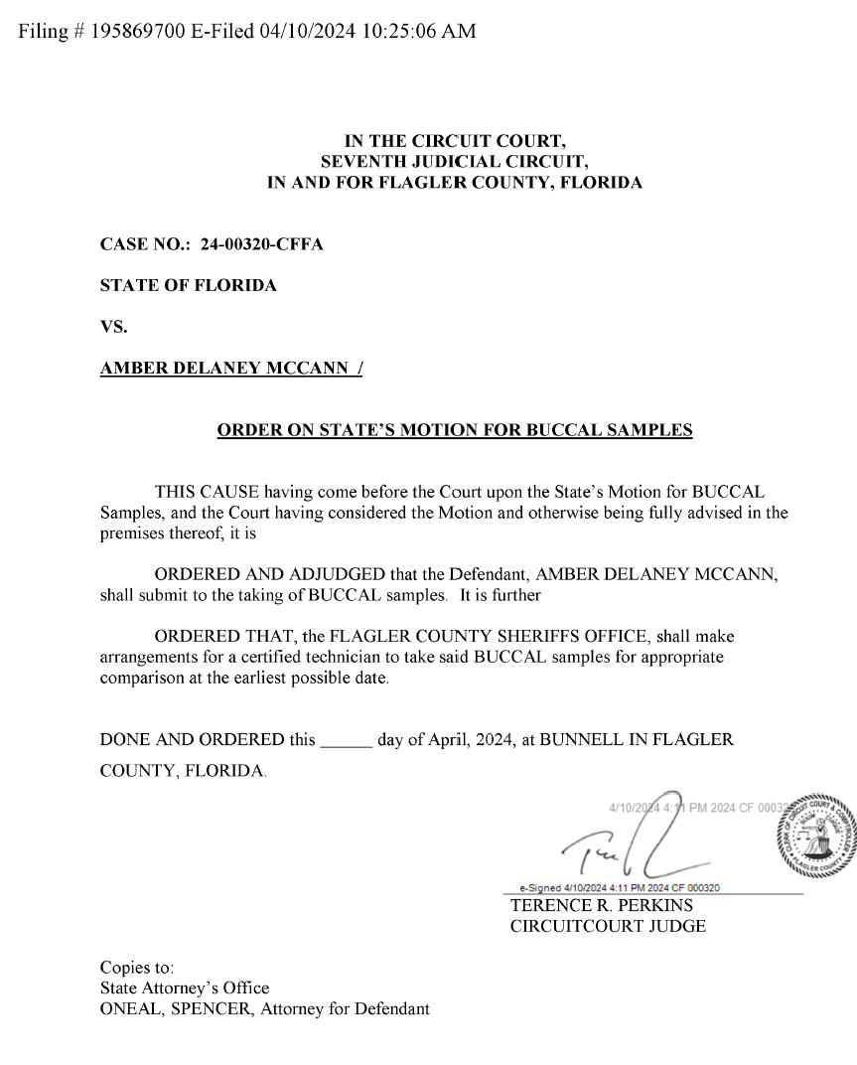
Amber was arrested on March 25, 2024, and was still in custody at the Flagler County Inmate Facility (FCIF). Detective Scalia traveled to FCIF, where Detention Deputies escorted Detective Scalia to Amber’s cell.

Amber was advised of the reason for the visit and inquired if the collection was mandatory. Detective Scalia stated it was, and was court ordered. Amber allowed Detective Scalia to collect the DNA samples (buccal swabs).

The buccal swabs were submitted into FCSO Evidence along with a copy of the signed Court Order, evidence sheet, and processing request form.

Detective Scalia had no other involvement with this investigation or case.

Items of Evidence:
Item # | Description | Date Collected | Collected By
720.1 | DNA Sample (Buccal swabs) from Amber Delaney McCann | 4/29/2024 | Detective Scalia

Conclusion:
Detective Scalia had no other involvement with this investigation or case.

