DUBLIN POLICE DEPARTMENT

**STANDARD OPERATING PROCEDURE**

**SECTION: E-006 ESTABLISHING PERIMETERS**

**EFFECTIVE DATE: 13 MAR 2023 NUMBER OF PAGES: 3**

**REVISED DATE: DISTRIBUTION AUTHORIZATION:**

**STANDARD COVERED *CHIEF KEITH MOON***

**N/A**

**I. PURPOSE**

During any law enforcement incident where a suspect is either at large, at a standoff with law enforcement, or at a crime scene, setting up a perimeter is vital to a successful conclusion, and the sooner the perimeter is established the better the chance for success. Perimeters are not only necessary for the protection of citizens and evidence but also for the apprehension of the suspects involved.

**II. DEFINITIONS**

Inner perimeter: The immediate area where the crime was committed or the area in immediate proximity to any Hostage/Barricade Incident in which police personnel, First Responders, and the general public are most vulnerable to direct gunfire or other harm from a suspect or police countermeasures. The Inner Perimeter is also the area in which the presence of uninvolved civilians and/or media can create the greatest obstruction to police actions intended to resolve the incident.

Outer Perimeter: A boundary outside the inner perimeter maintained by patrol officers and designed to prevent unauthorized persons from entering the area of the critical incident.

**III. POLICY**

It is the policy of the Dublin Police Department to establish police perimeters for the preservation of evidence and balancing the risk of injury, while apprehending offenders and securing available evidence.

**IV. PROCEDURES**

Supervisors shall have the responsibility of ensuring the following procedures are taken:

1. CRIME SCENES

Inner Perimeter- The most basic and superficial containment, this is the crime scene tape that surrounds the crime scene itself. The first level is usually determined by responding patrol officers and can be modified slightly after the initial response or other personnel arrives. The first level perimeter should encompass all known evidence plus an extra fifty (50) feet if extra space is available. Make sure to remember possible areas of entrance and egress by the suspect as these are the most commonly forgotten when containing a crime scene.

*Note: Establish a Perimeter Large Enough to Contain All Evidence*

Outer Perimeter **-** Though taking security to a higher level, this is not as complicated as it sounds. When investigators arrive, or before, put up a second barrier of crime scene tape that completely surrounds the first level making a buffer zone. The secondary level solves several problems: Officers and Command staff have a place to meet where they cannot be bothered by civilians or the media. Your crime scene log should be kept in this area and signed only by those who enter the inner level, or it can be signed by officers as they enter the outer level.

Outer Perimeter Containment - This third level is where is where manpower and vehicles come into play. Perimeter containment is done at most scenes to varying levels. This perimeter is created with barricades and police vehicles set up around the secondary tape. Roads are blocked to keep unauthorized vehicles away from the crime scene and foot traffic is routed elsewhere. This level may be tighter if you have media trying to get as close as possible and civilians trying to get right up to the crime scene tape. Manpower needs vary depending on how much foot traffic and unauthorized vehicles you are trying to keep out and how many access points you have for authorized vehicles. The point of perimeter containment is that you keep your first and second levels of containment more secure by ensuring that unauthorized personnel will not be close enough to intrude upon your crime scene.

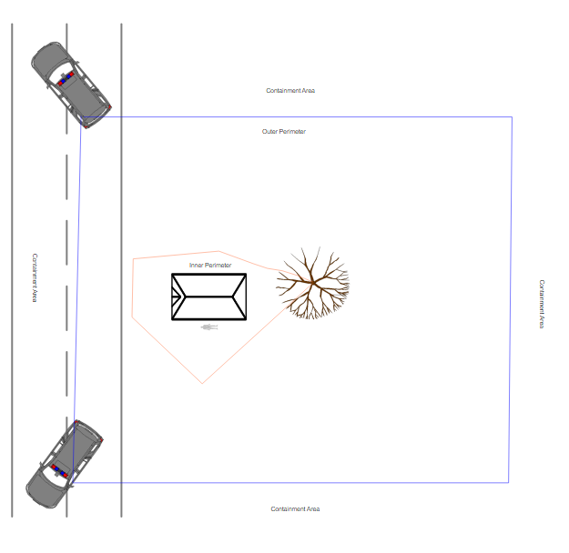

**Create A Plan and Communicate**

Determine The Type of Crime That Occurred

Identify Any Threats to the Evidence

Consider Additional Resources If Necessary

Communicate With Your Team About How to Proceed

**Keep Unauthorized People Out**

*Once things are locked down, you have to control and record who comes in and out of your crime scene. You need to treat your crime scene like classified information: need-to-know basis only. If you are working the crime scene, you're in. If you are a gawker you're out!*

*Note: Crime scene preservation and its importance can't be overstated, especially for first responders. Your actions, or lack thereof, will either help protect the crime scene or help destroy it. It's hard to get a conviction without evidence, so you need to preserve as much of the crime scene as possible.*

1. APPREHINDING FLEEING SUSPECTS

Foot pursuits of criminals can be one of the most hazardous situations an officer can encounter because they are unpredictable and contain many challenges and hazards in addition to the threat posed by the suspect.

*Perimeter containment involves ensuring that a suspect is contained within an area by deploying officers to the perimeter of the area, such that they have clear views of all sides of the containment area. A two-man team can then enter the contained area for a search.*

Supervisors shall respond to the scene and ensure a perimeter is established as soon as possible utilizing available resources but also ensuring sufficient resources remain available for immediate response to other emergencies*.*

***Officers assigned to observation posts must remain in place until they are relieved, requested for assistance, or must respond to an emergency.***

